Banner|Aetna Performance Network Docfind
- https://www.banneraetna.com/

- Click “Find a Doctor”

- Either search by logging in as a member or continue as a guest by typing in the zip code, city, or state and the range of miles.

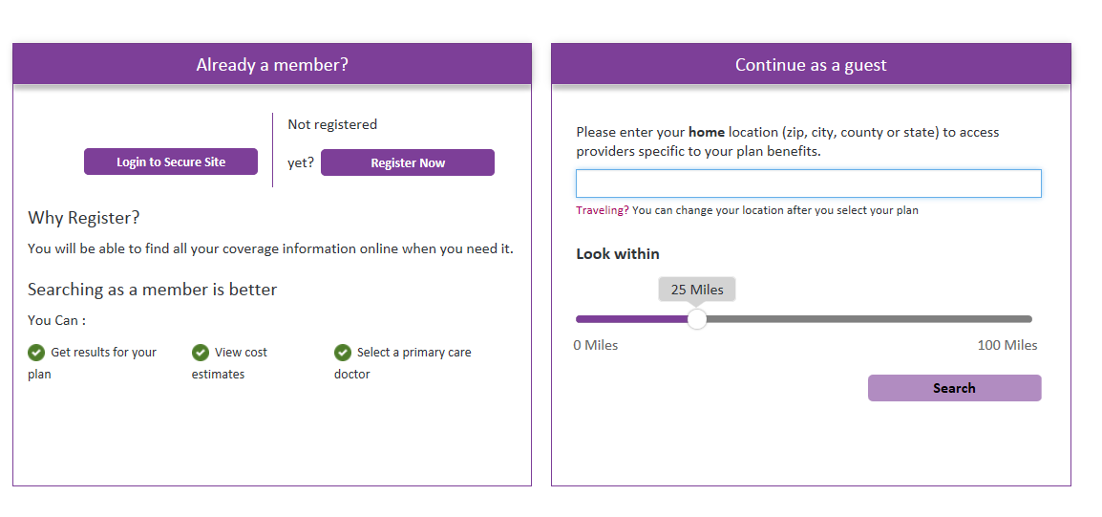

- Under the “Banner Health Network (Performance)” section, select “Banner Open Access POS II”
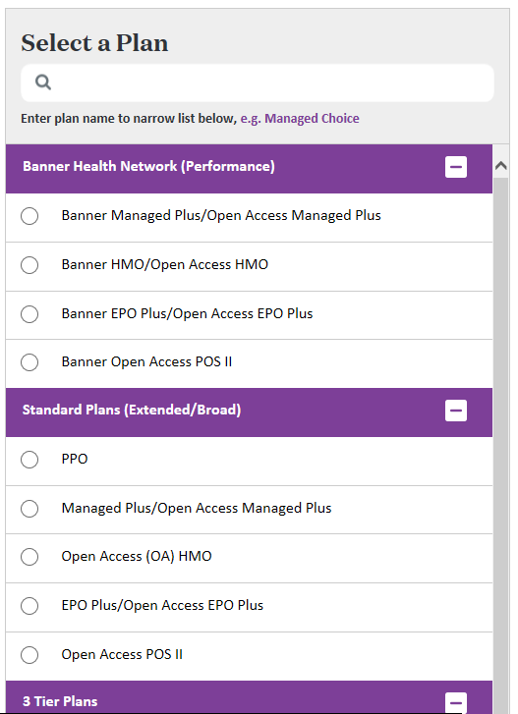
Banner
Performance Network
- Search by category or by typing in what you are looking for

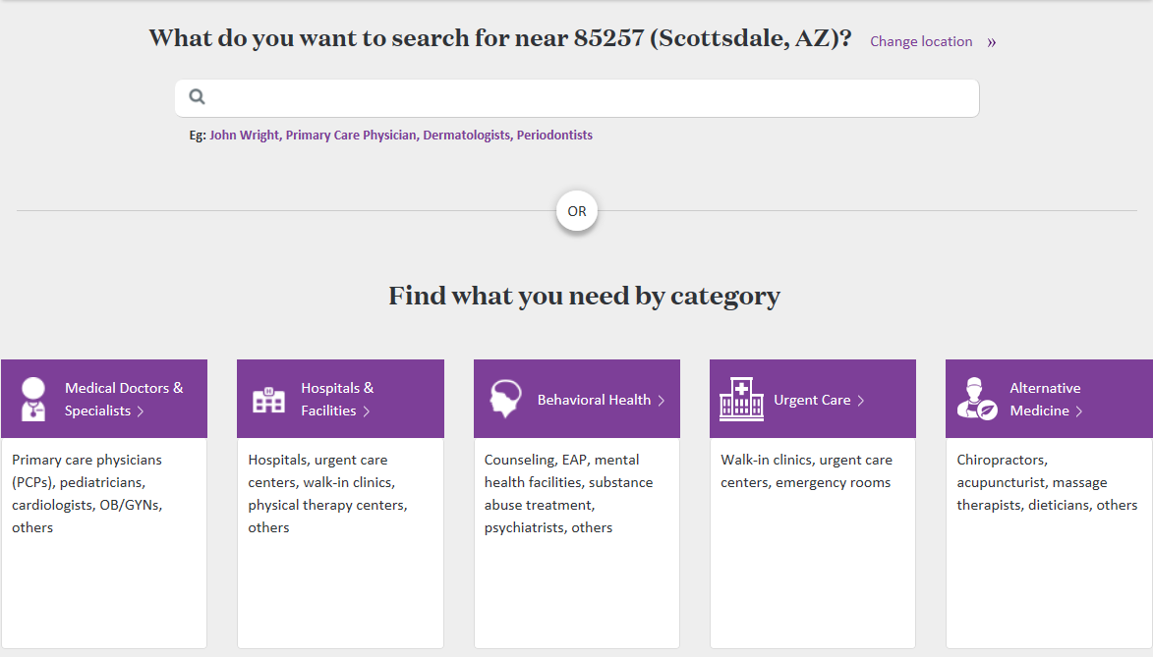

- Please see results of the search:

