Contents

I. General Plan 2
8
II. Active Shooter Information -– Code Grey 9
III. Assurance Button System Failure 11
IV. Bomb Threat and Imminent Threat – Code Yellow 12
If You Find a Suspicious Item 13
V. Earthquakes 13
VI. Electric Power Outages 15
VII. Evacuation 19
VIII. Fire – Code RED 22
IX. Major Storms and Flooding 23
X. Staffing During a Massive Disaster 24
XI. Toxic Plumes 25
XII. List of Appendices 27
A. APPENDIX - List of Low Mobility Residents 28
B. APPENDIX - FEMA Active Shooter Prepare/Respond 35
C. APPENDIX- Bomb Threat Checklist 37
D. APPENDIX - Evacuation Routes 38
E. APPENDIX - List of Vendors 39
F. APPENDIX - List of Inventory Maintained 40
G. APPENDIX - List of Emergency Numbers 41
H. APPENDIX - List of Residents with Special Dietary Needs 42
XIII. INDEX 43

General Plan
The Emergency Preparedness Plan (“EPP”) is designed to manage the consequences of a natural disaster or other emergencies that disrupt the ability of Grandview Terrace to provide services, security and safety to our residents. A separate detailed plan is established for GVT Health and Rehab operations.

Objectives
- Information on how each department will implement specific procedures in response to environmental or manmade events.
- Provisions for the management of space, supplies, communication, safety and security.
- Provisions for the management of staff and residents, including the distribution and assignment of responsibilities and functions.
- Provisions for the management of residents, including the scheduling of minimum service and control of information.

The Management Staff
- Executive Director and Administrative staff to include Business Office Manager and Human Resources
- Administrator
- Director of Nursing
- Business Office Manager
- Director of Dining Services
- Director of Customer Service
- Director of Resident Services
- Human Resources Representative
- Director of Environmental Services
- Director of Information Technology (as applicable)

Procedure
The actions involved in an internal or external emergency may include:
- Protection and continued services for residents.
- Suspension of some or all normal Grandview Terrace operations.
- Modification of services to Grandview Terrace residents.

Plan
- Command Post/Communication
- Water/Food
- Power
- Waste Management
- Contact Agencies
- Emergency Kit Checklist
- Committee Members
- Critical Staff/Staffing
- Responding to various emergency natural/unexpected disasters including evacuation plan
- Educational Resources

Management Staff Proactive Responsibilities
Administrative Steps:
- Establish a (24-hour) disaster notification/communication and disaster management plan among the Management Staff. Initiating the evacuation procedure when advised.
- With the best of information provided by the residents, maintain a list of low mobility residents who use walkers, wheelchairs or scooters and will require help to reach the ground level, if the elevators are not operating. This list must be kept in a fully accessible location at the front desk.

The Resident Services Director with assistance from Customer Service will be responsible for maintaining a Resident Roster that will include the names of:
- All Residents with their condo numbers.
- Resident with pet(s) list.
- Residents who are out of the building on vacation, in the hospital etc.
- Guests and their room numbers when informed.
- Residents who normally use a cane, a walker, a wheelchair or a scooter.

The Resident Information Sheet should include lists of (when provided by resident)
- Current medications
- Family addresses
- Family telephone numbers

All staff and residents should make themselves aware of possible evacuation routes
- From the condo
- From common amenities, including dining rooms
- Locations you utilize frequently at GVT

Establish the plan to include specifics for residents related to food, water, and supply storage and conservation.

Educate staff and residents on the Emergency Preparedness Plan.

Command Post/Communication
- The Executive Director will be in charge and direct operations. In the absence of the Executive Director, based on the nature of the emergency the Customer Service or Resident Services Director will assume responsibility for the GVTRC operations and the Administrator will take charge at GVTHR.
- The Command Post information will be communicated by text. If texting service is affected, report to 1st Floor Lobby/Front Desk. In the event front lobby area is affected, the dining room hostess station will become the command post, unless otherwise notified.
- If telephones are working, the emergency call/text system will be implemented.
- If telephone service, including cell phone service, is interrupted, staff will communicate via 2-way radios located at the front desk and EVS office. Department Directors will be issued radios to maintain essential communication.
- The management staff and staff/resident wing captains will be provided identifiers (individual armbands or similar tag) as authorized person that clearly identify their roles.
- Any media communication to be directed to Sun Health Corp Public Relations.
- Residents to remain in condo until further instructions. Keep your wireless/cell phone charged at all times and have extra batteries for the flashlight.

Immediate Departmental Responsibilities
- Executive Director, or designee, will take command and initiate departmental communication and activate the command center.
- The Dining Department will ensure that emergency food, water and paper products are available.
- Environmental Services will assure safety of the environment and preserve plant operations, to best of its ability.
- Customer Service will safeguard each entrance, as appropriate, to assure safety. (Map is attached showing each entrance)
- Information Technology Services will ensure computer backup procedures are initiated on all vital documentation and applications (e.g. SARA – resident emergency notification/ EMS/Freedom door access).
- Resident Services will provide a current list of resident names with condominium number and pet information. May require Resident Information Sheets with current medications, as well as family addresses and telephone numbers. Assign resident/staff wing captions to assist residents.
- Wing Captains (resident/staff): At the time of a disaster emergency, each wing will have an appointed wing captain(s) that will aid management during the event of an emergency. Duties include, but are not limited to the following:
  - Liaison for information from management to residents.
  - Assistance with waste management.
  - Assistance transporting meals to home bound residents.
  - Rounds to ensure well-being of residents on the assigned wing.
- Employee Services will provide current lists of personnel and telephone numbers.
- Administrative staff will support resident and staff communication.
- Sun Health Corp Public Relations will work directly with the media and social media.
- Other key staff will be assigned responsibilities depending on the nature of the emergency.
- Taking photos of the event and posting on social media is prohibited.

Overall Operations
Depending on the nature of the emergency, some of the routine operations may be suspended or modified to manage the emergency.
- Emergency affecting the Water supply
  - Each resident will be asked to store water in their condo. The request will be one gallon of water, per person per day. (Two quarts for drinking, two quarts for food preparation/sanitation.) A 5-day supply for each person in the household should be kept and stored in plastic containers.
  - Swimming in the pool will be prohibited. If necessary, this water will be used for sanitation or boiled and used for food preparation.
  - Grandview Terrace will store supplemental water to supply residents for 5 days at ½ gallon per resident per day. This will be utilized for drinking only. Two quarts of water are needed to maintain normal body function. Staff that arrives for duty will be asked to bring their own water supply.

- Emergency affecting Food supply
  - The elimination of electric, water and telephone would mean that kitchen equipment would not operate, with the exception of the walk-in cooler and freezer. There will be no way to wash or sanitize all equipment so all tableware will have to be disposable. Alternative, limited menu options/meal arrangements will be made.
  - The goal of the Dining Services Department will be to provide two meals a day, for 5 days, to all residents regardless of meal plan.
Following is a suggested plan that may vary, dependent on the extent of the emergency.
  - The early meal will be a continental breakfast.
  - The second meal will include a hot entrée and vegetable. If no gas, the second meal will be cold.
    - Continental breakfast will be served in two seating’s. One at 9:30 a.m. and the second at 10:00 a.m.
    - The second meal of the day will be served in two seating’s. First one at 4:00 p.m. and the second one at 5:00 p.m. If no gas line, this meal will be cold.
  - The morning and afternoon meals will consist of food groups appropriate for proper nutrition, based on USDA guidelines.
  - All meals would be buffet style or plated with assistance offered to those residents with special needs. We would not be in a position to offer special menus, so residents with special dietary needs, will have to stock their condo with product that meets those needs. We will strictly enforce the policy of not allowing residents to remove food items from the Dining Rooms. While we are offering an additional meal to the residents, it is not our intention to provide for all dietary needs of the residents.
  - Tables will be set with disposable plates, cups, and flatware. A beverage station will be set in the dining rooms. For the purpose of this plan, we will assume we could be working with a skeleton crew and may not be able to provide our usual levels of service in the dining rooms. Those residents who the nurse determines cannot make it to the dining room will be offered meal delivery.
  - Residents should store at least a 5-day supply of non-perishable food. Food selections should be compact and lightweight. Residents should have a non-electric can opener available in their condo.
  - Foods ready in preparation for an emergency event include:
    - Ready to eat canned meats, fruits and vegetables
    - Staples such as sugar, salt, pepper
    - High energy foods such as peanut butter, jelly, crackers, granola bars, trail mix
    - If water is limited, avoid foods high in salt, fats, and protein
    - Include vitamin and mineral supplements to assure adequate nutrition
    - Know the shelf life of any stored foods
- A general guideline for rotating common emergency foods is listed for resident convenience.
  - Use within six (6) months
    - Boxed powdered milk
    - Dried fruit in a metal container
    - Dry crackers in a metal container
    - Dehydrated potatoes
  - Use within one (1) year
    - Canned condensed meat and vegetable soup
    - Canned fruit, fruit juices, and vegetables
    - Ready to eat cereals and uncooked instant cereals in metal containers
    - Peanut butter
    - Jelly
    - Canned nuts
  - Indefinite storage
    - Wheat
    - Vegetable oils
    - Dried corn
    - Baking powder
    - Soybeans
    - Instant coffee, tea, cocoa
    - Salt
    - Non-carbonated soft drink
    - White rice
    - Dry pasta
    - Bouillon products

Power
- In the case of a power failure, the building can be supplied limited power through our emergency generator. The generator will power one elevator on each side of the building (B/C and D/E), lighting for the common area and entry lighting for each apartment. All residents should have at least 2 flashlights and batteries (no candles will be allowed). Elevators will operate only during meal times in order to conserve fuel. In the event electronic key/door access does not work, it will require the use of a hard key.

Waste Management
- If there is an interruption of a water supply to our building, the disposal of excrement will become the responsibility of management. We have chosen to use the method utilized by NASA and jet pilots.
- Residents will have a supply of plastic trash liners. These liners will be placed in the commode to collect the human waste in each apartment. On a daily basis staff will make rounds (approximate time to be communicated) to collect the bag and give each resident a new liner. Staff will then treat each bag with the appropriate chemicals. Staff will transport all bags containing waste to the designated area for proper disposal.

Contact Agencies
- Agencies contacted for support service:
  - Federal Emergency Management Agency (FEMA) – 1-800-621-FEMA (1-800-621-3362)
  - Maricopa County Emergency Management Department – 602-506-3011
  - American Red Cross – 1-866-438-4636

Committee Members Representation
- Executive Director and administrative staff to include Business Office Manager and Human Resources
- Administrator
- Customer Service
- Nursing
- Dining Services
- Environmental Services
- Resident Services

Critical Staff
- All staff will be considered “critical staff” and requested to report to duty in the event of an emergency. Those staff with family will be allowed to have them accompany them if they also bring appropriate amounts of food, water and clothing for the family. The Grand Room (4,307 square feet) will be utilized to house employees and family members. The Grand Room has the capacity to hold over 600 people (500 seating). The space will be assigned to family members and monitored by staff.

All staff and residents should make themselves aware of possible evacuation routes
- From the condo
- From common amenities, including dining rooms
- Locations you utilize frequently at GVT

Keep your wireless/cell phone charged at all times and have extra batteries for the flashlight.

Emergency Kit
The American Red Cross recommends keeping an emergency kit ready (one that has a shoulder strap to keep your hands free) that may include the following items:

Copies of important prescriptions | Non-electric can opener | A list of important telephone numbers – doctors, clergy and financial advisors
A 30-day supply of critical medications (Minimum of 7 day supply) | Needles/thread | A small amount of cash.
Aspirin | Paper/pencils | Negatives/Memory Cards of irreplaceable photographs/digital prints
Antacid | Multipurpose tool | A flashlight (with extra batteries) and a whistle
Anti-diarrhea medication | Extra eye glasses. | Portable radio (with extra batteries)
Ipecac | Small fire extinguisher | A list of insurance company policy numbers
Laxative | Toilet paper | A list of bank account numbers, credit card numbers and driver’s license numbers
Activated charcoal | Health insurance cards | Gauze pads
Soap-liquid detergent | The key to your safe deposit box | Roband (self-sticking) bandage
Household chlorine bleach | Self-adhesive bandages of various sizes | Scissors, Tweezers
Personal Hygiene Items | Plastic garbage bags and ties | Cleaning agents such as alcohol and hydrogen peroxide
Sturdy shoes/boots | Extra blankets, pillows, sleeping bags | Hat, gloves.
Thermal underclothes | Latex gloves | Cell Phone with Chargers
Car keys and house keys | Pet Supplies (collar, leash, ID, food, carrier, bowl) | Towels

Active Shooter Information -– Code Grey
General: When an active shooter (Code Grey) situation is called or announced all residents are to take immediate safe cover. RUN / HIDE / FIGHT

An active shooter is described as an individual actively engaged in killing or attempting to kill people in a confined and populated area. In most cases, active shooters use firearms and there is no pattern or method to their selection of victims.

Typically, the immediate deployment of law enforcement is required to stop the shooting and mitigate harm and victims. Most active shooter situations are over in 5-15 minutes. Prior to law enforcement arriving on scene, individuals must be prepared both mentally and physically to deal with an active shooter situation.

If an active shooter is in your vicinity, quickly determine the most reasonable way to protect your own life. Avoid the “Hot” area of an active shooter. Immediately RUN to safety. If evacuation is not possible, you should HIDE and take cover where the active shooter is less likely to find you. If you are unable to run or hide then you will need to FIGHT with everything within your power. Remember, your life is on the line.

Be Informed
- Participate in active shooter training.
- If you see something, say something to an authority right away.
- Sign up to receive local emergency alerts.
- Be aware of your environment and any possible dangers.

Make a Plan
- Make a plan and ensure everyone knows what they would do, if confronted with an active shooter.
- Look for the two nearest exits anywhere you go, have an escape path in mind and identify places you could hide.
- Understand the plans for individuals with disabilities or other access/functional needs.

During: RUN and escape, if possible.

- Getting away from the shooter or shooters is the top priority.
- Leave your belongings behind and get away.
- Help others escape, if possible, but evacuate regardless of whether others agree to follow.
- Warn and prevent individuals from entering an area where the active shooter may be.
- Call 9-1-1 when you are safe, and describe shooter, location, and weapons.

HIDE: if escape is not possible.
- Get out of the shooter’s view and stay very quiet.
- Silence all electronic devices and make sure they won’t vibrate.
- Lock and block doors, close blinds, and turn off lights.
- Don’t hide in groups- spread out along walls or hide separately to make it more difficult for the shooter.
- Try to communicate with police silently. Use text message or social media to tag your location.
- Stay in place until law enforcement gives you the all clear.
- Your hiding place should be out of the shooter's view and provide protection if shots are fired in your direction.

FIGHT: as an absolute last resort.
- Commit to your actions and act as aggressively as possible against the shooter.
- Recruit others to ambush the shooter with makeshift weapons like chairs, fire extinguishers, scissors, books, etc.
- Be prepared to cause severe or lethal injury to the shooter.
- Throw items and improvise weapons to distract and disarm the shooter.

After
- Keep hands visible and empty.
- Know that law enforcement’s first task is to end the incident, and they may have to pass injured along the way.
- Officers may be armed with rifles, shotguns, and/or handguns and may use pepper spray or tear gas to control the situation.
- Officers will shout commands and may push individuals to the ground for their safety.
- Follow law enforcement’s instructions and evacuate in the direction they come from, unless otherwise instructed.
- Take care of yourself first, and then you may be able to help the wounded before first responders arrive.
- If the injured are in immediate danger, help get them to a secure place.
- While you wait for first responders to arrive, provide first aid. Apply direct pressure to wounded areas and use tourniquets, if you have been trained to do so.
- Turn wounded people onto their sides if they are unconscious and keep them warm.
- Consider seeking professional help for you and your family to cope with the long-term effects of the trauma.

Resident’s Responsibilities
- If in a common area, you will need to find the very first open doorway and enter that room or closet. Close the door behind you and lock it, if possible. Stay calm and do not make noise. Silence your cell phone. A search team will discover you after the situation is controlled. You will not leave until an “All Clear” is issued.
- If you are in your condo, stay in your condo and keep your door locked. Do not make noise. Go to the back bedroom and wait. A search team will discover you when the situation is controlled. You will not leave until an “All Clear” is issued.
- When in a safe position call 9-1-1. Remain quiet.
- Help any other residents, if possible, while taking cover.
- If approached and unable to take cover, the last resort is to try to take out the active shooter. Fight with aggression. Remember, at this point your life is on the line.

All Staff Responsibilities
Staff are to efficiently announce and warn all residents, guests and staff of the threat at hand. Staff will take cover immediately and keep in communication, as best possible. Once in a safe area, call 9-1-1. Staff will assist all residents possible while escaping to a safe area. Await further directions from incident command or law enforcement.

Executive Director or Designee
Assume command and direct staff for the safety of residents. Take cover and communicate with admin staff via cell phone texting option, as it is quieter. If able, be ready to greet Law Enforcement on arrival. Assist Law Enforcement with all resources available. After situation is controlled, assist with thorough search of all spaces to verbally give “All Clear” to residents, guests, and staff. All communication with media will be directed to SH Corp Public Relations.

Law Enforcement
Law enforcement’s purpose is to stop the active shooter as soon as possible. Officers will proceed directly to the area in which the last shots were heard.

The first officers to arrive on scene will not stop to help the injured persons. Additional officers and EMT’s will arrive to serve as rescue teams. These teams will remove and treat injured victims. They may also call upon abled bodies to assist in removing the wounded from the premises.

Everyone is to follow all commands from law enforcement officers. Keep hands empty and raised with fingers spread.

The “All Clear” will first be issued by Law Enforcement and then the Executive Director (or designee) will issue an “All Clear”.

Assurance Button System Failure
The Assurance System called SARA (Situational Awareness and Response Assurance) in your condo is a very valuable system in more ways than one. It tells us that you have checked in and are doing well. It also tells us when you need us in an emergency and when there is smoke coming from your condo or other location in the building. At least one bathroom in each condo is equipped with the notification sensor and Emergency Call pull cord. In addition, each resident is provided with a pendant that works in the condo, as well as within the GVT external boundaries. Below is a reference of information if the system should be offline either due to a scheduled or unscheduled issue.
In a situation where the SARA Assurance System is offline, please do not panic. Our staff have procedures in place to always ensure your safety.

Wall-Mount System Failure
Our system alerts staff when there may be an issue with the system such as a low battery or unit failure. In an isolated situation, if the wall-mount system does not have a blinking light, the appropriate steps will be followed in order to get the system corrected and working normally. During this time, please follow the steps below. If phones are affected, residents will be provided with an emergency number (red phone) to call in case of medical emergency. Call 9-1-1 for a life threatening emergency.

Morning Check-In:
- On a piece of paper state the time of the day, state your name and place by your condo mailbox box. This indicates your morning check in. Complete this action by 10:00 a.m.
- Staff will round all the wings by 10:00 for morning check-in. If no paper check-in is found, the staff will access the condo.

Emergency:
- Use the pendant to notify our staff of an emergency.
- Please refrain from using the phone.

Pendant System Failure
If the pendant system is not working appropriately, please follow the below steps:

Morning Check-In:
- Pull the pull cord on the wall-mount.

Emergency:
- Use the emergency pull cord in the bathroom.
- Keep your phone close to you. If phones are affected, the residents will be provided with an emergency number (red phone) to call in case of a medical emergency. Call 9-1-1 for a life threatening emergency.

Both – Wall-Mount Pull Cord and Pendant System Failure
In this extremely rare situation when both wall-mount and pendant are in failure, one of our staff/wing captains will visit/connect with all occupied condos every two hours, if desired by the resident(s) until the system has been repaired. In addition to this safety measure, please also follow the steps below:

Morning Check-In:
- On a piece of paper state the time of the day, state your name and place by your condo mailbox box. This indicates your morning check in. Complete this action by 10:00 a.m.
- Staff/wing captain will round all the wings by 10:00 for morning check in. If no paper check-in is found, staff will access the condo.

Emergency:
- Contact the front desk at (623) 975-8000. Call 9-1-1 for a life threatening emergency. If necessary, redline – emergency number will be provided.
- Find a buddy and contact each other at regular intervals.
- Leave a note by your condo mailbox box to notify us if you are not in the building or do not need frequent checks, as you have made alternate check-in arrangements with family/friends.

Bomb Threat and Imminent Threat – Code Yellow
Bomb threats or suspicious items should always be taken seriously. How quickly and safely you react to a bomb threat could save lives, including your own. There have been many unfortunate events in the last few years around the world where individuals have entered places of business to inflict harm on others. Threats may occur in a variety of formats such as telephone, mail, e-mail, or any other means of communication. The guidance and resources listed below outline procedures for either bomb threats or suspicious items and will help you prepare and react appropriately during these events.

Every bomb threat is unique and should be handled in the context of the environment in which it occurs. Management and law enforcement will be in the best position to determine the credibility of the threat. Follow these procedures:
- Remain calm.
- If possible, signal or pass a note to other staff to listen and help notify authorities.
- Notify Executive Director/Department Director immediately:
  - Call 9-1-1 or your local law enforcement if a supervisor is not available.
- Refer to the Bomb Threat Checklist for guidance, if available.

For threats made via phone:
- Keep the caller on the line as long as possible. Be polite and show interest to keep them talking.
- Do not interrupt the caller, Listen carefully.
- DO NOT HANG UP, even if the caller does.
- Write down as much information as possible—caller ID number, exact wording of threat, type of voice or behavior, etc. This information may aid investigators.
- Record the call, if possible.

For threats made in person, via email, or via written note
- Refer to the Bomb Threat Checklist.
- Be available for interviews with management and/or law enforcement.
- Follow authorities’ instructions. Management and/or law enforcement will assess the situation and provide guidance regarding lock-down, search, and/or evacuation.

If You Find a Suspicious Item
Together, we can help keep our communities safe. If you see something that is suspicious, out of place, or doesn't look right, say something.

A suspicious item is any item (e.g., bag, package, vehicle, etc.) that is reasonably believed to contain explosives, an improvised explosive device (IED), or other hazardous material that requires a bomb technician and/or specialized equipment to further evaluate it. Examples that could indicate a bomb include unexplainable wires or electronics, other visible bomb-like components, and unusual sounds, vapors, mists, or odors.

Generally speaking, anything that is Hidden, Obviously suspicious, and not Typical (HOT) should be deemed suspicious. In addition, potential indicators for a bomb are threats, placement, and proximity of the item to people and valuable assets.

If you see something that is suspicious, out of place, or doesn't look right, say something.

In the event of Evacuation during Bomb Threat incident: immediately refer to the evacuation section.

Earthquakes
Earthquakes strike suddenly, violently and without warning. Identifying potential hazards and preparing a response can reduce the possibility of serious injury or loss of life. The geological record shows that the Grand Avenue Fault extends through this area, generally along Grand Avenue.

Further, be prepared for aftershocks that can occur in the first hour, days, weeks or even months after the initial event.

Although California and Alaska are generally considered to be the major earthquake locations, the most devastating earthquake ever recorded in North America occurred in St Louis, Missouri, in 1811. There is evidence that Sun City West has already experienced two minor earthquake tremors in the last 15 years. On August 8, 2000 Grandview Terrace Retirement Center residents clearly experienced a minor tremor.

So it is appropriate to consider an Emergency Preparation Plan that will recommend steps to be taken now, before the Earthquake. This Plan will recommend actions by both the residents and the Management Staff if/when the Earthquake occurs.

Take action now: Before an earthquake hits.
- Secure items that might fall and cause injuries (e.g., bookshelves, mirrors, light fixtures).
- Practice how to Drop, Cover, and Hold On
- Store critical supplies and documents.
- Plan how you will communicate with family members.
- Always keep you cell phone charged.

Residents Responsibility during Tremors
When you recognize a tremor: Drop, Cover, and Hold On

As soon as you feel the shaking,
- DROP down onto your hands and knees so the earthquake doesn’t knock you down.
- COVER your head and neck with your arms to protect yourself from falling debris. If you are in danger from falling objects, and you can move safely, crawl to a safer place or seek cover (e.g., under a desk or table).
- HOLD ON to any sturdy object until the shaking stops.
- If you are in bed, cover your head with a pillow and cover your body with blankets.
- If you are not in bed, crawl under the table that you have selected as a shelter or drop down against an interior wall and cover your head.
- When available, tune your TV to our GVT in-house channel, 1960, for a GVT status report and instructions.
- Pay attention to SARA phone/text messages or PA announcements.
- Listen to KTAR AM (620) on your battery operated radio.
- Subsequent to the tremor, be sure to open cupboards and other doors cautiously, since items may have shifted.
- Locate the nearest fire extinguisher cabinet in the hallway.
- Identify a strong table in each room that can be used as a shelter when tremors/aftershocks occur.
- Identify furnishings that may fall from the walls or from the top of tables etc. and secure them or relocate them.
- Relocate heavy objects away from above the bed, the couches and anywhere people sit.
- Place lists and copies of important documents in a safe deposit box.

Pets
Your pet’s behavior may change dramatically during and after an earthquake. Be sure to watch your pet closely and attach a leash or place the pet in a small carry kennel. Special facilities will be provided for pets, in the event they will not be allowed inside the shelter.

In the event of Evacuation during an earthquake incident: immediately refer to the evacuation section.

*The notification to evacuate the building may come from the Fire Department, the Red Cross or the Executive Director.*

Management Staff Procedures During an Earthquake
If the tremors are minor:
- Begin providing status reports and instructions via: our in-house channel 1960; SARA; or PA system,
- Assemble the Management Staff in the Command Center and review the plan of action.

If a major earthquake occurs:
- Shut off the gas line.
- In collaboration with the Fire Marshall, determine if the building is unsafe and, IF REQUIRED, announce that the building must be evacuated.
- Initiate the Command Center.
- Initiate calls for help:
  - Call 9-1-1 (SCW Fire Department & the Maricopa County Sheriff)
  - Red Cross
- Initiate the disaster call/text messaging.
- Determine if the elevators are unsafe and should be closed. Place a notice on the doors if the elevators are out of service.
- Recruit and direct help to get the low mobility residents down to the ground level and to the rally location.
- Get a copy of the roster of residents and guests (adjusted for travelers, etc.) to the rally location coordinator.
- Place request to the Maricopa County Sheriff Department to protect the building against vandalism and theft.

- Executive Director or Designee Management will call:
  - FEMA
  - Maricopa County Emergency Management Department
  - All appropriate officials and agencies
  - Utility companies for this campus

Electric Power Outages
Electric power outages can occur without any advance warning. Both the power generating plants and the entire West Coast’s electrical distribution system are vulnerable to interruption from natural causes, terrorist attacks and human errors. The system is also vulnerable to overload due to high summer demand. Recent history provides many examples of electrical system failures throughout the country due to overloads.

Power outages may be scheduled by Arizona Public Service or they may be beyond Arizona Public Service’s control and for an extended period of time. Short-term power outages occur randomly and may be due to natural or man-made causes.

The Arizona Public Service “Curtailment Plan” provides that whenever the demand exceeds its ability to provide full power levels to all of its customers they will alternately schedule 30 minutes of power outage to all non-critical customers. Grandview Terrace is classified as a non-critical customer.

Therefore, it is appropriate to consider an Emergency Preparation Plan that will recommend steps to be taken now, before an electric power outage occurs. This emergency plan will also recommend action by both the residents and the Grandview Terrace management staff when electric power outages occur.

During Short-Term Power Outages
Resident Information:
When Arizona Public Service power is interrupted, the Grandview Terrace emergency stand-by generator will start and become fully operational in less than 20 seconds. This will cause all elevators to temporarily stop. After a brief halt, all elevators will go to the first floor. For the duration of this short-term power outage only the D/E middle elevator will be available for residents in the D/E wing who cannot use the stairs and only the B/C middle elevator will be available for the residents in the B/C wing who cannot use the stairs. Have your Condo hard key with you as electronic key access will not work. Use the main entrance, as side entrances will not work with the E-key during an outage.

Management Staff Information:
The Management (front desk) Staff will immediately call Arizona Public Service to announce that Grandview Terrace has an electric power outage and to determine when electric power will be returned to normal. Staff will assist with condo door access.

In addition:
- All air conditioning and heating will be suspended.
- The hall lights and stairwell lights will be interrupted only briefly.
- The entrance light inside each condo can be activated by the light switch just inside the front door.
- The emergency medical alert system will continue to function. If affected, refer to the directions for Assurance System (SARA) Failure.
- The use of candles is prohibited at all times because of fire threat.

The in-house PA/SARA system will be used to announce dining schedules if the outage occurs during regularly scheduled dining periods.

Residents’ Responsibility - Before a Major Power Outage
Reserve Stock:
- Five gallons of water per condo occupant (the Red Cross recommends two quarts for drinking and two quarts for food preparation and sanitation each day).
  - Store the water in heavy plastic containers. Do not store the water in containers that will easily break or decompose such as milk cartons or glass bottles.

Residents should also have:
- A manual can opener.
- At least 2 flashlights and extra batteries.
- A battery operated radio.
- Residents should maintain a 10-day supply of non-perishable food.

Residents with special dietary needs should stock the special dietary items that they require and be prepared to provide their own meals during an electrical power outage.

Residents will be encouraged to organize into “neighborhood” groups and establish a person (and/or persons) who will volunteer to be their “buddy”. When possible, Management staff will assign wing captains.

Management Staff Responsibilities – Before a Major Power Outage
The Employee Services Department will be responsible for maintaining a current list of all personnel and their telephone numbers. This list will be updated as changes occur and will be located at the front desk.

The Resident Service Department will be responsible for maintaining a current list of resident’s names and their condo numbers. The Resident Information Sheet will be classified as CONFIDENTIAL information and limited to those who “need to know”. It will be retained at the front desk and will be updated as changes become known.

General Responsibilities
- Grandview Terrace will maintain a water supply adequate to provide all residents ½ gallon of water each day for 10 days.
- At least twice a month, the stand-by-emergency generator will perform a test run and the fuel tank will be flushed at least every other year.
- The Management staff will review their compliance with the Emergency Preparedness Plan for Electric Power Outages at least annually.
- The Management staff will prepare an educational program that will regularly remind the present residents of the main features of the Emergency Preparedness Program and also inform each new resident as they move in.
- Develop a plan for relocating the residents whenever the temperature of the building creates a health risk.
- Develop a plan for providing status reports to the residents during a power outage.

Resident Responsibilities - During a Major Electric Power Outage
Meals Provided by Grandview Terrace:
- Residents will be provided brunch in two seating’s: one will be at 9:00 a.m. and the second seating will be at 10:00 a.m.
- Residents will be provided their second meal of the day in two settings: beginning at 4:00 p.m. and 5:00 p.m.

*The nurse will determine which residents qualify for meal delivery.*
*Food cannot be removed from the dining room during this period.*
All Residents will be encouraged to use the stairs.

Wing Captain Responsibilities:
- The Wing Captains will be under the direction of the Management staff and will be identified by armbands or similar tags.
- The duties of the Wing Captains will include, but not be limited to:
  - Forwarding information from the Management staff to the residents.
  - Assisting residents.
  - Delivering meals to predetermined home-bound residents.
  - Daily monitoring the status of the residents in their assigned wing.
  - Assisting with waste management.

Instructions and General Information
- At the earliest warning of any power outage, begin watching our in-house Channel (1960) and the bulletin boards at the elevators for instructions and general information the Management staff may also use the in-house PA/SARA system to provide instructions and general information. When applicable – keep your cell phone fully charged.
- Residents may find it helpful to listen to KTAR (620 AM on their battery-operated radio) for general information about the power outage.
- The use of candles is prohibited at all times because of fire threat.
- Lighting will be limited to the common areas and the ceiling entrance light in each apartment. This light is controlled from a switch panel next to the entrance door.
- The air conditioning and the heating will not work.
- If the water supply is interrupted, the residents will be required to place plastic trash liners in one of their commodes to collect the human waste. Each morning, have the “used plastic liners” available to be picked up by the maintenance staff. Concurrently, the used liner will be replaced with a new plastic liner.
- Be prepared to vacate your condo and reside in a shelter selected by the Red Cross, if the temperature rises and the temperature becomes a health risk. Take your E keys and hard keys with you for door access on return. See evacuation section for details
- Prepare an evacuation kit. The evacuation kit should include a 10-day supply of medications, copies of important records, a flashlight and a key to your safe deposit box.

GVT Management Staff
- Organization:
  - The Executive Director (or designee) will direct operations, and when applicable, the emergency call /text system will be implemented.
  - The Customer Service or the Resident Service Director will assume full responsibility if the Executive Director is not available. A priority list will also identify other members of the management staff to be responsible for directing the operations when the Executive Director and the Customer or Resident Services Directors are out of the building.
  - A command post will be established on the 1st floor near front desk or near the hostess desk.
  - If telephone service is interrupted, each management staff member will be issued a 2-way radio for communicating. The emergency call/text system will be implemented.
  - The Information Technology Services Department will be responsible for ensuring the computer backup procedures are initiated on all vital communications. Each department will be responsible for removing and safeguarding all the Grandview Terrace vital documents whenever the building is evacuated.

- Food:
  - The Dining Department will be responsible for providing food, water and paper products.
  - The kitchen equipment (with the exception of the walk-in cooler and freezer that will continue to be supplied electric power from the emergency generator) will not operate without APS electricity.
  - Expectation is that the evening meal will be a hot meal.
  - Since hot water will not be reliable; all tableware will be disposable. All meals will be buffet style.
  - The Dining Services Department will be prepared to provide two meals a day for ten days to all residents, regardless of their meal plans.
  - A continental breakfast will be served at 9:00 a.m. and at 10:00 a.m.
  - An evening meal will include a hot entrée and be served beginning at 4:00 p.m. and at 5:00 p.m
  - The continental breakfast will be determined (TBD) by the chef.
  - The evening meal will be determined by the chef.
  - No food can be removed from the dining room during this period.
  - Special dietary needs cannot be accommodated during an electric power outage.
  - A beverage station will be available in the dining room.
  - The nurse will determine which residents qualify for delivery of their meals.

Instructions and General Information
- At the very earliest warning of any power outage the management staff will begin using Channel 1960, the in-house PA or SARA system and the bulletin boards at the elevators to provide instruction and information.
- The pool will be closed. If it becomes necessary, the pool water may be used for sanitation, or may be treated and used to prepare food.
- The stored water supply will only be used for drinking (two quarts of water are needed each day to maintain the normal body functions).

Waste Management
- If there is an interruption of a water supply to our building, the disposal of excrement will become the responsibility of management. We have chosen to use the method utilized by NASA and jet pilots.
- Residents will have a supply of plastic trash liners. These liners will be placed in the commode to collect the human waste in each apartment. On a daily basis staff will make rounds (approximate time to be communicated) to collect the bag and give each resident a new liner. Staff will then treat each bag with the appropriate chemicals. Staff will transport all bags containing waste to the designated area for proper disposal.

Staff
- The management staff will be classified “critical” and be requested to report for duty. Other selected personnel will also be directed to report for duty.
- The staff that arrives for duty will be required to bring their own water supply.
- Families of staff members will be allowed to join the staff members if they also bring appropriate amounts of food, water and clothing.
- The Grand Room will be used to house the employees and their family members.
- The management staff will assign the space in the Grand Room and be responsible for monitoring the full operation. The 4,307 square foot Grand Room has the capacity to accommodate 200 people (500 seating).

Evacuation
*The notification to evacuate the building may come from the Fire Department, the Red Cross or the Executive Director*
In an extreme case when a portion, or all of the building, must be evacuated all residents will be given instructions via the in-house PA system. In the event that the PA system is not operational residents will be notified in person by management, lay staff, Red Cross, Fire Department, and/or resident wing captains. Residents should leave the building using the safest and nearest exit and remain outside the building at designated rally locations indicated below. Receive instructions only from staff /officials identified with an approved ID badge.

Management Preparation
Management Staff will:
Notify the Residents in the quickest and most efficient way possible during the emergency. These could include:
- A series of audible signals, announcement using the in-house PA/SARA system.
- For mass evacuation, staff will notify hospital for possible triage.
- Determine if evacuation to another Sun Health community is an option. If not, identify a shelter(s) for all the residents (Red Cross) who do not plan to visit friends or have some other arrangements.
- If the resident is unable to provide transportation to the shelter, management will arrange for their transportation.
- The management staff will keep a record of where each person went for shelter so they can advise each resident when they can return.
- Ask radio station KTAR at 620 AM to provide regular status reports.
- Provide assistance in arranging shelter for pets.
- Determine the location of the Rally Location where the residents will assemble away from the building when they are required to evacuate - and the best route to the Rally Location.

Resident Preparation
Residents should be prepared by determining, in advance, not only the best route to evacuate the building (without using the elevator) but also alternate routes. Emergency personnel and the management staff will provide assistance to all residents with limited mobility.
Recommendations on leaving your condo:
- Follow instructions for evacuating the building.
- Dress in clothing appropriate for the weather (layers are recommended) and wear sturdy shoes.
- Keep all windows and doors closed.
- Identify the most direct route to the nearest stairway with an alternate route(s) to other stairways. Elevators will be out of service.
- If within reach, take your cell phone (and charger) with you.
- Bring pets as you leave their condos – if applicable.
- If time permits, bring evacuation kits (see attachment) with the whistle and the flash light.
- Use the back of your hand to test the door to see if it is hot (during fire emergency). Do not use the palm of your hand as you may need to crawl and you do not want to burn your palm.
- Do not open the door if it is hot.
- Open the door carefully only after making this test.
- When threatened by smoke, stay close to the floor. When possible, cover your mouth and nose with a wet cloth and take short shallow breaths.
- Leave a pillow or house hold item against the outside of door to indicate that the condo has been vacated.
- Use the stairs so the elevators will be available for low mobility residents.
- Report to management staff monitor in the first floor lobby or designated site for information on the Rally location before leaving the building.
- Go directly away from the building to the Rally Location.
- Register with the Rally Coordinator when you arrive at the Rally Location. He/she may be a fireman, a Red Cross person, etc.
- Wait for directions to a shelter.
- Receive directions for transportation to a shelter.
- Request volunteers to assist in relocating residents to a designated shelter by driving their personal cars.
Limited Mobility Residents
- Residents on the 2nd through the 6th floor who have limited mobility and regularly use a walker, a wheel chair or a scooter should advise the Management Staff that they will require assistance to evacuate the building, if the elevators are out of service. After notifying staff that assistance is required the residents should go to the stairs using the best route available and wait for staff to arrive.
- As limited mobility residents retire each night, they should place their wheelchair next to the bed and lock the wheels on the wheelchair so that it cannot role away if the floor undulates.

Rally Locations
- Residents in the B and C wings should go to the back row of the parking lot near Granite Valley Drive, to the GVT Health and Rehab parking lot or to the boundary with the golf course property depending on which exit they use and wait for further instructions.
- Residents in the D and E wings should go to the golf cart area, to the GVT Health and Rehab parking lot or to the boundary with the golf course depending on which exit they use and wait for further instructions.
- Do not re-enter the building until an all clear is announced

General:
- Staff/volunteers will be asked to prepare a triage area with seating, hydration and basic amenities to the best of their abilities based on the nature of the emergency.
- Rally Point Positions/Triage area: The person in charge at the command center is required to designate one or more persons to fill the positions required to carry out specific duties at the Rally location/Triage area as listed below.
- Rally Coordinator: will be assigned by Executive Director or designee. This person will be responsible to take charge of the Rally location, housing assignments, transportation, etc. The Rally Coordinator will provide situational communication to the Executive Director or designee.
- The Check-in Person: The Check-in Person will be assigned by Rally Coordinator. This role should obtain an up-to-date list of Emergency Response Personnel (ERP) and their alternates. This person should contact and notify ERP personnel in fire, medical, chemical, rescue or other emergencies.
- EMT/Medical Assistance: in case of minor injury, the EMT staff will attend. For a major injury, call 9-1-1 to assist with transfer to hospital.

Temporary Housing
The Executive Director will contact Sun Health communities for shelter options and if adequate options are not available will contact the Red Cross with the request to find appropriate shelter for the residents. The management staff will assign the residents to the designed locations and will provide transportation for any resident who cannot provide their own transportation. Residents are asked to notify the Management staff if they leave the building to temporarily reside at some other address. E-locks should automatically lock the condos (although a hard key may be needed, dependent on the nature of the event). Please ensure your condo is secure.

The Executive Director will request the Maricopa County Sheriff and the Posse to patrol the building to provide security in addition to the regular employee security. Residents must notify the front desk before returning to their condo during this period to get any medication, important papers, etc. that they may need. Depending on the situation, return to the condo may not be permitted

After an acute emergency:
- Coordination with team where each person is being “sheltered”.
- Determine when residents can return.
- Transport residents to the building.

After the disaster condition is deemed returned to normal the Fire Marshall/Officials may give the “all clear” for authorized staff to re-enter the building to assess restart of operation.
- The Management staff will determine when all aspects of the operations will be returned to a fully satisfactory condition and manage reinstitution of partial and full operation.
- Residents will be permitted to enter the building after an “all clear” has been announced by the Executive Director or designee.

Fire – Code RED
Grandview Terrace has one of the best fire control systems available. The construction features poured concrete walls between each condo, floors and ceilings. The walls have a four-hour “fire rating”. Smoke detectors and automatic sprinklers are in all condos and throughout the entire building.

The GVT emergency generator and battery backups will continue to support this fire control system during an electric power failure. If a fire is in an adjacent condo or in a common area the Fire Marshall considers the condo to be the safest place. In case of fire, the following steps are recommended by Grandview Terrace Management and the Sun City West Fire Marshall.

Building Plant controls and its operations will be directed by EVS Director or designee.

Fires In Common Areas
- A resident who detects a fire in a common area should activate one of the pull down fire alarms or pull the emergency cord in one of the public or condo restrooms.

General Recommendations
  - Do not attempt to fight any fire in your condo.
  - Do not panic when the smoke detector alarm (horn) makes a loud noise in your condo.
  - Calmly prepare to evacuate your condo but remain in the condo until you receive further instructions.
  - Receive instructions only from staff with approved ID badge.

Smoke from a Known Source in the Condo
- If a resident observes a fire in his condo before the smoke detector senses any smoke and issues an audible alarm, immediately evacuate the condo, then:
  - Pull the nearest emergency alert cord. Each floor has a pull cord in each public bathrooms.
  - Call the front desk. 623-975-8000
  - Call 9-1-1 (by cell phone once you in a safe area).
  - Wait for further instructions from the EMT or security personnel who will respond to your condo.
*If the EMT or security personnel cannot extinguish the fire, they will also call 911*

Smoke is Entering the Condo from an Unknown Source outside the Condo
- If the resident is in his/her condo when the smoke alarm sounds and smoke is entering the condo from an unknown source:
  - Refer back to Evacuation Section (page 19- section VII) before opening door.
  - Residents should go to the nearest stairwell and exit the building.
  - Residents who are not able to descend the stairs, or if the corridor becomes filled with smoke, should wait at the top of the stairwell until the firemen and/or members of the staff arrive to provide assistance.

Smoke Detector Senses Smoke
- When any smoke detector senses smoke:
  - That smoke detector’s horn will sound an audible alarm.
  - The front desk will also receive an alarm that identifies the condo number or common area where smoke has been detected.
- The front desk will then investigate by either calling the condo to determine if the alert was caused by a minor accident (burned toast) or will go to the location identified by the fire panel.

*If the alert is determined to be significant, call 9-1-1.*

In the event of Evacuation during a fire incident – Immediately refer to evacuation section VII on page 19.

Major Storms and Flooding
Extensive rainfall combined with high water levels in the McMicken and the New River dams could result in structure failures and/or emergency water releases that could inundate areas that border Sun City West. The failure of these dams could isolate Sun City West and Grandview Terrace to the south and the east. These dams could also be destroyed by sabotage.

High winds can cause flying debris, fallen trees, and fallen electrical wires that create a safety threat to all movement outside the building. The parking lot and the first floor could be flooded.

The Maricopa County Disaster Planning Manual predicts that a breakdown of the McMicken dam could inundate an area west of the Santa Fe railroad from the intersection of Deer Valley Road and Grand Avenue south through Surprise and El Mirage toward the Glendale Municipal Airport. This Manual also predicts that a breakdown of the New River Dam could inundate an area between Sun City West and Sun City that would cross Bell Road from the north and southward toward the Glendale Municipal Airport.

It is also recognized that these dams could be destroyed as part of a sabotage or a terrorist activity.

Supplies and general ground level traffic could be interrupted. Residents, employees and commercial vehicles might be unable to return to Grand Avenue from the east or the south or depart in those directions. The delivery of supplies to the gas stations, and the grocery stores could be interrupted. The delivery of food and other supplies to Grandview Terrace could be curtailed in addition to physical damage to the building. In a severe thunderstorm, windows could be shattered by the force of the wind or flying roof tiles along with the possibility of outages/interruption of services (i.e. electric power, telephone service, mail service and drinking water, etc.).

Weather Emergency
Advance warnings will be provided by the National Weather Service and broadcast regularly via TV and radio media. GVT will work closely with assigned governmental agencies to manage the disaster as this will affect more than the immediate area surrounding GVT.

Management Responsibilities:
- Provide centralized meals.
- Convert to emergency electrical service and restrict the elevator service to the (single) freight elevator in each wing during assigned meal times.

Grandview Terrace will begin issuing instructions as the weather warnings justify detailed planning.

Resident Responsibilities:
- Only residents with limited mobility would be authorized to use the freight elevators while on Emergency Electrical Service. All other residents would be required to use the stairs.
- Prepare for an emergency, by keeping a supply of water, food (pre-prepared and dry goods), a can opener and maintain an Emergency Kit.
In the event of Evacuation during major weather incident: Immediately refer to the evacuation section to manage our part. In most cases such mass disaster is directed by government officials, as it is not limited to only Grandview Terrace.

Staffing During a Massive Disaster
During an massive disaster when staff may be required to be on site by either staying after his/her scheduled shift or by needing to come into work to relieve staff that have been extended, the following protocol will be followed.
Staffing Coordinator
In the event of a massive disaster where staff will need to be available 24 hours a day to assist residents there will be staffing coordinator(s) assigned. Responsibilities may include:
- Track hours staff work.
- Be aware of staffing needs – childcare responsibilities, length of time, breaks, distance from work, etc.
- Work with State transportation/Red Cross/Emergency services to determine accessible routes for employees to enter and exit the property safely.

Boarding & Lodging
Staff that is required or electing to stay to assist during a massive disaster will be provided food, water, and a place to rest.
Staff Rest
Rest areas and alternating rest times will be arranged for staff by the staffing coordinator. The areas that will be reserved for staff to rest in will be the following:
- All unoccupied guest rooms.
- If guest rooms are otherwise occupied by guests, staff will take their rest in any unoccupied condo.
- If all condos are otherwise occupied, the Grand Room will be set up for staff to take their rest.

Clothing
As options allow, staff members that do not have a change of clothes will be provided alternatives for another set of clothing.

Communication
Work cell phones must be fully charged in order to maintain a high level of communication. It is highly recommended that personal cell phones be maintained fully charged as well. Be sure to always have an additional charger with you as there will be a limited quantity provided in an emergency.

Transportation
In the event that a staff member(s) will need to either leave or arrive at Grandview Terrace, the transportation department will be available to transfer staff to the necessary location using the company vehicles.

Family/Home Situation
As much as possible, the Staffing Coordinator will take into account a staff member(s) family/home life (i.e. children, primary caregiver, distance from work, etc.). However, it is the responsibility of the staff member(s) to notify the Staffing Coordinator of their family/home life situation if the staff member(s) feels that it would prevent him/her to staying at work until the massive disaster has been cleared.

Toxic Plumes

The Grandview Terrace Retirement Center is located within a quarter of a mile of both a railroad spur and a major highway. Toxic materials are transported in rail cars and in trucks. Both the rail cars and trucks may become involved in accidents that cause toxic plumes that may require an evacuation.

Therefore, it is appropriate to consider an Emergency Preparedness Plan that will recommend steps to be taken now, before any evacuation is required due to toxic plumes.

Residents Responsibilities - Before a Toxic Plume
Residents should be prepared to evacuate for three days by:
- Preparing an emergency kit (see attachment).
- Maintaining an Emergency kit.
- Placing important documents in a safe deposit box.
- Identifying the best possible evacuation route without using the D/E wing exit doors away from the railroad and at least one alternate route.
- Keeping a flashlight within arm’s reach at night by the bed.

Management Staff Responsibilities - Before a Toxic Plume
- Establish the location for a Command Center that will be beyond the range of a Toxic Plume.
- Identify the records that will be required at the Command Center and assign responsibility for bringing these records.
- Maintain an accurate roster of residents and guests.
- Establish and communicate the plan.

During toxic plume event – Management/staff will:
- Immediately stop all makeup air intake fans. (EVS)
- Turn off the main gas line. (EVS)
- Close the west exit doors (the D and E wing exits). (Customer Service)
- Notify the Residents that an incident has occurred that has released toxic plumes using:
  - A series of audible signals.
  - An announcement using the in-house PA or SARA system.
- Identify a shelter(s) for all the residents (Red Cross) who do not plan to visit friends or make some other arrangements.
- Residents may not be allowed to remove their cars from the west side parking lot. If the resident is unable to provide transportation to the shelter, management will arrange for their transportation.

In the event of Evacuation during Toxic Plumes incident: Immediately refer to the evacuation section

Emergency involving entire GVT campus:
GVT Health and Rehab has a detailed emergency disaster plan. An emergency disaster affecting the entire campus will impact and require GVT Retirement Center and GVT Health and Rehab to collaborate on the plan. Education on the disaster plan can save you and others.

From Grandview Management we thank you for your attention to this manual.

List of Appendices
- List of Low Mobility Residents

- FEMA Active Shooter Prepare/Respond

- Bomb Threat Checklist

- Evacuation Route Maps

- List of Vendors

- List of Inventory Maintained

- List of Emergency Numbers

- Residents with Special Dietary Needs

APPENDIX - List of Low Mobility Residents

Last Name | First Name | Mobility Device | Second Person | Mobility Device | Side | Unit

I took out our resident listing for privacy reasons!
You get the idea though.

Andy

APPENDIX - FEMA Active Shooter Prepare/Respond
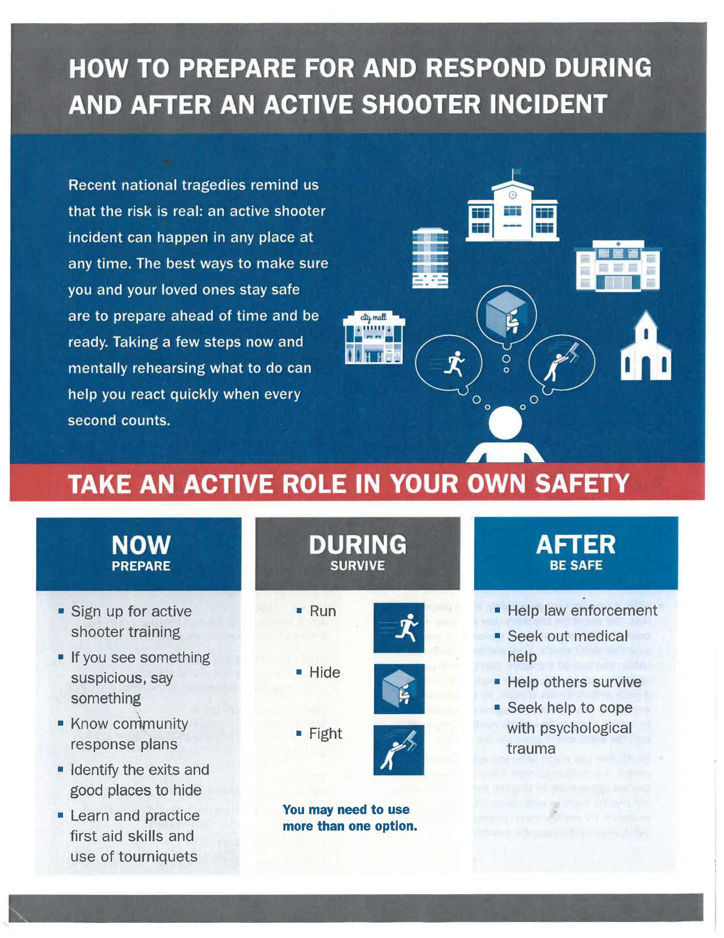

FEMA Active Shooter Prepare/Respond
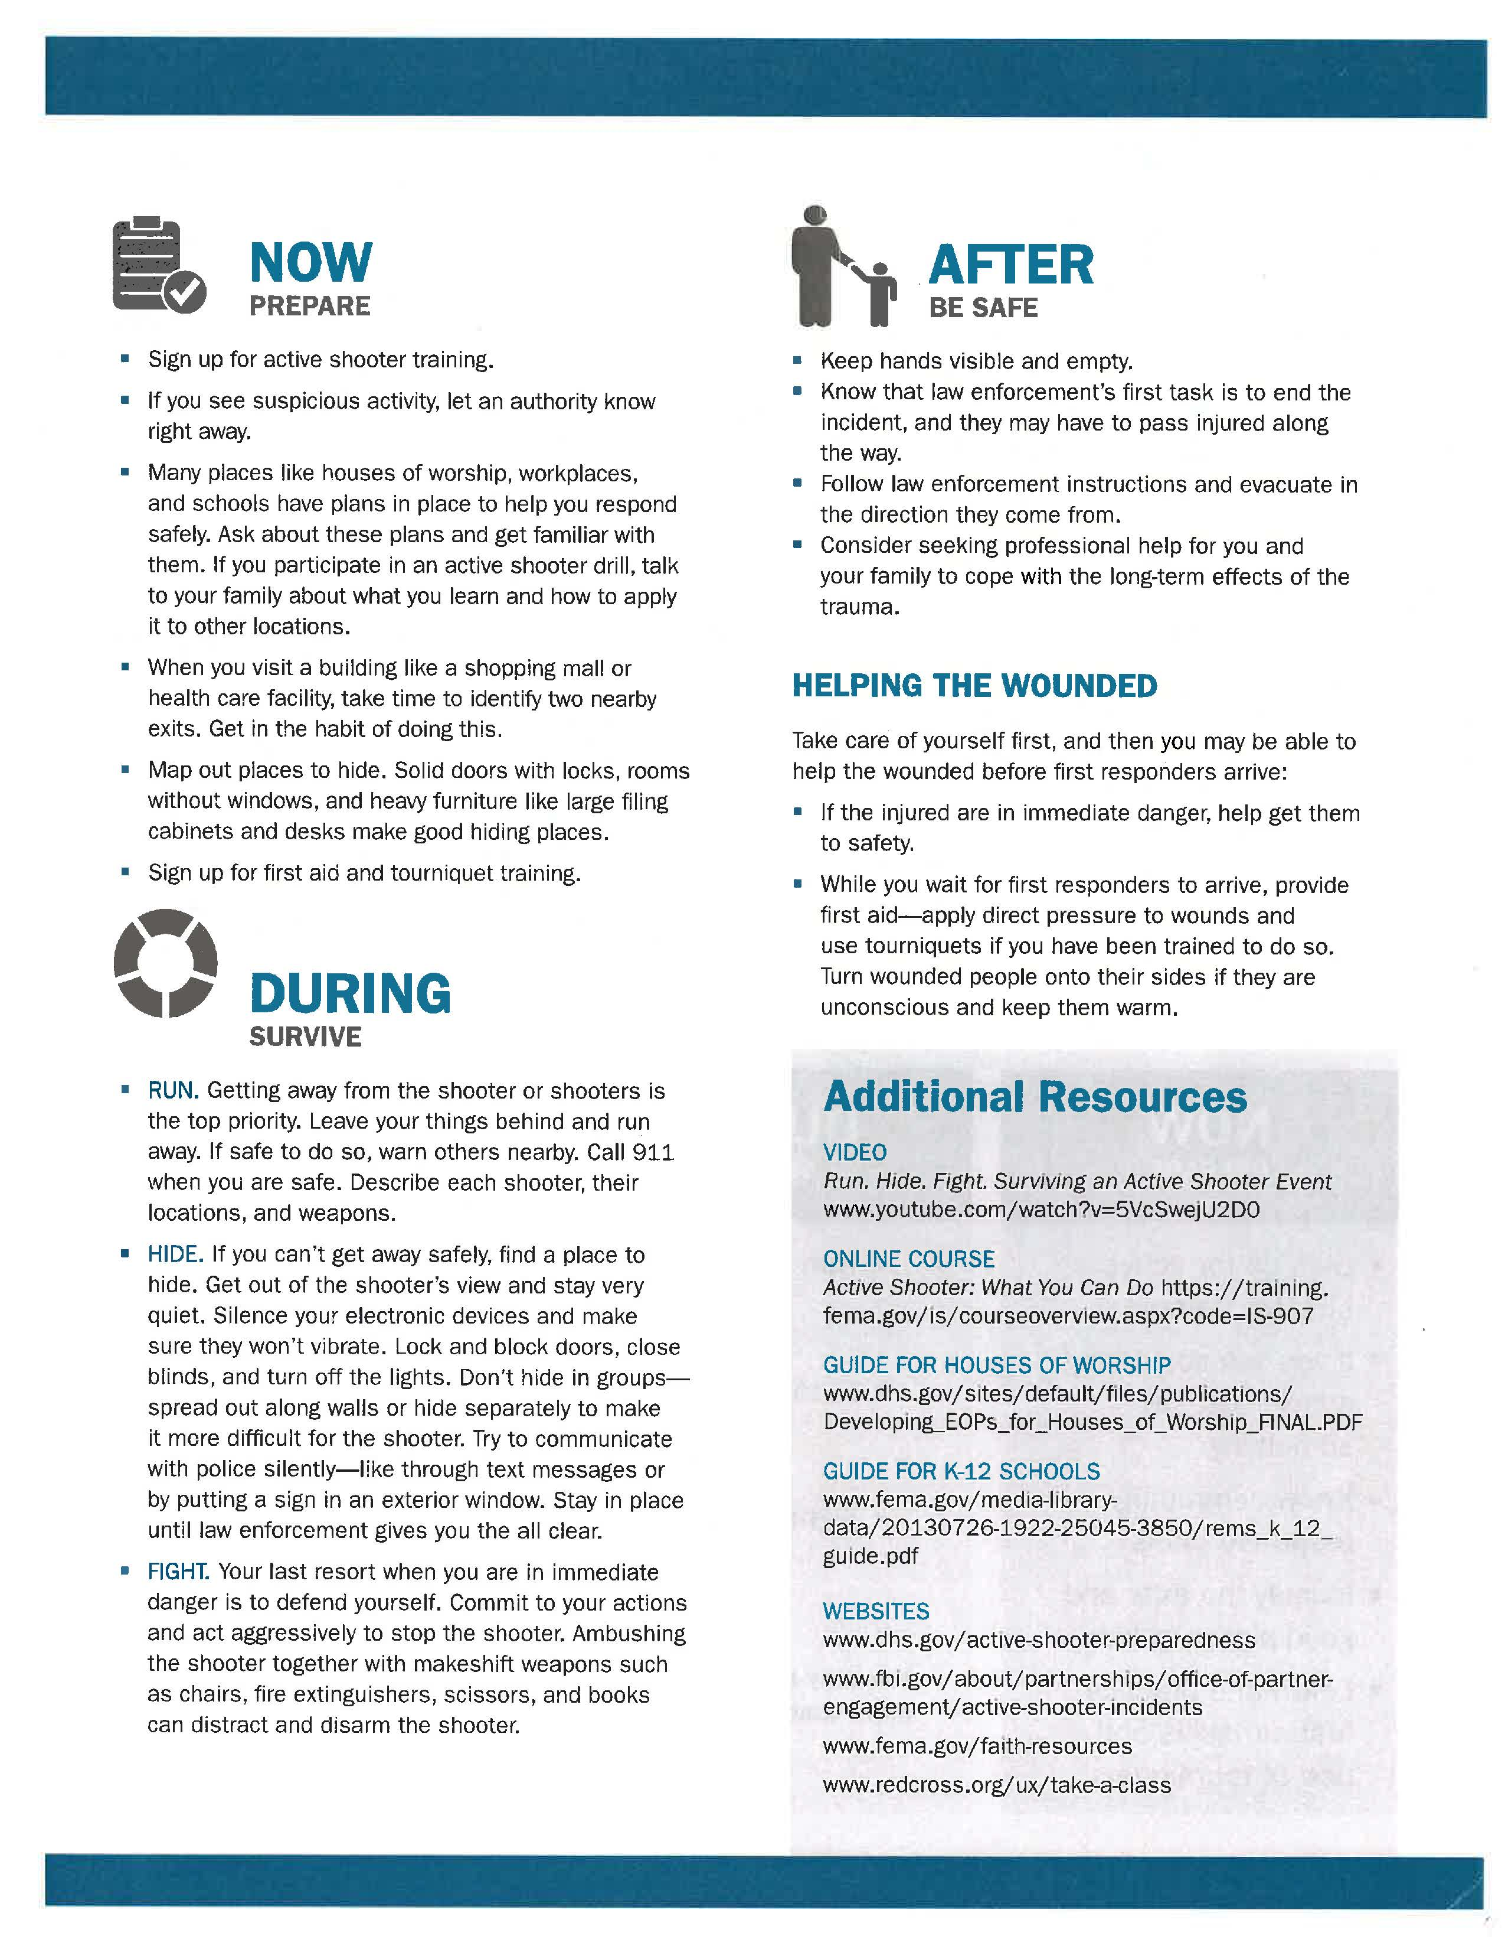

APPENDIX- Bomb Threat Checklist

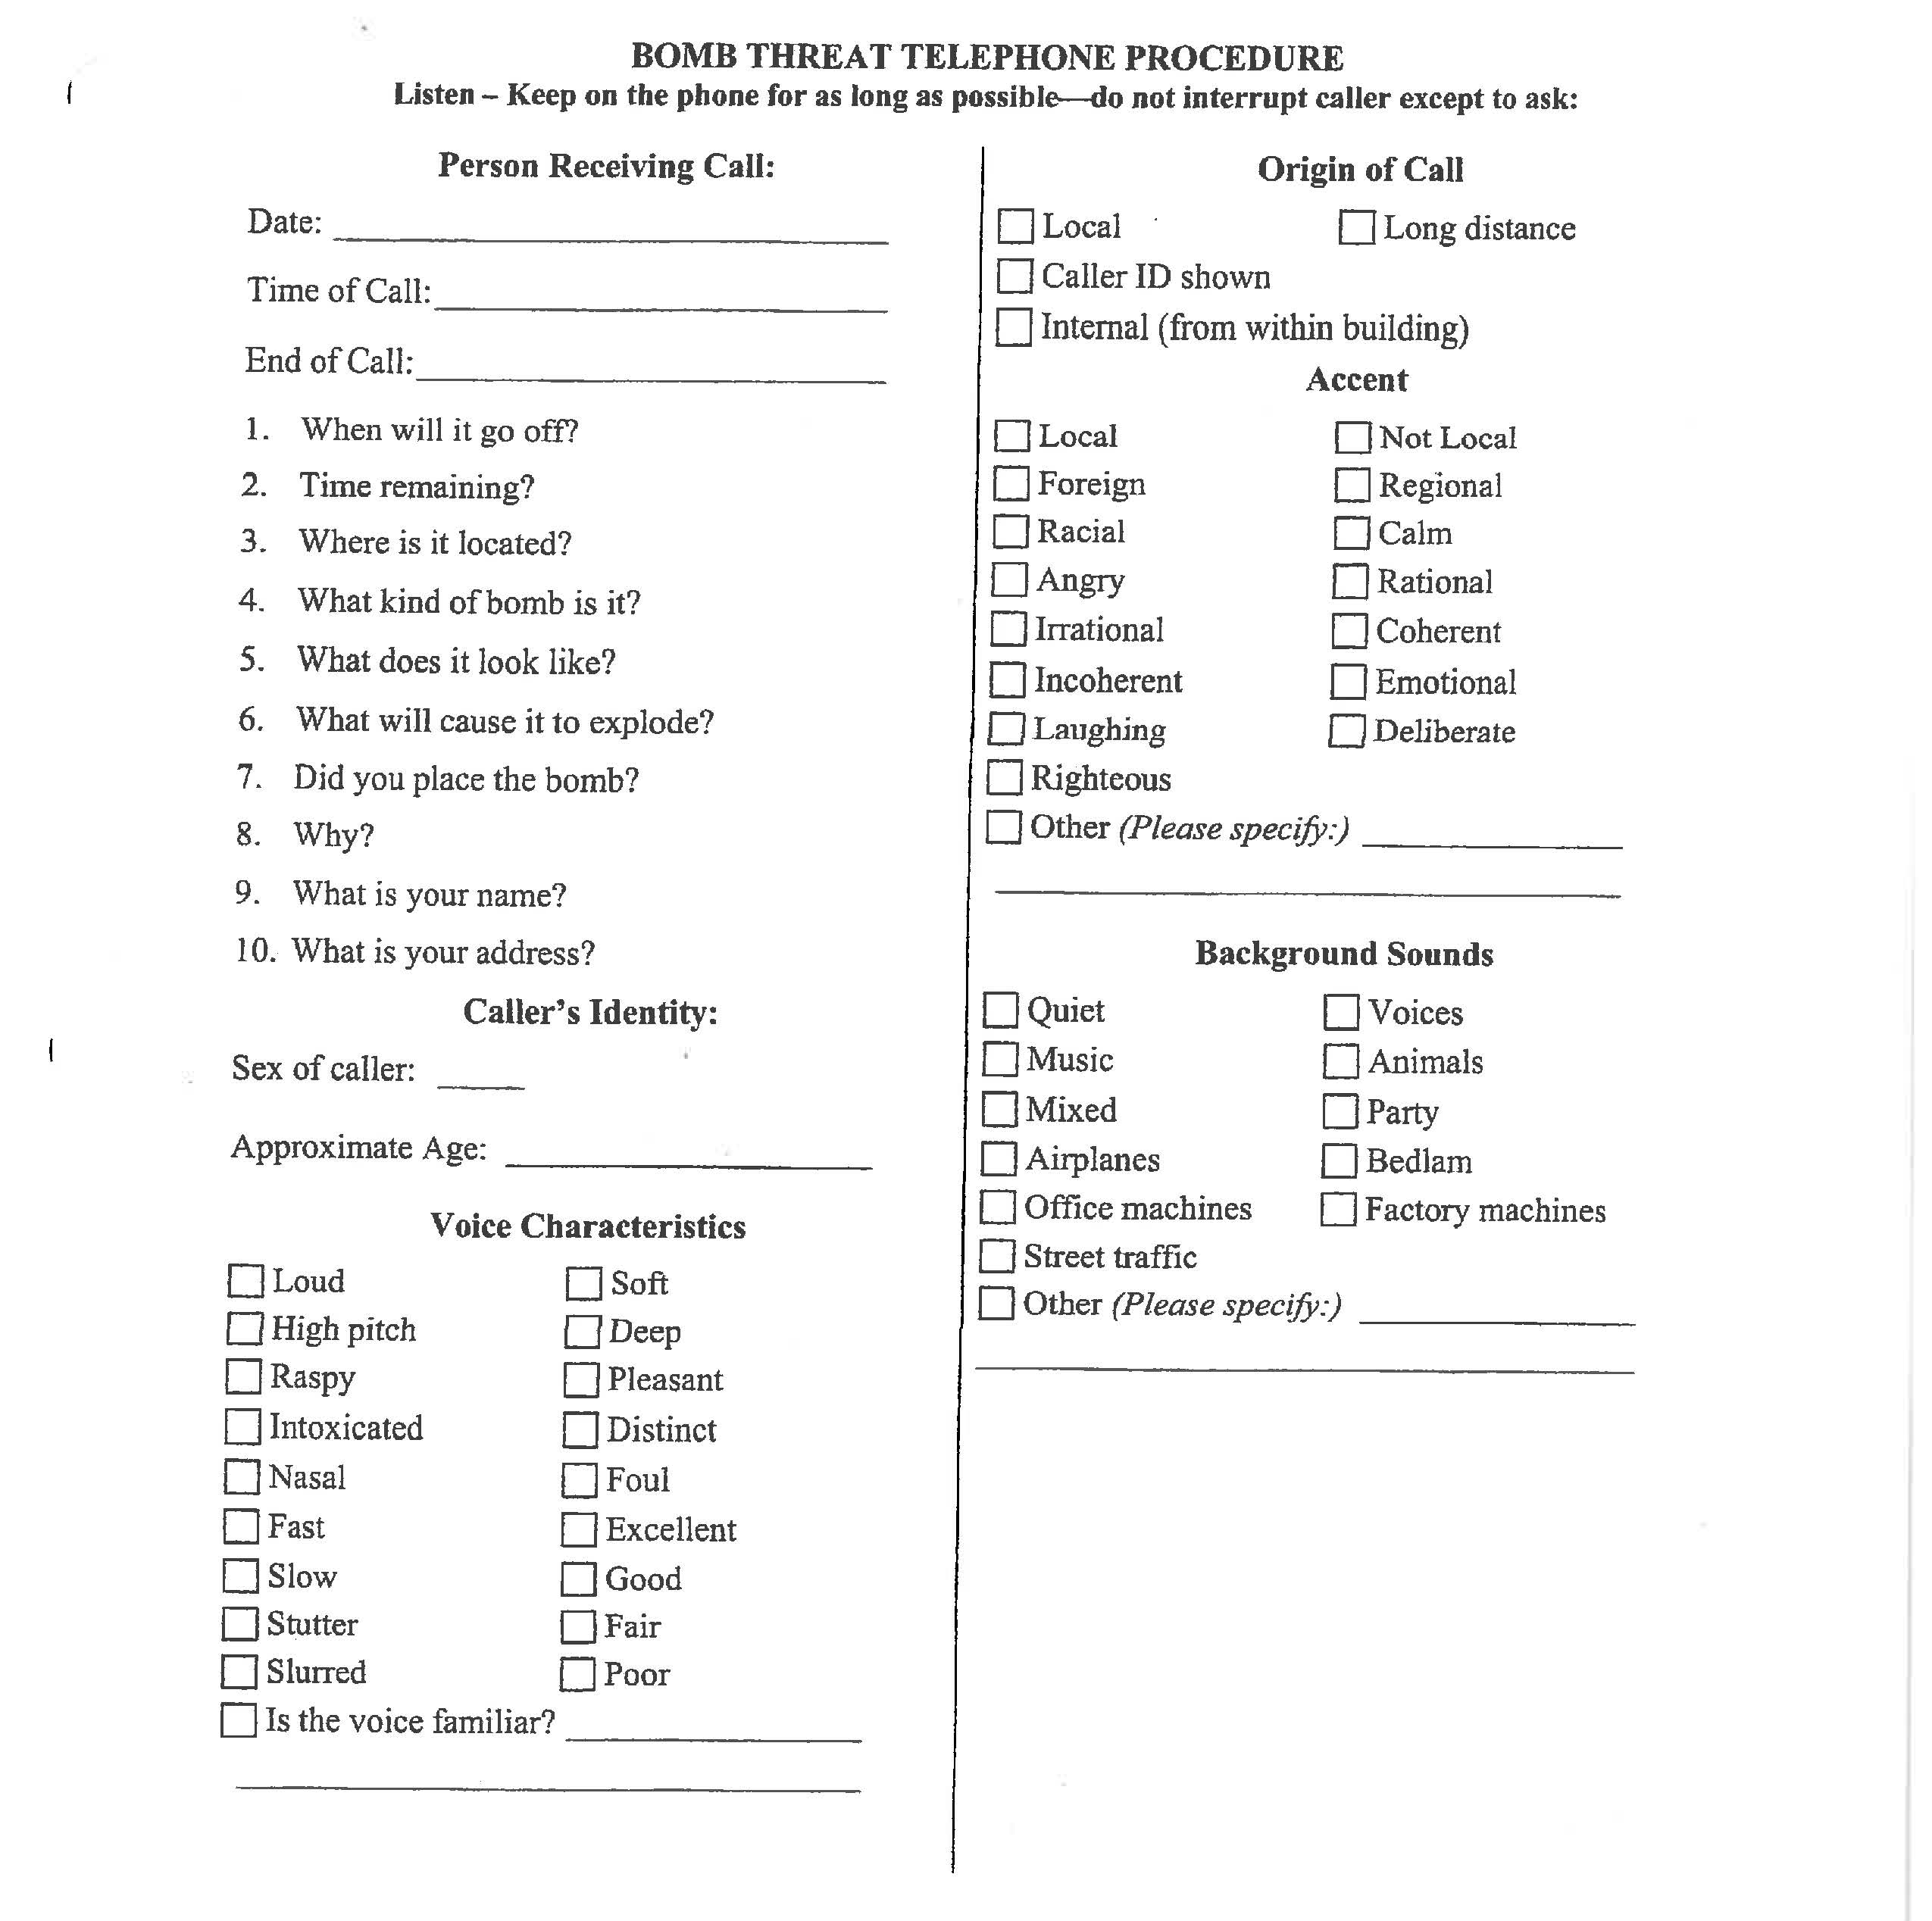

APPENDIX - Evacuation Routes

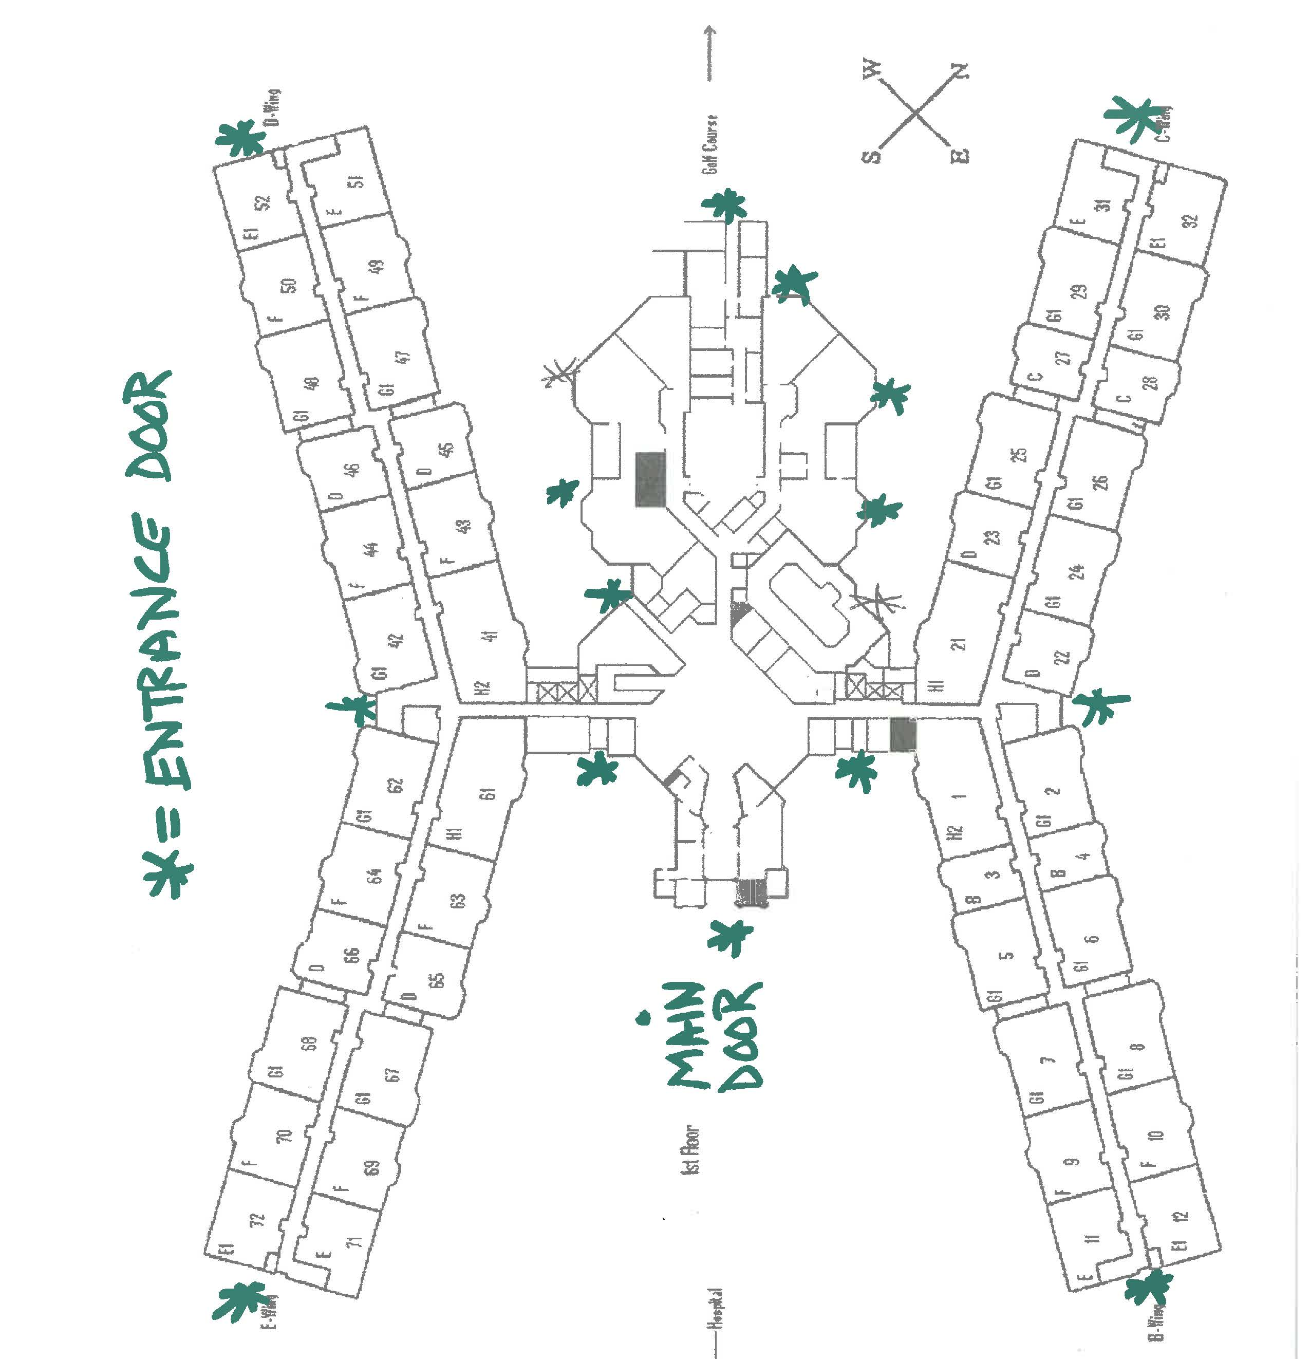

APPENDIX - List of Vendors

APPENDIX - List of Inventory Maintained

APPENDIX - List of Emergency Numbers

APPENDIX - List of Residents with Special Dietary Needs

INDEX

A
Active Shooter Information -– Code Grey, 9
Assurance Button System Failure, 11
B
Bomb Threat and Imminent Threat – Code Yellow
Bomb Threat Checklist, 12
E
Earthquakes, 13
Electric Power Outages, 15
Evacuation, 19
Evacuation Routes, 38
F
Fire – Code RED, 22
G
General Plan, 2
Emergency Kit, 2
L
List of Appendices, 27
List of Emergency Numbers, 41
List of Inventory Maintained, 40
List of Residents with Special Dietary Needs, 42
List of Vendors, 39
M
Major Storms and Flooding, 23
P
Pets, 14
S
Staffing During a Massive Disaster, 24
T
Toxic Plumes, 25

