Table of Contents

- General Plan 2
- Active Shooter Information – Code Gray 8
- Emergency Button System Failure 10
- Bomb Threat and Imminent Threat – Code Yellow 11
If you find a suspicious item 12
- Seismic Incidents 12
- Electrical Outages 14
- Evacuation 17
- Fire – Code Red 19
- Major Storms and Flooding 21
- Staffing During a Major Disaster 22
- Toxic Plumes 23
Appendices
APPENDIX A – Command Structure 25
APPENDIX B – FEMA Active Shooter Prepare/Response 26
APPENDIX C – Bomb Threat Check List 28
APPENDIX D – Evacuation Routes 29
APPENDIX E – Radio Communications 33
APPENDIX F – Emergency Contacts 34
APPENDIX G – Vendors List 35
- General Plan
The Emergency Preparedness Plan is designed to manage the consequences of a natural disaster or other emergencies that disrupt the ability of The Colonnade to provide services, security and safety to our residents. A separate detailed plan is established for TC Assisted Living/Memory Support operations.

Objectives
  - Information on how each department will implement specific procedures in response to environmental or manmade events.
  - Provisions for the management of space, supplies, communication, safety and security.
  - Provisions for the management of staff, including the distribution and assignment of responsibilities and functions.
  - Provisions for the management of residents, including the scheduling of minimum service(s) and control of information.

The Management Staff
  - Executive Director
  - Director of Dining Services
  - Director of Customer Service
  - Director of Resident Services
  - Human Resources Representative
  - Director of Environmental Services
  - Business Office Manager
  - Director of Information Technology (as applicable)

Procedure
The actions involved in an internal or external emergency may include:
  - Protection of and continued services for residents.
  - Suspension of some or all normal Colonnade operations.
  - Modification of services to Colonnade operations.

Plan
  - Command Post/Communication
  - Power
  - Waste Management
  - Contact Agencies
  - Suggested Emergency Kit Checklist for residents and staff
  - Committee Members
  - Critical Staff/Staffing
  - Responding to various emergency natural/unexpected disasters including evacuation plan • Educational Resources

Management Staff Proactive Responsibilities Administrative Steps:
  - Establish a (24-hour) disaster notification/communication and disaster management plan among the Management staff. Initiating the evacuation procedure when needed or advised.
  - With the best information provided by the residents, maintain a list of low mobility residents who use walkers, wheelchairs or scooters and will require help to reach the ground level, if the elevators are not operating. This list must be kept in a fully accessible location at the front desk and in the EMT/Security go bag.

The Resident Services Director with assistance from Customer Service Manager will be responsible for maintaining a Resident Roster that will include the names of:
  - All Residents with their residence numbers.
  - Resident with pet(s) list including type of pet(s).
  - Residents who are out of the community on vacation, in the hospital etc. • Guests registered in the Inn at the Colonnade.

The Resident Information Sheet should include lists of (provided by resident)
  - Current medications
  - Family addresses
  - Emergency contact information/Family telephone numbers

All residents and staff should make themselves aware of all possible evacuation routes
  - From residences
  - From common area amenities, including dining rooms, pools, and recreation center
  - Other locations utilized frequently at TC

Educate management staff and residents on the Emergency Preparedness Plan.

Command Post/Communication
  - The Executive Director will be in charge and direct operations. In the absence of the Executive Director, based on the nature of the emergency the Environmental Services Director or Resident Services Director will assume responsibility for the TC operations. The Command Post information will be communicated by group text to the Emergency Response Team. If texting service is affected, ERT members are to report to the Recreation Center Front Desk. In the event front desk area is affected, the AL/MS front desk will become the command post.
  - If telephones are working, the emergency call/text system will be implemented. All needed staff for resident/site support will be recalled to TC.
  - If telephone service, including cell phone service, is interrupted, staff will communicate via 2-way radios located at the EMT office (Rec. Ctr.), Directors Offices, and EVS shop. Incident Command staff will be issued radios to maintain essential communication.
  - The management and essential staff will be provided with identifiers as an authorized person that clearly identify their roles.
  - Any media communication to be directed to Sun Health Corp Public Relations officer, if Public relations is not available the Executive Director will coordinate a response if needed.
  - Residents are to remain in their residence until further instructions are issued. Keeping their wireless/cell phone charged at all times and have extra batteries for flashlight(s).

Immediate Departmental Responsibilities

  - Executive Director, or designee, will take command and initiate departmental communication and activate the command center.
  - The Dining Department will ensure that emergency food, water, and paper products are available for residents and staff responding to or affected by the emergency.
  - Environmental Services will assure safety of the environment and preserve normal community operations, to best of its ability.
  - Customer Service/Security will safeguard each entrance, as appropriate. (Map is attached showing each entrance)
  - Information Technology Services will ensure computer backup procedures are initiated on all vital documentation and applications (e.g. SARA – resident emergency notification/ Energy Management System/Freedom Bridge door access).
  - Resident Services will provide a current list of resident names with residence numbers that includes pet information. Require Resident Information Sheets with current medications, as well as family addresses and telephone numbers. Assign staff to assist residents.
  - Zone leader (staff): At the time of a disaster/emergency, each affected zone will have an appointed zone leader(s) that will aid management of the zone during the emergency by coordinating staff assigned to their zone. Duties include, but are not limited to the following:
    - Zone leader to provide information from management to residents and maintain communication with command center. o Assistance with waste management.
    - Round area to ensure well-being of residents and staff in the assigned area.
  - Human Resources will provide an updated list of personnel and telephone numbers.
  - Administrative staff will support resident and staff communication.
  - Sun Health Public Relations will work directly with the media and social media.
  - Other staff will be assigned responsibilities depending on the nature of the emergency.
  - Taking of photos of the event and posting on social media or providing photos to print/television media is strictly prohibited.

Overall Operations

Depending on the nature of the emergency, some of the routine operations may be suspended or modified to manage the emergency.
  - Emergency affecting the water supply o Each resident will be asked to store water in their residence. The request will be one gallon of water, per person per day. (Two quarts for drinking, two quarts for food preparation/sanitation.) A 5-day supply for each person in the household should be kept and stored in plastic containers.
    - Usage of the pool will be strictly prohibited. If necessary, this water will be used for sanitation or treated and used for food preparation.
Residents should store at least a 5-day supply of non-perishable food. Food selections should be compact and lightweight. Residents should have a non-electric can opener available in their residence. o Foods ready in preparation for an emergency event include:
      - Ready to eat canned meats, fruits and vegetables
      - Staples such as sugar, salt, pepper
      - High energy foods such as peanut butter, jelly, crackers, granola bars, trail mix
      - If water is limited, avoid foods high in salt, fats, and protein
      - Include vitamin and mineral supplements to assure adequate nutrition
      - Know the shelf life of any stored foods
  - A general guideline for rotating common emergency foods is listed for resident convenience.
    - Use within six (6) months
      - Boxed powdered milk
      - Dried fruit in a metal container
      - Dry crackers in a metal container
      - Dehydrated potatoes o Use within one (1) year
      - Canned condensed meat and vegetable soup
      - Canned fruit, fruit juices, and vegetables
      - Ready to eat cereals and uncooked instant cereals in metal containers
      - Peanut butter
      - Jelly
      - Canned nuts o Indefinite storage
      - Wheat
      - Vegetable oils
      - Dried corn
      - Baking powder
      - Soybeans
      - Instant coffee, tea, cocoa
      - Salt
      - Non-carbonated soft drink
      - White rice
      - Dry pasta
      - Bouillon products

Waste Management

  - If there is an interruption of a water supply to our building(s), the disposal of excrement will become the responsibility of management. One to two times daily.
  - Residents will have a supply of plastic trash liners. These liners will be placed in the commode to collect the human waste in each apartment. On a daily basis staff will make rounds
(approximate time to be communicated) to collect the bag and give each resident a new liner. Staff will then treat each bag with the appropriate chemicals. Staff will transport all bags containing waste to the designated area for proper disposal.

Critical Staff

  - In an emergency all staff will be considered “critical staff” and requested to report to duty in the event of a serious emergency affecting the entire area or region. The La Vita Room will be utilized to house employees and family members. The La Vita Room has the capacity to hold approx. 250 people (300 dinner seating). The space will be assigned to family members and monitored by staff.

All staff and residents should make themselves aware of possible evacuation routes
  - From residences
  - From common amenities, including dining rooms • Locations utilized frequently at TC

Keep your wireless/cell phone charged at all times and have extra batteries for your flashlight(s).
An external battery for cell phone(s) is recommended as well.

Suggested Emergency Kit for both Residents and Staff

The American Red Cross recommends keeping an emergency kit ready (one that has a shoulder strap to keep your hands free) that should include the following items:

Copies of important prescriptions | Non-electric can opener | A list of important telephone numbers – doctors, clergy and financial advisors
A 30-day supply of critical medications (Minimum of 7 day supply) | Needles/thread | A small amount of cash.
Aspirin | Paper/pencils | Negatives/Memory Cards of  irreplaceable photographs/digital prints
Antacid | Multipurpose tool | A flashlight (with extra batteries) and a whistle
Anti-diarrhea medication | Extra eye glasses. | Portable radio (with extra batteries)
Ipecac | Small fire extinguisher | A list of insurance company policy numbers
Laxative | Toilet paper | A list of bank account numbers, credit  card numbers and driver’s license numbers
Activated charcoal | Health insurance cards | Gauze pads and first aid tape
Soap-liquid detergent | The key to your safe deposit box | Self-adhering bandages/wraps
Household chlorine bleach | Self-adhesive bandages of various sizes | Scissors, Tweezers
Personal Hygiene Items | Plastic garbage bags and ties | Cleaning agents such as alcohol and  hydrogen peroxide
Sturdy shoes/boots | Extra blankets, pillows,  sleeping bags | Hat, gloves.
Thermal underclothes | Latex gloves | Cell Phone with Chargers
Car keys and house keys | Pet Supplies (collar, leash,  ID, food, carrier, bowl) | Towels

Active Shooter Information – Code Grey
General: When an active shooter (Code Grey) situation is called or announced all residents are to take immediate safe cover. RUN / HIDE / and FIGHT as a last resort.

An active shooter is described as an individual actively engaged in killing or attempting to kill people in a confined and populated area. Active shooters use firearms and there is no pattern or method to their selection of victims.

Typically, the immediate deployment of law enforcement is required to stop the shooting and mitigate harm to victims. Most active shooter situations are over in 5-15 minutes. 60% of incidents are over prior to law enforcement arriving on scene, individuals must be prepared both mentally and physically to deal with an active shooter situation. The Surprise PD average response time in 2018 was 5:15.

If an active shooter is in your vicinity, quickly determine the most reasonable way to protect your own life.
Avoid the target area of an active shooter. Immediately RUN to safety. If evacuation is not possible, you should HIDE and take cover where the active shooter is less likely to find you. If you are unable to run or hide then you will need to FIGHT with everything within your power. Be aggressive, remember your life is on the line.

Be Informed
- Participate in active shooter training when available
- If you see something, say something, to a authority right away.
- Sign up to receive local emergency alerts on your cell phone, email, and social media. • Be aware of your environment and any possible dangers.

Make a Plan
- Make a plan and ensure everyone knows what they would do, if confronted with an active shooter.
- Look for the two nearest exits anywhere you go, have an escape path in mind and identify places you could hide and items you can use to fight with as a last resort.
- Understand the plans for individuals with disabilities or other access/functional needs.

During and active shooter event: RUN and escape, if possible.

- Getting away from the shooter(s) is the top priority.
- If possible take your cell phone but leave other belongings behind and get away.
- If possible help others escape, but evacuate regardless of whether others agree to follow.
- Warn and prevent individuals from entering an area where the active shooter may be as you leave.
- Call 9-1-1 when you are safe and, describe shooter, the location, and the weapon(s).

HIDE: if escape is not possible.
- Get out of the shooter’s view and stay very quiet.
- Silence all electronic devices and make sure they won’t vibrate.
- Lock and/or block doors, close blinds, and turn off all lights.
- Don’t hide in groups- spread out or hide separately to make it more difficult for the shooter.
- Try to communicate with police silently. Use text message or social media to tag your location.
- Stay in place until law enforcement gives you the all clear.
- Your hiding place should be out of the shooter's view and provide protection if shots are fired in your direction.

FIGHT: as an absolute last resort.
- Commit to your actions and act as aggressively as possible against the shooter.
- Recruit others to ambush the shooter with makeshift weapons like chairs, fire extinguishers, scissors, books, pen/pencils, silverware, etc.
- Be prepared to cause severe or lethal injury to the shooter.
- Throw items and improvise weapons to distract and disarm the shooter.

After the shooting stops
- Keep your hands visible and empty.
- Know that law enforcement’s first task is to end the incident, and they may have to pass injured victim along the way until the scene is safe.
- Officers will be armed with rifles, shotguns, and/or handguns and may use pepper spray, pepper balls, or tear gas to control the situation.
- Officers will shout commands and may push individuals to the ground for their safety.
- Follow law enforcement’s instructions and evacuate in the direction they come from, unless otherwise instructed.
- Take care of yourself first, then you may be able to help the wounded before additional first responders arrive. If you are hurt you won’t be able to help anyone.
- If the injured are in immediate danger, attempt to help get them to a secure place.
- While you wait for first responders to arrive, provide first aid. Apply direct pressure to wounded areas and use tourniquets, if you have been trained to do so.
- Turn wounded people onto their sides if they are unconscious and keep them warm.
- After the all clear consider seeking professional help for you and your family to cope with the long-term effects of the trauma (PTSD).

Resident’s Responsibilities
- If you are in a common area, you will need to find the very first open doorway and enter that room or closet. Close the door behind you and lock it, if possible. Stay calm and do not make any noise. Silence your cell phone. A search team will discover you after the situation is controlled. You will not leave the area or the community until an “All Clear” is issued.
- If you are in your residence, stay inside and keep your doors locked. Do not make any noise. Go to a back bedroom and wait. A search team will discover you when the situation is controlled. You will not leave until an “All Clear” is issued.
- When in a safe position call 9-1-1. Remain quiet as possible.
- Help other residents, if possible, while taking cover.
- If approached and unable to take cover, the last resort is to try to harm the shooter in any way you can. Fight with the highest level of aggression you can muster, use any improvised weapons at hand. Canes, walkers, silverware, drinking glasses, etc. can all be used. Remember, at this point your life is on the line.

Staff Responsibilities
Staff responsibilities are the same as resident responsibilities during active shooting. After the shooting stops and law enforcement give the all clear, any able bodied staff should seek management for instructions.

Executive Director or Designee and all ERT members
Assume command and direct staff for the safety of all present. Take cover and communicate with admin staff via cell phone texting option if available, as it is quieter. If able, be ready to meet Law Enforcement upon arrival. Assist Law Enforcement with all resources available. After situation is controlled, assist with thorough search of all spaces to verbally give “All Clear” to residents, guests, and staff. All communication with media will be directed to SH Corp Public Relations.

Law Enforcement
Law enforcement’s purpose is to stop the active shooter as soon as possible. Officers will proceed directly to the area in which the last shots were heard.

The first officers to arrive on scene will not stop to help injured persons. Additional officers and EMT’s will arrive to serve as rescue teams. These teams will remove and treat injured victims when safe passage is available. They may also call upon all able bodies to assist in removing the wounded from the premises.

Everyone is to follow all commands from law enforcement officers and rescue personnel. Keep your hands empty and raised with fingers spread for your safety.

The “All Clear” will first be issued by Law Enforcement and then the Executive Director (or designee) will issue an “All Clear”.

Emergency Button System Failure
The Assurance System called SARA (Situational Awareness and Response Assurance) in your condo is a very valuable system in more ways than one. It tells us that you have checked in and are doing well. It also tells us when you need us in an emergency and when there is smoke coming from your residence or other location in the building. At least one bathroom in each residence is equipped with the notification sensor and Emergency Call pull cord. In a situation where the SARA Assurance System is offline, please do not panic, keep your cell phone charged and near you at all times. Our staff have procedures in place to always ensure your safety.

Wall-Mount System Failure
Our system alerts staff when there may be an issue with the system such as a low battery or unit failure. In an isolated situation, if the wall-mount system does not have a blinking light, the appropriate steps will be followed in order to get the system corrected and working normally. Call 9-1-1 for a life threatening emergency.

Morning Check-In:
- On a piece of paper state the time of the day, state your name and place by your residence information box. This indicates your morning check in. Complete this action by 10:00 a.m.
- Staff will round all residences by 10:00 for morning check-in. If no paper check-in is found, the staff will access the residence.

Pendant System Failure
If the pendant system is not working appropriately, please follow the below steps:

Morning Check-In:
- Call the front desk (623) 236-3700 and let staff know that you are OK. If the phone goes to voicemail please leave a message that includes your name(s) and residence number.

Emergency:
- Use the emergency pull cord in the bathroom.
- Keep your phone close to you. Call 9-1-1 for a life threatening emergency.

Both – Wall-Mount Pull Cord and Pendant System Failure
In this extremely rare situation when both wall-mount and pendant are in failure, one of our zone leaders will visit/connect with all occupied residences every two hours, if desired by the resident(s) until the system has been repaired. In addition to this safety measure, please also follow the steps below:

Morning Check-In:
- On a piece of paper state the time of the day, state your name and place at your door. This indicates your morning check in. Complete this action by 10:00 a.m.
- Staff will round all the zones by 10:00 for morning check in. If no paper check-in is found, staff will access the residence.

Emergency:
- Contact the front desk at (623) 236-3700. Call 9-1-1 for a life threatening emergency • Find a buddy and contact each other at regular intervals.
- Leave a note by your residence information box to notify us if you are not in the building or do not need frequent checks, as you have made alternate check-in arrangements with family/friends.

Bomb Threat/Imminent Threat – Code Yellow
Bomb threats or suspicious items should always be taken seriously. How quickly and safely you react to a bomb threat could save lives, including your own. When possible use only land based telephone systems. There have been many unfortunate events in the last few years around the world where individuals have entered places of business to inflict harm on others. Threats may occur in a variety of formats such as telephone, mail, e-mail, social media, or other means of communication. The guidance and resources listed below outline procedures for either bomb threats or suspicious items and will help you prepare and react appropriately during these events.

Every bomb threat is unique and should be handled in the context of the environment in which it occurs. Management on the advice of law enforcement will be in the best position to determine the credibility of the threat. Follow these procedures:
- Remain calm.
- If possible, signal or pass a note to other staff to listen and help notify authorities.
- Notify Executive Director/Department Director immediately: o Call 9-1-1 or your local law enforcement if a supervisor is not available.
- Refer to the Bomb Threat Checklist for guidance, if available.

For threats made via phone:
- Keep the caller on the line as long as possible. Be polite and show interest to keep them talking.
- Do not interrupt the caller, listen very carefully.
- DO NOT HANG UP, even if the caller does.
- Write down as much information as possible—caller ID number, exact wording of threat, type of voice or behavior, etc. This information can aid investigators.
- Record the call, if possible.

For threats made in person, via email, or via written note • Refer to the Bomb Threat Checklist.
- Be available for interviews with management and/or law enforcement.
- Follow authorities’ instructions. Management and/or law enforcement will assess the situation and provide guidance regarding lock-down, search, and/or evacuation.

If You Find a Suspicious Item
If you see something that is suspicious, out of place; do not attempt to touch or move it, if it doesn't look right, say something.

A suspicious item is any item (e.g., bag, package, vehicle, etc.) that is reasonably believed to contain explosives, an improvised explosive device (IED), or other hazardous material that requires a bomb technician and/or specialized equipment to further evaluate it. Examples that could indicate a bomb include; unexplainable wires or electronics, other visible bomb-like components, and unusual sounds, vapors, mists, or odors.

Generally speaking, anything that is Hidden, Obviously suspicious, and not Typical (HOT) should be deemed suspicious. In addition, potential indicators for a bomb are threats, placement, and proximity of the item to people and valuable assets.

If you see something that is suspicious, out of place, or doesn't look right, say something.

In the event of Evacuation during Bomb Threat incident: immediately refer to the evacuation section.

Earthquakes
Earthquakes strike suddenly, violently and without warning. Identifying potential hazards and preparing a response can reduce the possibility of serious injury or loss of life. The geological record shows that the Grand Avenue Fault extends through this area, generally along Grand Avenue.

Further, be prepared for aftershocks that can occur in the first hour, days, weeks or even months after the initial event.

Although California and Alaska are generally considered to be the major earthquake locations, the most devastating earthquake ever recorded in North America occurred in St Louis, Missouri, in 1811. There is evidence that Sun City West has already experienced two minor earthquake tremors in the last 15 years.

So it is appropriate to consider an Emergency Preparation Plan that will recommend steps to be taken now, before the Earthquake. This Plan will recommend actions by both the residents and the Management Staff if/when the Earthquake occurs.

Take action now: Before an earthquake hits.
- Secure items that might fall and cause injuries (e.g., bookshelves, mirrors, light fixtures). • Practice how to Drop, Cover, and Hold On • Store critical supplies and documents.
- Plan how you will communicate with family members.
- Always keep you cell phone charged.

Residents Responsibility during Tremors

When you recognize a tremor: Drop, Cover, and Hold On

As soon as you feel the shaking,
- DROP down onto your hands and knees so the earthquake doesn’t knock you down.
- COVER your head and neck with your arms to protect yourself from falling debris. If you are in danger from falling objects, and you can move safely, crawl to a safer place or seek cover (e.g., under a desk or table).
- HOLD ON to any sturdy object until the shaking stops.
- If you are in bed, cover your head with a pillow and cover your body with blankets.
- If you are not in bed, crawl under the table that you have selected as a shelter or drop down against an interior wall and cover your head.
- When available, tune your TV to the in-house channel, 1960, for a Colonnade status report and instructions.
- Pay attention to SARA phone/text messages.
- Listen to KTAR AM (620) on your battery operated radio.
- Subsequent to the tremor, be sure to open cupboards and other doors cautiously, since items may have shifted.
- Identify a strong table in each room that can be used as a shelter when tremors/aftershocks occur.
- Identify furnishings that may fall from the walls or from the top of tables etc. and secure them or relocate them.
- Relocate heavy objects away from above the bed, the couches and anywhere people sit.
- Place lists and copies of important documents in a safe deposit box.

Pets
Your pet’s behavior may change dramatically before, during, and after an earthquake. Be sure to watch your pet closely and attach a leash or place the pet in a small carry kennel. Efforts will be made to locate facilities that can provide shelter for pets.

In the event of Evacuation during an earthquake incident: Immediately refer to the evacuation section.

*The notification to evacuate the building may come from the Fire Department, the Red Cross or the Executive Director or other Colonnade staff.*

Management Staff Procedures during an Earthquake If the tremors are minor:
- Begin providing status reports and instructions via: our in-house channel 1960 or SARA; • Assemble the Management Staff in the Command Center and review the plan of action.

If a major earthquake occurs:
- Shut off the gas lines.
- In collaboration with the Fire Marshall, determine if the building is unsafe and, IF REQUIRED, announce that the building must be evacuated.
- Initiate the Command Center.
- Initiate calls for help:
  - Call 9-1-1 (Surprise Fire & Police Departments) o Red Cross
  - Any unaffected Sun Health entity • Initiate the disaster call/text messaging.
- Determine if the elevators are unsafe and should be closed. Recall to ground floor. Place a notice on the doors if the elevators are out of service.
- Recruit and direct help to get the low mobility residents down to the ground level and to the rally location.
- Get a copy of the roster of residents and guests (adjusted for travelers, etc.) using the Off Property Report for accuracy to the rally location coordinator.
- Place request to the Surprise Police Department to protect the building against vandalism and theft.

- Executive Director or Designee Management will call:
  - FEMA
  - Maricopa County Emergency Management Department
  - Surprise Office of Emergency Management o All appropriate officials and agencies o Utility companies for this campus

Electric Power Outages
Electric power outages can occur without any advance warning. Both the power generating plants and the entire West Coast’s electrical distribution system are vulnerable to interruption from natural causes, terrorist attacks and human errors. The system is also vulnerable to overload due to high summer demand. Recent history provides many examples of electrical system failures throughout the country due to overloads during periods of high temperatures.

Power outages may be scheduled by Arizona Public Service or they may be beyond Arizona Public Service’s control and for an extended period of time. Short-term power outages occur randomly and may be due to natural or man-made causes.

The Arizona Public Service “Curtailment Plan” provides that whenever the demand exceeds its ability to provide full power levels to all of its customers they will alternately schedule 30 minutes of power outage to all noncritical customers. The Colonnade is classified as a non-critical customer.

Therefore, it is appropriate to consider an Emergency Preparation Plan that will recommend steps to be taken now, before an electrical power outage occurs. This emergency plan will also recommend action by both the residents and The Colonnade management staff when electric power outages occur.

During Short-Term Power Outages

Management Staff Information:
The Management (front desk) Staff will immediately call Arizona Public Service to announce that The Colonnade has an electric power outage to determine when electric power will be returned to normal. Staff will assist with residence door access.

In addition:
- All air conditioning and heating will be suspended.
- The Villa hall lights, common area lights, and stairwell lights will be interrupted only briefly. Battery backup lights will last for approximately 90 minutes
- The emergency medical alert system will continue to function. If affected, refer to the directions for Assurance System Failure (SARA).
- The use of candles is prohibited at all times because of fire threat.

Residents’ Responsibility - Before a Major Power Outage Reserve Stock:
- Five gallons of water per residence occupant (the Red Cross recommends two quarts for drinking and two quarts for food preparation and sanitation each day).
o Store the water in heavy plastic containers. Do not store the water in containers that will easily break or decompose such as milk cartons or glass bottles.

Residents should also have:
- A manual can opener.
- At least 2 flashlights and extra batteries.
- A battery operated radio.
- Residents should maintain a 10-day supply of non-perishable food.

Residents with special dietary needs should stock the special dietary items that they require and be prepared to provide their own meals during an electrical power outage.

Residents will be encouraged to organize into “neighborhood” groups and establish a person (and/or persons) who will volunteer to be their “buddy”.

Management Staff Responsibilities – Before a Major Power Outage

The Human Resources Department will be responsible for maintaining a current list of all personnel and their telephone numbers. This list will be updated monthly as changes occur and will be located at the front desk and a copy provided for the EMT/Security go bag.

The Resident Service Department will be responsible for maintaining a current list of resident’s names and their residence numbers. The Resident Information Sheet will be classified as CONFIDENTIAL information and limited to those who “need to know”. It will be retained at the front desk and in the EMT/Security go bag and will be updated as monthly changes become known.

General Responsibilities
- The Colonnade will maintain a water supply adequate to provide all residents ½ gallon of water each day for 10 days.
- The Management staff will review their compliance with the Emergency Preparedness Plan for Electric Power Outages at least annually.
- The Management staff will prepare an educational program that will regularly remind the present residents of the main features of the Emergency Preparedness Program and also inform each new resident as they move in.
- Develop a plan for relocating the residents whenever the temperature of the building creates a health risk.
- Develop a plan for providing status reports to the residents during a power outage.

Resident Responsibilities - During a Major Electric Power Outage

Instructions and General Information
- Residents may find it helpful to listen to KTAR (92.3 FM on their battery-operated radio) for general information about the power outage.
- The use of candles is prohibited at all times because of fire threat.
- The air conditioning and the heating will not work.
- If the severity of the outage effects the water supply, the residents will be required to place plastic trash liners in one of their commodes to collect the human waste. Each morning, have the “used plastic liners” available to be picked up by the maintenance staff. Concurrently, the used liner will be replaced with a new plastic liner.
- Be prepared to vacate your residence and reside in a shelter selected by the Red Cross, if the temperature rises and the temperature becomes a health risk. Take your ID, swipe card, and hard keys with you for residence access on return. See evacuation section for details
- Prepare an evacuation kit, go bag. The evacuation kit should include a 10-day supply of medications, copies of important records, a flashlight, a cell phone/charger with an additional exterior power source.

TC Management Staff • Organization:
  - The Executive Director or designee will direct operations, and the appropriate command structure will be put in place relative to the scale of the incident. (See Appendix A)
  - As required the emergency call /text system will be implemented to bring staff in to build on emergency response teams for The Colonnade. This structure will be proportionate to the severity of the event.
  - Directors/Environmental Services Director are off the property. A command post will be established in the ALMS conference room where a communication post will also be established. o In the case of major incidents telephones are often rendered useless as lines jam up with traffic. To avoid this scenario the Colonnade will have 24 dedicated 2-way radios with 22 corresponding channels for command and control use. (See Appendix E)
  - The Information Technology Services Department will be responsible for ensuring the computer backup procedures are initiated on all vital communications where possible. Each department will be responsible for removing and safeguarding all of The Colonnade vital documents where vital building are evacuated.

Instructions and General Information
- At the very earliest warning of any power outage the management staff will begin using Channel 1960 or SARA system and notices posted at the elevators to provide instruction and information.
- The pool will be closed. If it becomes necessary, the pool water may be used for sanitation, or may be treated and used to prepare food.
- The stored water supply will only be used for drinking (two quarts of water are needed each day to maintain the normal body functions).

Waste Management
- If there is an interruption of a water supply to our building, the disposal of excrement will become the responsibility of management.
- Residents will be issued a supply of plastic trash liners at the time of implementation. These liners will be placed in the commode to collect the human waste in each apartment. On a daily basis staff will make rounds (approximate time to be communicated) to collect the bag and give each resident a new liner. Staff will then treat each bag with the appropriate chemicals. Staff will transport all bags containing waste to the designated area for proper disposal.

Staff
- The management staff will be classified “critical” and be requested to report for duty. Other selected personnel will also be classified “critical” and directed to report for duty.
- Families of staff members will be allowed to join the staff members if they also bring appropriate amounts of food, water and clothing.
- The La Vita Room will be used to house the employees and their family members.
- The management staff will assign the space in the La Vita Room and be responsible for monitoring the full operation. The 4,980 square foot La Vita Room has the capacity to accommodate 300 people (275 seating).

Evacuation
*The notification to evacuate the building may come from the Fire Department, the Red Cross or the Executive Director/designee*
In an extreme case when a portion, or all of the building, must be evacuated all residents will be given instructions. Residents will be notified in person by management, staff, or municipal emergency response staff. Residents should leave the building using the safest and nearest exit and remain outside the building at designated evacuation rally locations as directed by the TC evacuation plan. Receive instructions only from staff or municipal officials.

Management Preparation
Management Staff will:
Notify the Residents in the quickest and most efficient way possible during the emergency. These could include:
- SARA system text notification and door to door notification as needed.
- For mass evacuation, staff will notify Del E. Webb hospital for possible triage.
- Determine if evacuation to another Sun Health community is an option. If not, identify a shelter(s) for all the residents (Red Cross) who do not plan to visit friends or have some other arrangements.
- When possible the management staff will keep a record of where each person went for shelter so they can advise each resident when they can return.
- Provide assistance in arranging shelter for pets where available.
- Determine the location of the Rally Location where the residents will assemble away from the building when they are required to evacuate - and the best route to the Rally Location.

Resident Preparation
Residents should be prepared by determining, in advance, not only the best route to evacuate the building (without using the elevator) but also consider alternate routes. Emergency personnel and management staff will provide assistance to all residents with limited mobility.
Recommendations on leaving your residence:
- Follow instructions for evacuating the building.
- Dress in clothing appropriate for the weather (layers are recommended) and wear sturdy supportive shoes.
- Keep all windows and doors closed.
- Identify the most direct route to the nearest stairway with an alternate route(s) to other stairways. The elevators will be out of service.
- If within reach, take your cell phone (and charger) with you.
- Bring pets as you leave your residence – if applicable.
- If time permits, bring evacuation kits (see attachment) with your whistle and the flashlight.
- In the event of a fire use the back of your hand to test the door to see if it is hot. Do not use the palm of your hand as you may need to crawl, or open doors and you do not want to burn your palm.
- Do not open the door if it is hot.
- Open the door carefully only after doing this test.
- Leave a pillow or household item against the outside of door to indicate that the residence has been vacated.
- Report to management Colonnade staff monitor at designated rally point. Go directly away from the building to the Rally Location.
- Register with Colonnade staff when you arrive at the Rally Location.
- Wait for directions to a shelter.
- Receive directions for transportation to a shelter.

Limited Mobility Residents
- Residents on the 2nd through the 4th floor who have limited mobility and regularly use a walker, a wheel chair or a scooter should advise the Management Staff that they will require assistance by making their way to the nearest and safest area of refuge located in the stairwells on each floor and using the call phone at that location.
- In the event of a non-fire evacuation elevators may be used.

Rally Locations General:
- Staff will be asked to prepare a triage area with seating, hydration and basic amenities to the best of their abilities based on the nature of the emergency.
- Rally Point Positions/Triage area: The person in charge at the command center will designate one or more persons as Zone Leaders to coordinate activities at the Rally location/Triage area as listed below.
- Zone Leaders: will be assigned by Executive Director or designee. These people will be responsible to take charge of the Rally location, housing assignments, transportation, etc. The Rally Coordinator will provide situational communication to the Executive Director or designee.
- The Check-in Person: The Check-in Person will be assigned by Zone Leader. This role should obtain an up-to-date list of Emergency Response Personnel (ERP) and their alternates. This person should contact and notify ERP personnel in fire, medical, chemical, rescue or other emergencies.
- EMT/Medical Assistance: in case of minor injury, the EMT staff will attend. For a major injury, call 9-1-1 to assist with transfer to hospital.

Temporary Housing
The Executive Director will contact Sun Health communities for shelter options and if adequate options are not available will contact the Red Cross with the request to find appropriate shelter for the residents. The management staff will assign the residents to the designated locations and will provide transportation for any resident who cannot provide their own transportation. Residents are asked to notify the Management staff if they leave the building to temporarily reside at another address. For Villa residents please make sure that you take your keys and ID badge as the Freedom Bridge locking system might not function correctly after a significant event. Casita residents please take your key(s) with you. Please ensure your residence is secure when you depart.

The Executive Director will request the Surprise Police Department and/or allied agencies to patrol the building to provide security in addition to the regular employee security. Residents must notify the front desk before returning to their residence during this period to get any medication, important papers, etc. that they may need. Depending on the situation, return to their residence may not be permitted

After an acute emergency:
- Coordination with ERT/Incident command where each person is being “sheltered”.
- Determine when residents can return.
- Transport residents to their residences.

After the disaster condition is deemed returned to normal the Fire Marshall/Officials may give the “all clear” for authorized staff to re-enter the building to assess resumption of normal operation.
- The Management staff will determine when all aspects of the operations will be returned to a fully satisfactory condition and manage reinstitution of partial and full operation.
- Residents will be permitted to enter the building after an “all clear” has been announced by the Executive Director or designee.

Fire – Code RED
All residences and amenities on The Colonnade campus are equipped with fire sprinklers. All buildings are also equipped with fire alarms as well. In the Casitas an exterior bell alarm will sound in the event the sprinkler system is activated. In the Villas and amenity buildings you will be notified of a fire by siren type alarms and strobe lights. If a fire occurs please make you way out of whatever structure you are in and proceed to the appropriate rally point on the community maps you were provided with. The Villas and amenity buildings also
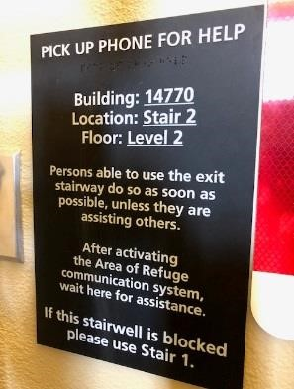. If you are unable to make it down the stairs
to safety without help stop and pick up the phone next to the sign and give your location to the front desk, your location is on the sign. You can also call 911 to notify first responders of your location and condition.

Fires In Common Areas

- A resident who detects a fire in a common area should activate one of the pull down fire alarms or pull the emergency cord in one of the public restrooms or hallways.

General Recommendations

  - Do not attempt to fight any fire in your residence. o Do not panic when the smoke detector or alarm (horn) makes a loud noise in your residence or emergency strobe lights activate.
  - Calmly evacuate the area and proceed to the nearest designated rally area.

Smoke from a Known Source in the Residence

- If a resident observes a fire in his/her residence before the smoke detector senses any smoke and issues an audible alarm, immediately evacuate the residence, then:
  - Leave the immediate area
  - Leave the building in the quickest and safest manner available pulling any wall mounted fire alarm that you pass on your way out.
  - Dial 9-1-1

Smoke is entering your residence from an unknown source outside
- If the resident is in his/her residence when the smoke alarm sounds and smoke is entering the residence from an unknown source:
  - Residents should go to the nearest stairwell and exit the building and proceed to the nearest rally point provided to you on your evacuation map.
  - Residents who are not able to descend the stairs, should make their way to the nearest stairway, which is the area of refuge for all Villas. After entering the area of refuge locate the phone on the wall, pick it up, it will automatically ring the front desk, let them know your location. If you are uncertain of your location next to the phone is a sign that states your location. Like this one:

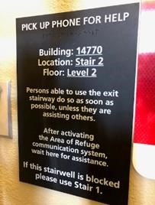
Give your location to the staff member on the phone with you, should the phone not work due to the emergency at hand use your cell phone and call 911 giving them the information on the sign.

Smoke Detector Senses Smoke • When any smoke detector senses smoke:
  - That smoke detectors horn will sound an audible alarm. o The front desk will also receive an alarm that identifies the Villa or amenity building where smoke has been detected. Smoke detectors in the Casitas do not notify the front desk, Casita residents are encouraged get to safety immediately then call the front desk or 911 immediately after you are safe. If a fire is occurring in a Casita the alarm monitoring company is notified that water is flowing from the sprinklers and the fire department will be automatically dispatched.
- Villa smoke detectors automatically notify the alarm monitoring company and the fire department will be automatically dispatched. After this the Environmental Services Director and Executive Director are notified then The Colonnade Emergency Response Team will be activated, consisting of all department directors, managers, and select supervisors.

Major Storms and Flooding
Extensive rainfall combined with high water levels, natural disasters, or a terror attack at the McMicken and New River dams could result in structure failures and/or emergency water releases that could inundate areas that border Sun City West and Sun City Grand. The failure of these dams could isolate areas in or around Sun City West, Sun City Grand and The Colonnade. Parking lots and the ground floor of residences and amenity buildings could be flooded.

The Maricopa County Disaster Planning Manual predicts that a breakdown of the McMicken dam could inundate an area west of the Santa Fe railroad from the intersection of Deer Valley Road and Grand Avenue south through Surprise and El Mirage toward the Glendale Municipal Airport. This Manual also predicts that a breakdown of the New River Dam could inundate an area between Sun City West and Sun City that would cross Bell Road from the north and southward toward the Glendale Municipal Airport.

Supplies and general ground level traffic could be interrupted. Residents, employees, and commercial vehicles might be unable to return to Grand Avenue from the east, the south, or depart in those directions. The delivery of supplies to the gas stations, and the grocery stores could be interrupted. The delivery of food and other supplies to The Colonnade could be curtailed in addition to physical damage to the building. In a severe thunderstorm (Monsoon), windows could be shattered by the force of the wind or flying roof tiles along with the possibility of outages/interruption of services (i.e. electric power, telephone service, mail service and drinking water, etc.).

Weather Emergency
Advance warnings will be provided by the National Weather Service and broadcast regularly via TV and radio media. The Colonnade will work closely with assigned governmental agencies to manage the disaster as this will affect more than the immediate area surrounding The Colonnade.

Management Responsibilities:

The Colonnade will begin issuing instructions as weather warnings justify detailed planning.

Resident Responsibilities:
- All residents will be required to use the stairs in the event of a power failure. If a resident is unable to navigate stairs a resident would need to notify the front desk and request assistance.
- Prepare for an emergency, by keeping a supply of water, food (pre-prepared and dry goods), and a manually operated can opener and maintain an Emergency Kit.
In the event of evacuation during major weather incident: Immediately refer to the evacuation section for instructions. In most cases such mass disaster is directed by government officials, as it is not limited to only The Colonnade.

Staffing During a Massive Disaster
During a massive disaster when staff may be required to be on site by either staying after his/her scheduled shift or by needing to come into work to relieve staff that have been extended, the following protocol will be followed.
Staffing Coordinator
In the event of a massive disaster where staff will need to be available 24 hours a day to assist residents there will be staffing coordinator(s) assigned. Responsibilities may include:
- Track hours staff work.
- Be aware of staffing needs – childcare responsibilities, length of time, breaks, distance from work, etc.
- Work with State transportation/Red Cross/Emergency services to determine accessible routes for employees to enter and exit the property safely.

Boarding & Lodging

Staff that is required or electing to stay to assist during a massive disaster will be provided food, water, and a place to rest.
Staff Rest
Rest areas and alternating rest times will be arranged for staff by the staffing coordinator. The areas that will be reserved for staff to rest in will be the following:
- All unoccupied guest rooms.
- If guest rooms are otherwise occupied by guests, staff will take their rest in any unoccupied residence.
- If all residences are otherwise occupied, the La Vita/Sorrento/Trevi/Employee lounge room(s) will be set up for staff to take their rest.

Clothing
As options allow, staff members that do not have a change of clothes will be provided alternatives for another set of clothing or access to laundry facilities.

Communication
Work cell phones must be fully charged in order to maintain a high level of communication. It is highly recommended that personal cell phones be maintained fully charged as well. Be sure to always have an additional charger and/or external battery with you as there will be a limited power available in an emergency.

Transportation
In the event that a staff member(s) will need to either leave or arrive at The Colonnade, the transportation department will be available to transfer staff to the necessary location using the company vehicles.

Family/Home Situation
As much as possible, the Staffing Coordinator will take into account a staff member(s) family/home life (i.e. children, primary caregiver, distance from work, etc.). However, it is the responsibility of the staff member(s) to notify the Staffing Coordinator of their family/home life situation if the staff member(s) feels that it would prevent him/her to staying at work until the massive disaster has been cleared.

Toxic Plumes

The Colonnade is located within a quarter of a mile of both a railroad spur and a major highway. Toxic materials are transported in rail cars and in trucks. Both rail cars and trucks may become involved in accidents that cause toxic plumes that may require an evacuation.

Therefore, it is appropriate to consider an Emergency Preparedness Plan that will recommend steps to be taken now, before any evacuation is required due to toxic plumes.

Residents Responsibilities - Before a Toxic Plume Residents should be prepared to evacuate for three days by:
- Preparing an emergency kit (see attachment).
- Maintaining an Emergency kit.
- Placing important documents in a safe deposit box.
- Identifying the best possible evacuation route using exit doors away from the railroad/highway and at least one additional alternate route.
- Keeping a flashlight within arm’s reach at night by the bed.

Management Staff Responsibilities - Before a Toxic Plume

- Establish the location for a Command Center that will be beyond the range of a Toxic Plume.
- Identify the records that will be required at the Command Center and assign responsibility for bringing these records.
- Maintain an accurate roster of residents and guests.
- Establish and communicate the plan.

During toxic plume event – Management/staff will, as safe working conditions allow:
- Immediately stop all makeup air intake fans. (EVS)
- Turn off the main gas line. (EVS)
- Notify the Residents that an incident has occurred that has released toxic plumes using:
o The Colonnade TV channel 1960 o An announcement using SARA system.
- Identify a shelter(s) for all the residents (Red Cross) who do not plan to visit friends or make other arrangements.
- Residents may not be allowed to remove their cars from the parking lot or the parking garages under the Villas. If the resident is unable to provide transportation to the shelter, management will arrange for their transportation.

In the event of Evacuation during Toxic Plumes incident: Immediately refer to the evacuation section

Emergency involving the entire Colonnade campus:
The Colonnade Assisted Living and Memory Support has a detailed emergency disaster plan. An emergency disaster affecting the entire campus will impact and require TC Retirement Center and TC Assisted Living and Memory Support to collaborate on the plan. Education on the disaster plan can save you and others.

From Colonnade Management we thank you for your attention to this manual.

A. Command Structure

Emergency Command Structure

The establishment of a command post and the relative command structure will be established in all emergency situations. However, it should also be remembered that the command set up for any emergency incident should be relative to the incident size and type and therefore remain fluid in its creation and implementation. It is also important that the senior staff remain at the command center so that critical decisions can be made at any time without delays. By having Zone Leaders and a Communications Officer they will be free to concentrate on the objectives most critical at any time during the incident, as well as direct liaison with Emergency Service Leadership and other outside organizations as may be required.
The table below gives and outline of how the command structure will be layered so that communications remain controlled as does the emergency situation.

Senior Director in Charge
*
*
*
Environmental Services Director Resident Services Director ALMS Director HR Director
- * * *
- * * *
- * * *

Communications Officer Command Center – This individual with have direct communication with Zone Leaders and report to the appropriate Directors as information is received. They will also disseminate information from Command Center to the Zone Leaders. In the case of major incidents there may be several communications officers in place. The purpose is to keep clear and organized lines of communication so that the command center can concentrate on priorities and not have to answer every question or collate all the messages from staff.
*
*
*
Zone Leaders – These will be nominated individuals that will control and specified area in the community and report directly with the Command and Control Center. There is no limit to the number of Zone Leaders other than the number of Radios available for the incident and the limit of radio channels for use.
Medical/Triage at an assembly area
Transportation for safe movement of residents
Specific areas to aid in evacuation
Food and Water in the event of allocations being requires
Assembly Area Coordinators for safe shelter and resident attendance tracking
These are examples but are not by any means exhaustive. Again remember that the command structure is fluid and is built up and appropriately broken back down as the incident is brought to a close.

B. APPENDIX - FEMA Active Shooter Prepare/Respond
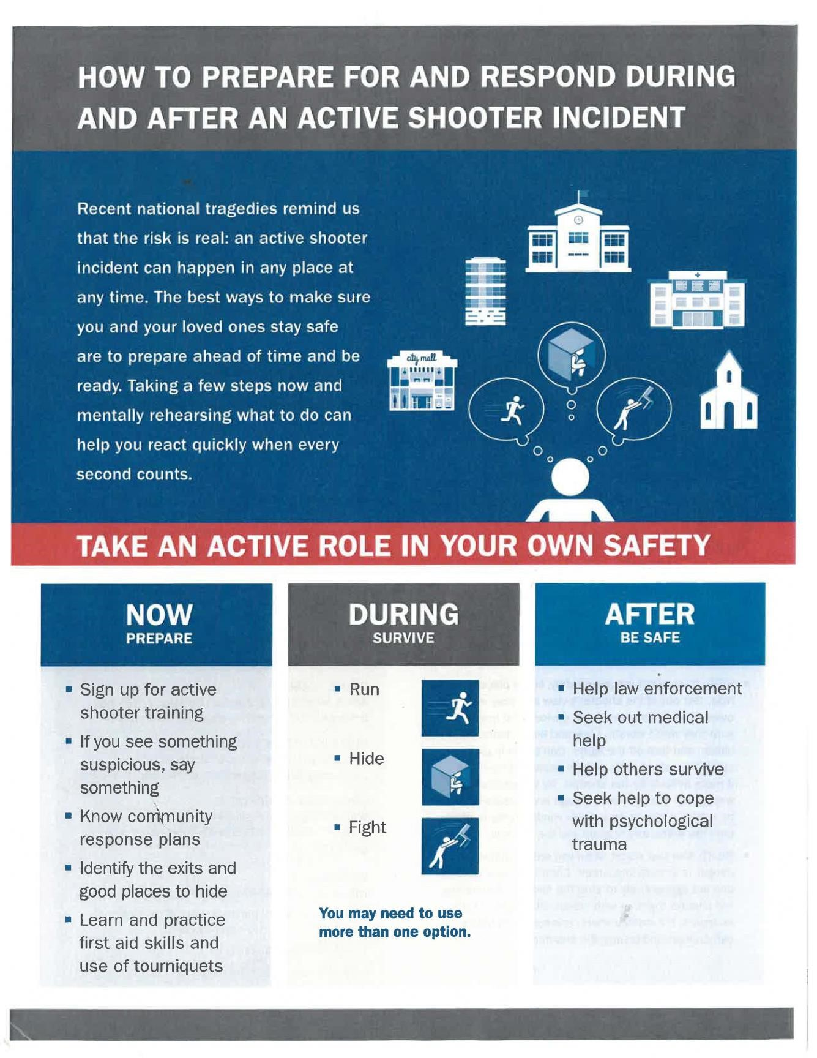

FEMA Active Shooter Prepare/Respond
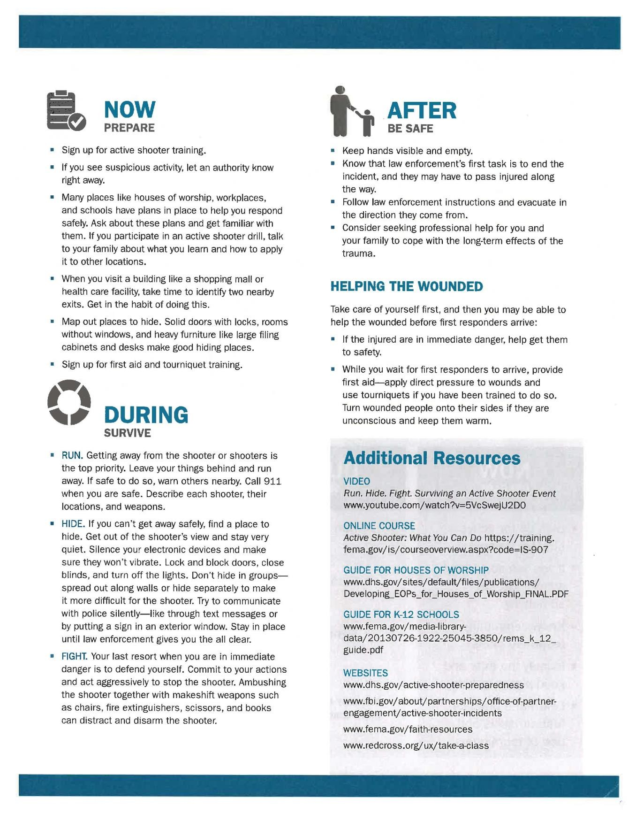

APPENDIX- Bomb Threat Checklist

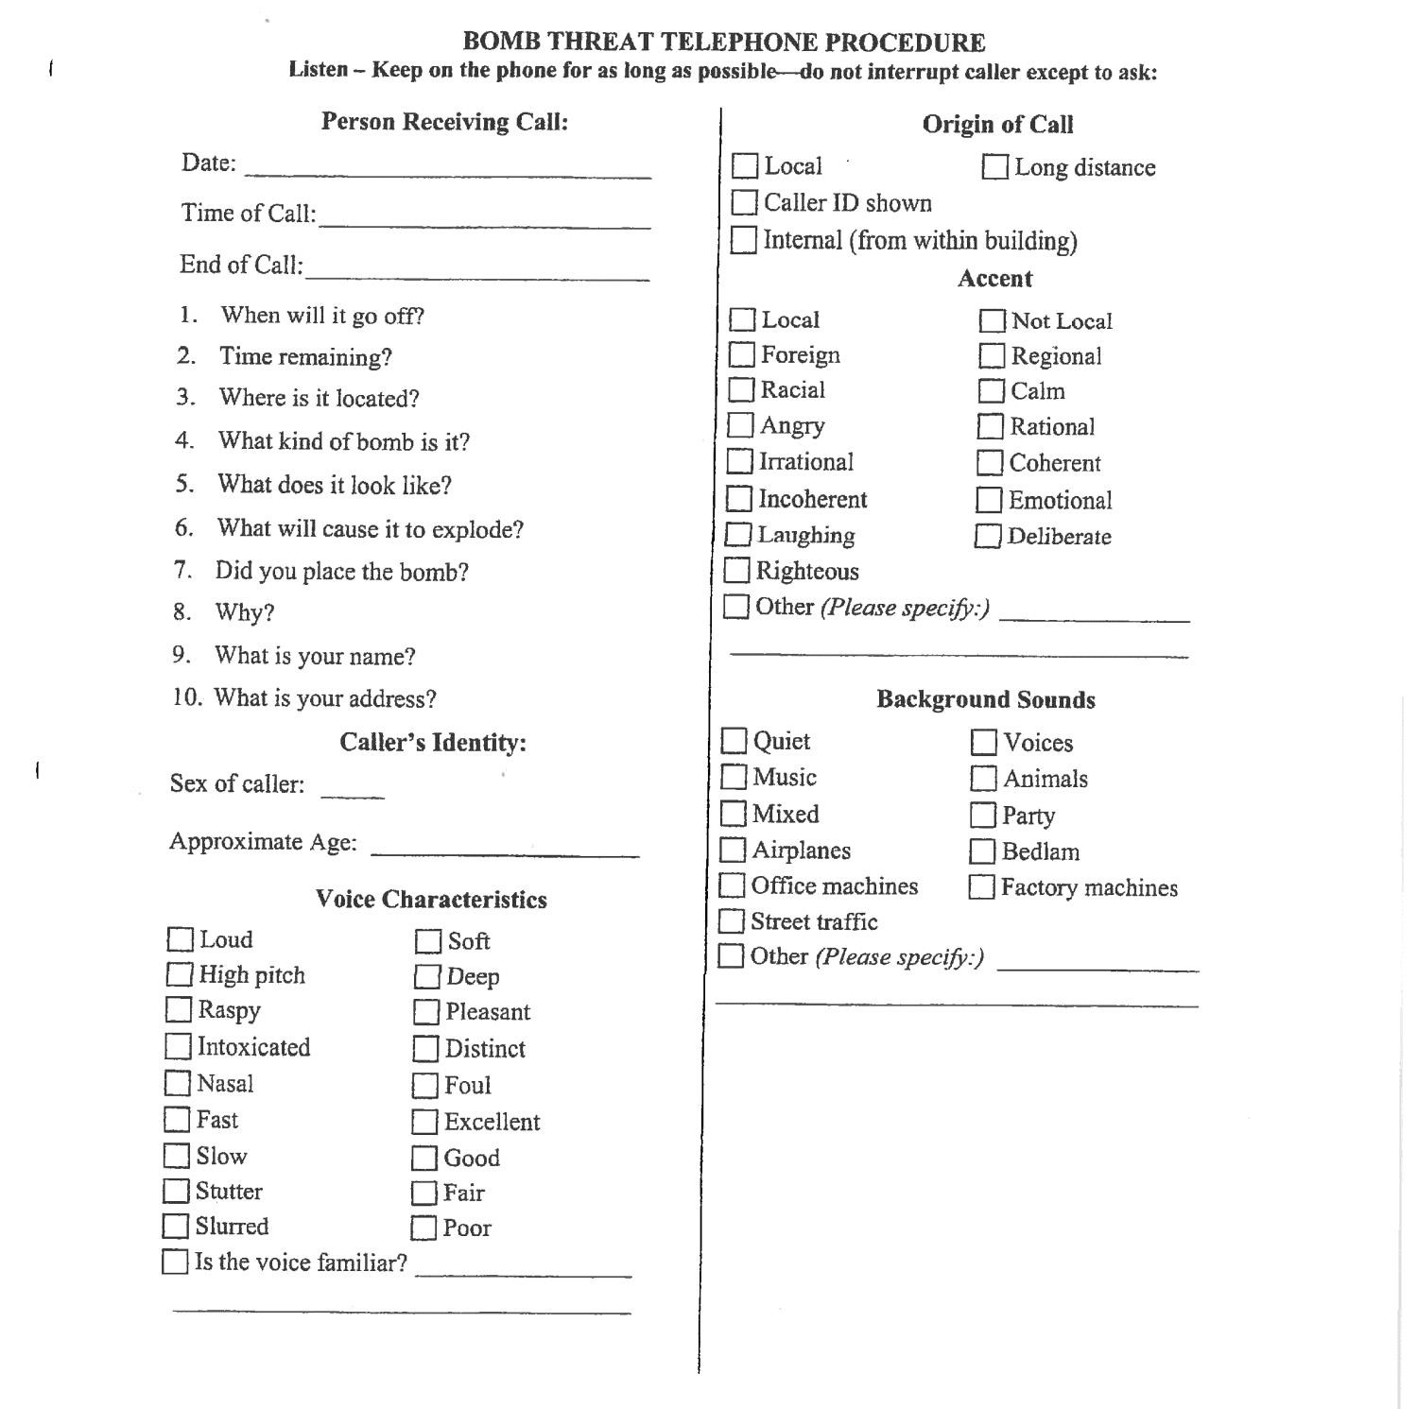
D. APPENDIX - Evacuation Routes

The Colonnade presents several differing evacuation scenarios as facilities and differing types of residences are present in our community. Hence the plans must reflect the varied types of evacuation and rally points for all eventualities.

Villa Evacuation

In the event that one or multiple Villa buildings need to be evacuated due to an emergency, please be aware of the evacuation routes to the designated rally locations. Both elevators may not be accessible during an evacuation and you will need to use one of the stairwells.

Evacuation Routes

Villa 3 and 5
Please exit the building through the safest and closest stairwell to your apartment. Follow the yellow route on the map to the Rec Center. Villa 4 and 6
Please exit the building through the safest and closest stairwell to your apartment. Follow the red route to Club Sole.

Areas of Refuge

If you cannot navigate down the stairs safely, stay on the stairwell landing and use the phone located on the wall to contact the Front Desk. Let the Receptionist know which stairwell you are in and which villa you are in. This information is provided on a sign next to the phone.

Staff Locations

Colonnade Staff will be stationed at each rally point during an evacuation their location will be driven by which Villa is evacuated and where the emergency is.

The pink dots on the map are the potential locations of employees.

Villa Evacuation Map

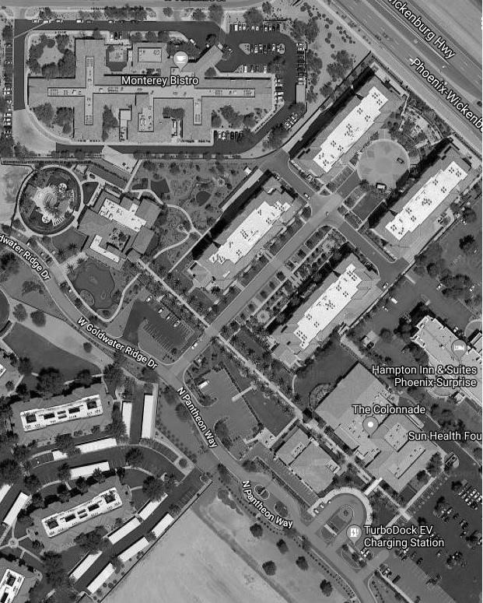

Legend:

Stars = Rally Points

Pink Dots = Employee Locations

Yellow = Villa 3 & 5

Red = Villa 4 & 6

Casita and Town House Evacuation

In the event that a Casita or Multiple Casitas need to be evacuated due to an emergency, please be aware of the 3 evacuation routes to a designated rally location. Please note, if one Casita is on fire, the three Casitas surrounding the involved residence should be evacuated as well and remain vacant until an all clear is given by emergency personnel in conjunction with TC staff.

Evacuation Routes

Eastside of Goldwater Ridge Dr.
- Follow the red evacuation route to Pisa St.
Westside of Goldwater Ridge Dr.
- Follow the green evacuation route to Porto Rd.
Florentino St
- Follow the yellow evacuation route to the entrance to the Assisted Living
Town Houses on Goldwater Ridge Dr.
- Follow the blue evacuation route to the entrance of the Assisted Living
*If you choose to evacuate to a friend or neighbors residence, which is at a safe distance away from the fire, please call the Front Desk and let the TC staff know where you are at and provide contact information. This will help with tracking the location and safety of the residents who were involved in the fire.

Staff Locations

Someone from the Colonnade Staff will be stationed at each rally point depending on which area is evacuated and where the emergency is.
The pink dots on the map are the potential locations of employees.

Casita and Town House Evacuation Map

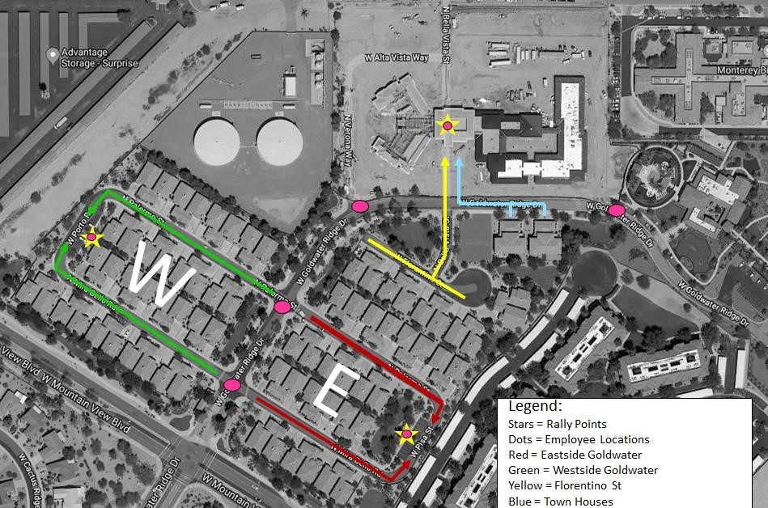

E. APPENDIX – RADIO COMMUNICATIONS

Emergency Radio Communications

The Colonnade will have 24 dedicated 2-way radios for use during emergency situations. There will be 22 channels dedicated to these radios for The Colonnade exclusive use at an incident.

Site Locations

Radios will be stored at the Environmental Services Workshop and the Recreation Center of the Colonnade. In Addition to this each Director will have one dedicated radio in their office.
In the event of an emergency event the directors will go to the Command Center in ALMS bringing their radios with them. All other radios will be brought from storage areas to the commander center for allocation as the incident develops.

Radio Channel Allocation

Ch1 - Senior Director in Charge of Command
Ch2 – Environmental Service Director
Ch3 – Resident Services Director
Ch4 – ALMS Director
Ch5 – HR Director
Ch6 – Food Services Director
Ch7 to 10 – Command Communications Officer (Only one channel would normally be required but in extreme situations additions Comms Officers may be required due to flow of information being handled) Ch11 to 16 Zone Leaders
Ch17 to 22 Spare channels not allocated to allow for flexibility in Command structure.

These allocations of radio channels will allow for the fluidity of an incident size as described in APPENDIX A Command structure.

F. Emergency Contacts

Surprise Police Department –
Emergency dial 911
Non-emergency dial (623) 222-4000

Surprise Fire Department –
Emergency dial 911
Non-emergency dial (623) 222-5000

Surprise Office of Emergency Management (623) 222-1019

Surprise Department of Public Works (623) 222-1900

Maricopa County Sheriff’s Office –
Emergency dial 911
Non-emergency dial (602) 876-1000

Arizona Department of Public Service (DPS)
Emergency dial 911
Non-emergency dial (602) 223-2000

Arizona DOT (ADOT) (602) 255-0072

Maricopa County DOT (MCDOT) (602) 506-8600

Federal Emergency Management Agency (FEMA) – 1-800-621-FEMA (1-800-621-3362)

Arizona State Office of Emergency Management (602) 244-0504

Maricopa County Emergency Management Department – (602) 506-3011

American Red Cross – 1-866-438-4636

Epcor 1-800-383-0834 Regional (623) 972-2698 Local normal business hours

Southwest Gas 1-877-860-6020 Customer Service 1-877-654-2765

APS 1-800-240-2014 aps.com

Cox Communications 1-800-234-3993 TC Rep – Brian Phillips (602) 316-4004

Gen Tech – Generator service and emergency fuel supply (623) 937-1719 – AL/MS

Power Plus – 1-800-863-2525 TC Rep – Joe (480) 308-8020 – Corporate generator

G. APPENDIX - List of Vendors

Gen Tech – Generator service and emergency fuel supply (623) 937-1719 AL/MS

Power Plus – 1-800-863-2525 TC Rep – Joe (480) 308-8020

Sunwest True Value – (623) 584-7888 TC Rep – Susan (623) 810-4853 Cell

Lowe’s – (623) 687-3818 Brad or Pete at PRO desk TC Rep – Tamara (480) 216-2739 Cell

Home Depot – (623) 584-1033

Schindler Elevator – (800) 225-3123

AERO Fire Sprinkler - (623) 580-7800 TC Rep – Bob Sowers (602) 763-4623

Southwest Integrated Systems - (623) 322-5088 24 hour emergency service
TC Reps and additional contact numbers
Harold Ammons (602) 908-3226
Rob Souvigny (602) 677-1781
Ryan Quijada (602) 989-3801
Ryan Kiffner (602) 354-1477
Brian Herold (602) 501-3711

Arizona Control Specialists – (480) 829-9421 24 hour emergency service
Additional contact numbers
Joe Schultz (602) 571-8405 Service Manager
Nathan Mathison (602) 571-2883 Field Supervisor
William Truet (602) 206-6943 President

Surprise Locksmith – (480) 776-4269

Arrowhead Commercial Equipment (623) 773-1365 Kitchen equipment repair

Automatic Gate Systems PHX (602) 267-7778

High Peaks Water Softeners (602) 277-7208

Cool Blew HVAC/Plumbing (623) 242-6706

36
Revised 10/24/2019

37
Revised 10/24/2019

