

## **How to Add the COVID-19 Vaccination Badge to Your Email Signature**

1. On the [COVID 19 Vaccine Badge page](https://employees.sunhealth.org/vaccine-badge), right-click the small badge icon click **Copy**.
2. In Outlook, click **File** and then click **Options**.

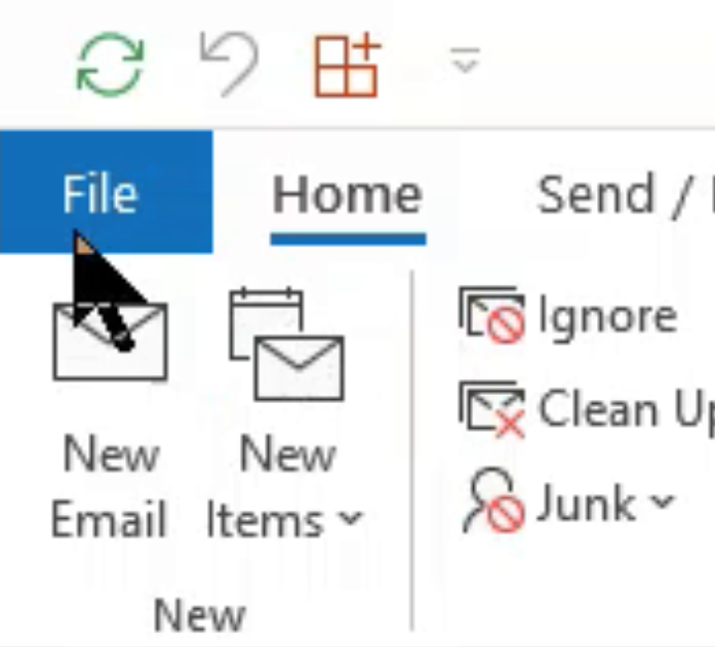 

1. On the left-hand side, click **Mail**.

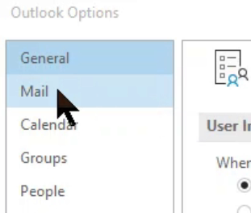

1. Click the **Signatures** button.

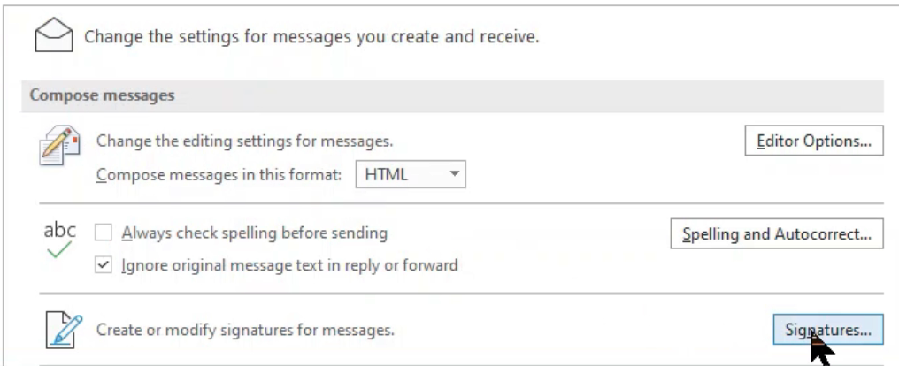

1. Select your main email signature to edit. *See Figure 1 below.*

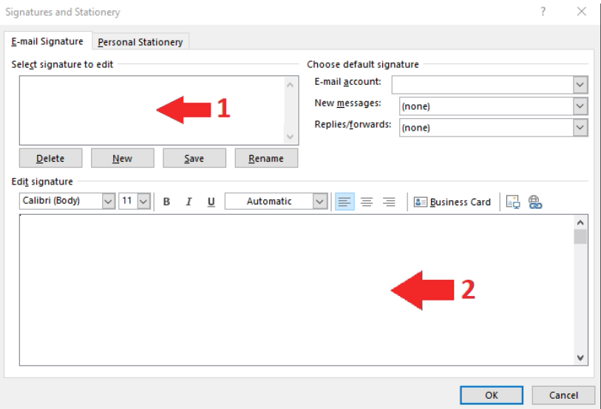

1. Place your text cursor directly to the right of the logo(s), where indicated below.



1. Once the cursor is placed to the right of the logo(s), paste the badge using one of the two methods below:
   1. Type “CONTROL” and then “V” at the same time OR
   2. Right-click and choose Paste (Keep source formatting) to insert the badge into your signature.



1. Click OK to save.

**Your updated signature should be ready to use!**

If you need help applying the new badge, please contact IT Service Desk for assistance.