  - APPLICATION:
  - NextGen Office
  - Document Release Date: 12/9/2020
Reviewed Date: 12/9/2020
Approved Date: 1/15/2020
Version: V1.0

Table of Contents

Table of Contents 1
Application Overview 2
Usage 2
Application Details and Ownership 2
Access 3
Permissions and Login 3
How to change your password 4
Modifications 5
User Guide 6
Introduction 7
Purpose 7
Integrations 7
Schedule an Appointment 8
Appointment Check-In 9
Charge Entry 11
Billing & Providers 15
Patient Payment 19
Create a Claim 23
Reports 24
Post Payment 37
Payment Type 40
Billing codes/Fee schedule 46
Practice Mangement/EHR 47

Application Overview

NextGen HealthFusion will help everyone in your office from the person who checks the patients in to the provider who does the charting to when the money is received from the insurance company. NextGen has mastered this process and makes it seamless experience for employees using their software.
NextGen Office, is a set of cloud-based software solutions developed primarily for smaller, independent medical practices. Health facilities use this to provide higher quality care while creating a better experience for both the patient and provider. It includes customization features, mobile apps, drag-and-drop scheduling, revenue management and more. Patients can schedule appointments, receive alerts and notifications and make payments all online.
Sun Health uses this software for something that will be explained here

Application Details and Ownership
Application Manager: Torres, Jaime
Vendor: NextGen Office
Vendor POC Name: Bailey, Stephanie
Vendor POC Contact Information:
Bailey, Stephanie
Email: bstephanie@healthfuison.org
Primary number: 1-877-523-2120
Customer Service PIN: 7089150
License Type: Registered Trademark
Subject matter expert(S): Bowls, Paul
Current Release of Software: June 3, 2020 - This release includes enhancements to NextGen® Office EHR and a new Patient Portal login feature. In EHR, Mac users with macOS Catalina installed can now upload scanned documents. In Patient Portal, patients can now log in by entering a verification code.
Application Location: https://login.healthfusion.com/

Levels of accessibility
- Permissions
Administration Rights Super user: Gives the user access to all functions within the NextGen platform.
  - Eligibility
  - Precert Inquiry
  - Precert Add
  - Referral Inquiry
  - Referral Add
  - Claim Status Inquiry
  - Claim Status Report
  - Claim Upload
  - Claim Direct Data Entry
  - Claim Status Display
  - ERA, Administrator
  - Charge Entry User
  - Scheduling User
  - Reports User
  - Billing User
  - Admin Clerk
  - EHR Admin
Billing Rights: Gives the user access to all Billing functions with in the NextGen platform.
  - Charge Entry
  - Claim status
  - Payments
  - Insurance ledger
  - Statements
  - Patient ledger
  - Secondary Billing
Reporting Rights: Gives the user access to all Reporting functions with in the NextGen platform.
  - Front office
  - Back office
  - Financial
  - Clinical
  - Provider

Access

Permissions and Login
You can add or edit user IDs in Administration: User Maintenance. You can also add or edit user information, preferences, permissions, and roles. Creating unique user IDs and passwords for each user is essential for proper documentation and workflow management. User IDs are tagged to activities in both the NextGen Office EHR and Practice Management (PM). The setup and use of user IDs ensures that all users have proper access to the site, accurate user-based custom reporting, and EHR document
Navigate to Administration: User Maintenance
- Click Admin.
- Below Practice and Users, click User Maintenance.
Add or Edit a User
You have options to add a user, edit, delete, or disable an existing user ID, change the user password, and create a report.
- To create a new user, click Add a New User.
- To edit an existing user, click .
- To delete the user, click .
- To change the user's password, click .
- To disable the user, clear the Enable checkbox.
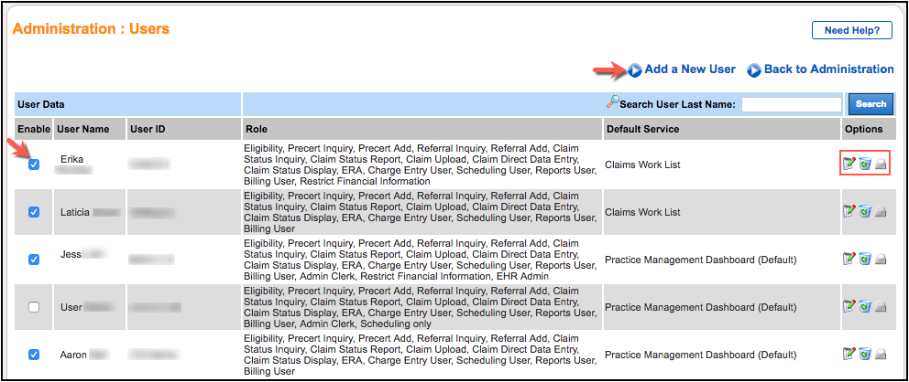

How to change your password
Strong passwords help ensure account security and prevent unauthorized access to patient information. Password strength is validated every time you log in. If your password does not meet our password criteria, you are prompted to change your password.
Your account password must be:
- At least eight characters
- At least one uppercase letter
- At least one lowercase letter
- At least one number
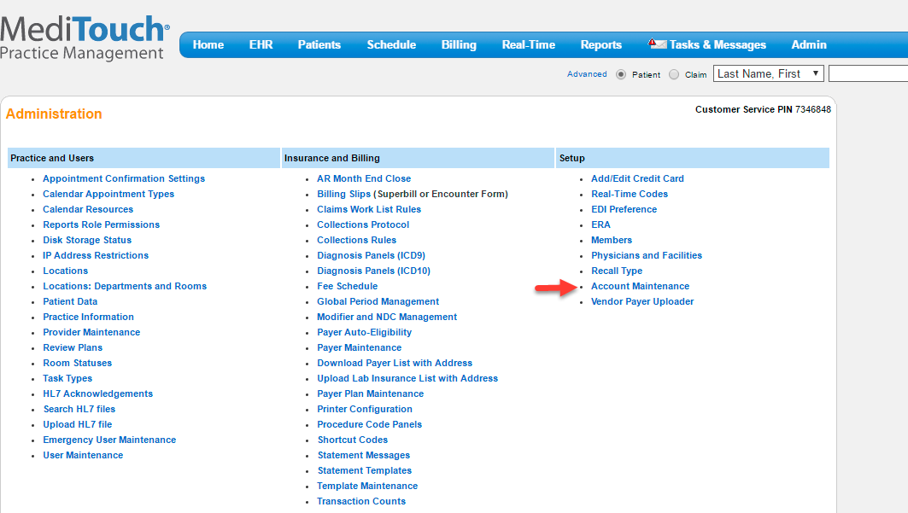
- From the menu bar, click Admin and then click Account Maintenance.
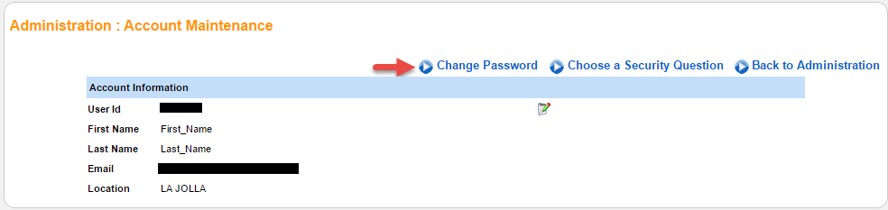
- Click Change Password.
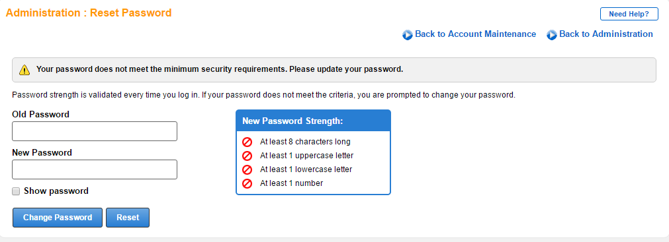
- Enter the old password.
- Enter the new password.
- To view the new password, select the Show Password checkbox.
- Note: The password strength indicator box changes color and displays checkmarks as your password strength increases.
- Click Change Password.

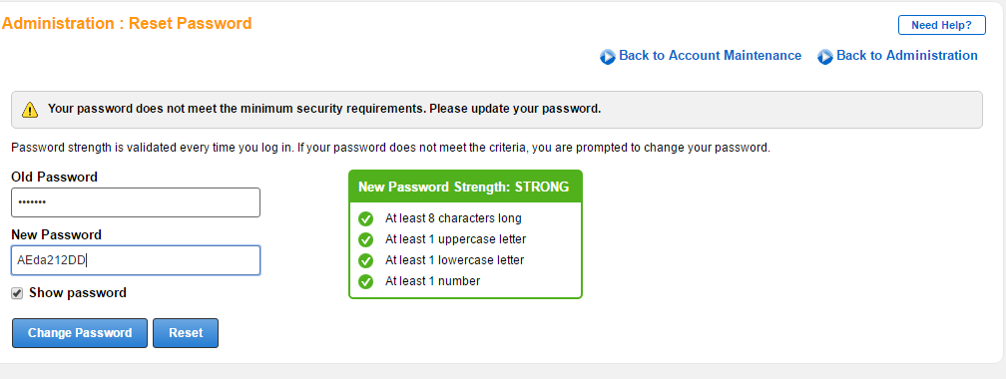
- An example of a strong password.

Modifications
This will let the user know of any modifications that need to be made beyond the basic install or access to align with Sun Health Usage. Special themes, fonts, branding, etc. – No modifications

User Guide
Introduction – NextGen Healthcare. NextGen Healthcare offers NextGen Office—a cloud-based HER specifically designed for private practices. NextGen Office is a fully integrated practice management solution that includes specialty-specific content, a claims clearinghouse, and an easy-to-use patient portal.
Purpose- Sun Health Center for Health and Wellbeing utilze NextGen office to provide high quality care while creating a better experience for both the patient and provider. It includes customization features, such as mobile apps, drag-and-drop scheduling, revenue management and electronic health records.
Integrations
- No known integrations at this time
The Daily Schedule displays all of the calendar resource's appointments for the day. You can also schedule appointments for patients. Scheduling walk-in appointments can only be performed from the Daily Schedule page.
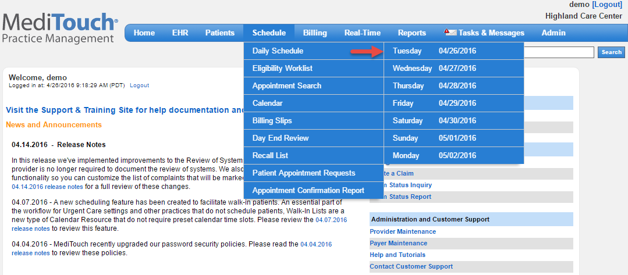
- From the menu bar, hover the cursor over Schedule, select Daily Schedule, and then click the desired day.
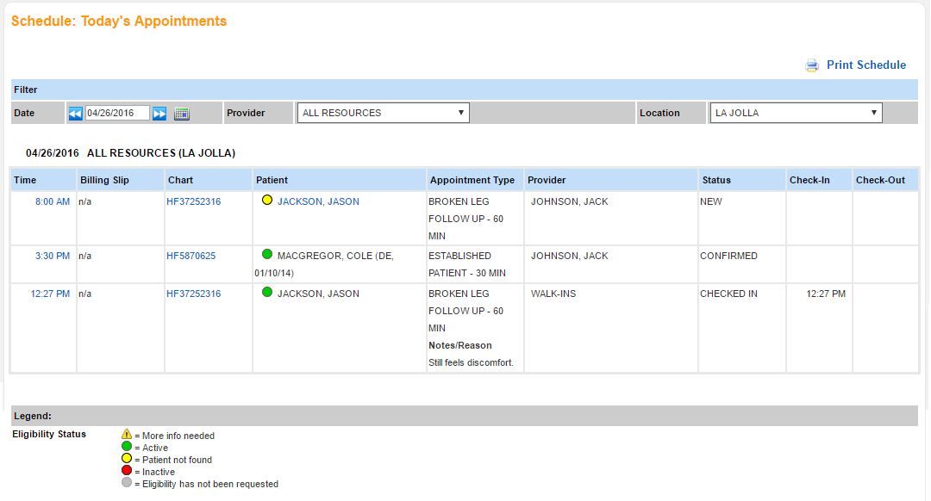
- Filter the displayed appointments by date, provider, and location.
- Time: Hover the cursor over the time to display the scheduling options (described in the next screen capture).
- Billing Slip: The billing slip (or encounter form) that is associated with this appointment.
- Chart: Click the chart number to view the patient's chart.
- Patient: The patient's name appears as a blue hyperlink if eligibility has been verified. The color of the circle icon to the left of the patient's name indicates their eligibility status. See the legend on the bottom of the page.
- Appointment Type: Displays the appointment type and any notes or follow-up comments that were entered when the appointment was scheduled.
- Provider: The rendering provider.
- Status: The appointment status.
- Check-In: The checked-in time.
- Check-Out: The checked-out time.
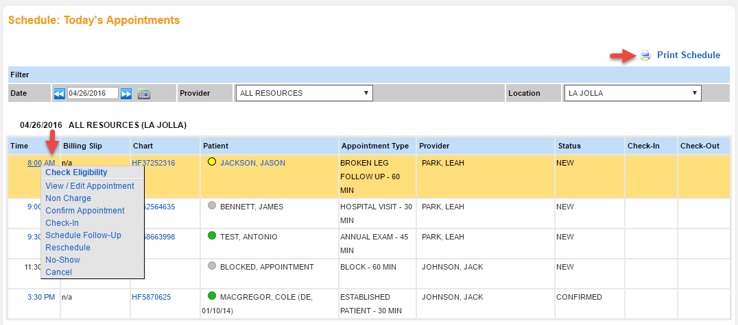
- Hover the cursor over the appointment time to display the scheduling actions, including checking insurance eligibility.
- To print or download a PDF of the day's schedule, click Print Schedule.

Schedule an Appointment
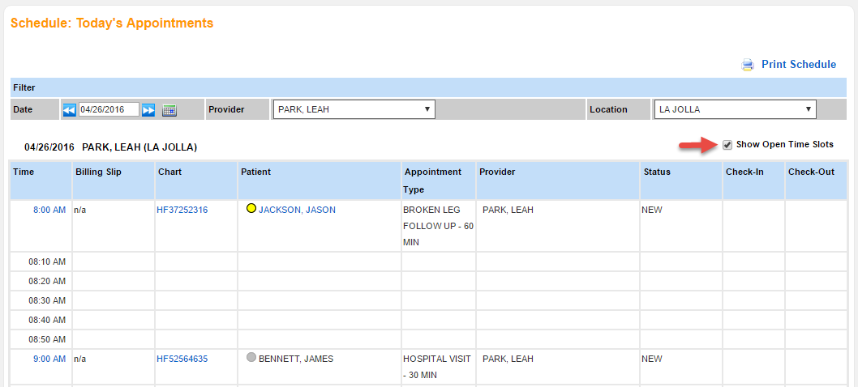
- To display all available time slots for the day for the selected resource, select the the Show Open Time Slots checkbox.
- The checkbox is only available when viewing one resource at a time.
- Click the desired time slot.

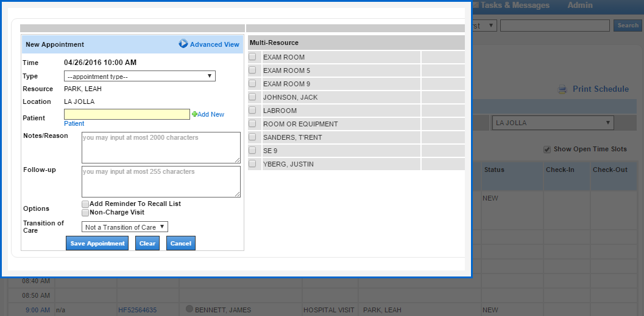
- Enter the details to schedule an appointment and then click Save Appointment.

Appointment Check-In
The Check-In option is available on all schedule and appointment pages. Check-In is initially available for all new and confirmed appointments. After an appointment is checked in, the Check-In option is replaced with the Check-Out option.
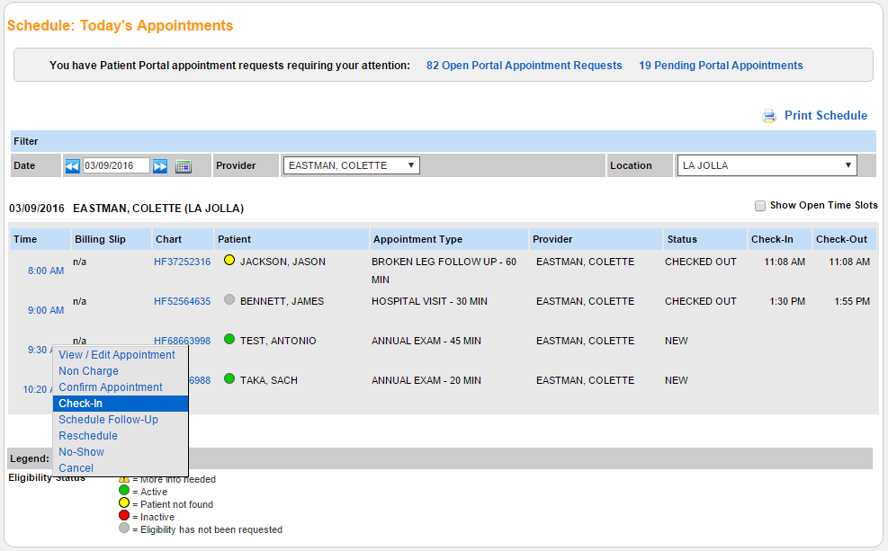
- Navigate to an appointments page (e.g., Schedule > Daily Schedule).
- Hover the cursor over the appointment time to display the appointment options menu.
- Click Check-In.
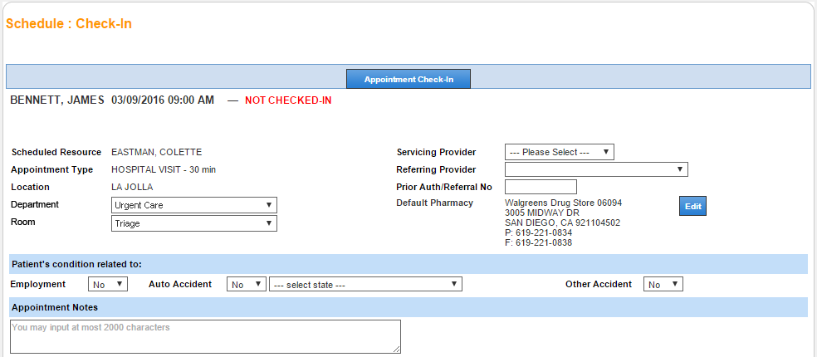
- You are navigated to the Check-In page.
- Complete the check-in form and then click Appointment Check-In.
- Note: You will only see the department and room menu options if you have configured them for your practice in Administration: Locations: Departments and Rooms; else, you will see a text box to fill in the room.
Note: The appointment is not officially checked in until you have clicked Appointment Check-In.
Upon check-in, you are returned to the appointments page. The Appointment Check-Out option is now available for the appointment.
Post a Patient Payment (Optional)
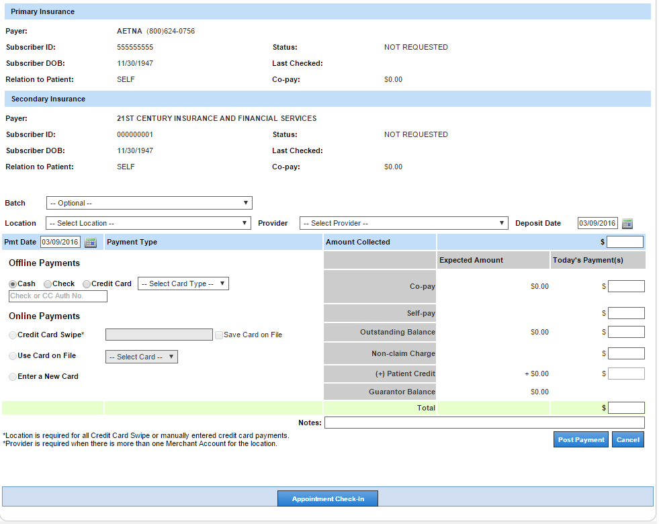
- At the bottom of the Check-In page, you have the option to Post Patient Payments prior to appointment check-in.
- After posting the payment, you can print a receipt (click Print Payment Receipt).
- Click Appointment Check-In.

Charge Entry
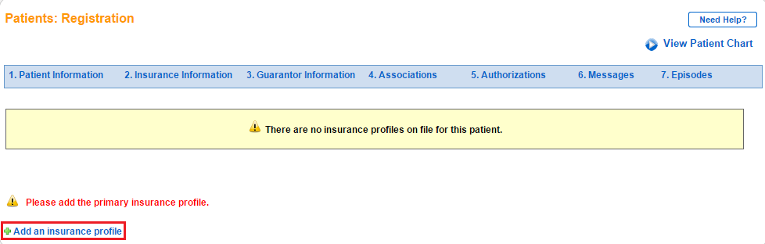
- Note: Patients must have primary insurance.
- If the patient does not have primary insurance, you are redirected to the patient registration page where you can add the insurance.

Access the Charge Entry Page
- From the appointment
- From the patient's chart
- From the claim

From the Appointment
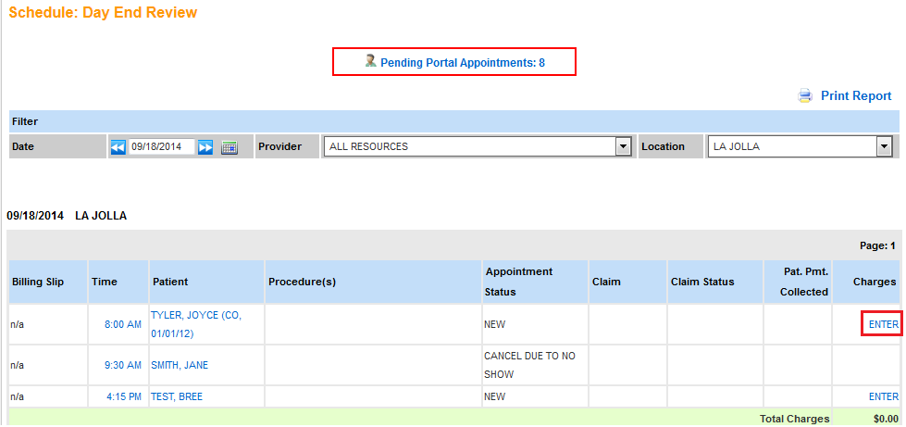
- Navigate to an appointment day (Schedule > Day End Review and then select a date).
- Click ENTER in the row corresponding to the appointment that you would like to create a claim for.

From the Patient’s Chart
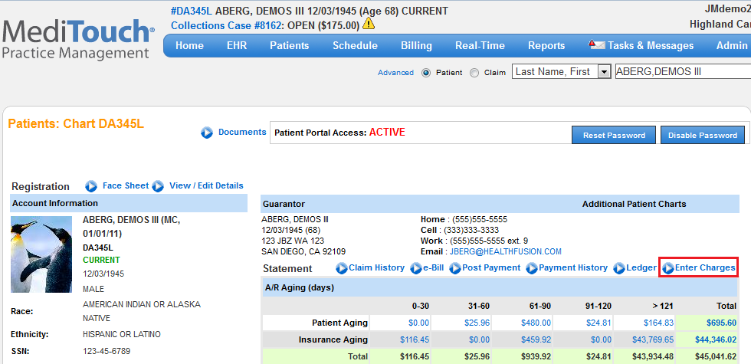
- Navigate to the patient’s chart and click Enter Charges.
- If you are entering charges for an existing appointment, click that appointment date/time.
- Else, click proceed to Charge Entry.

From the Claim
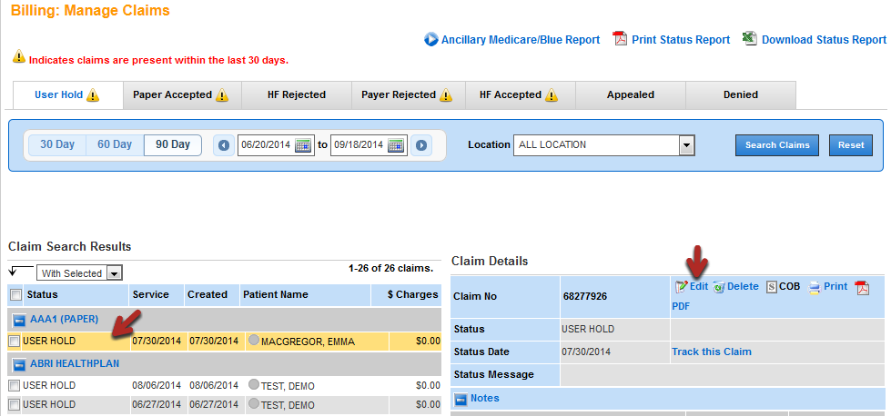
- Navigate to a claim with a user hold status (Billing > Claims > Manage Claims) and click Edit.

Navigate Charge Entry
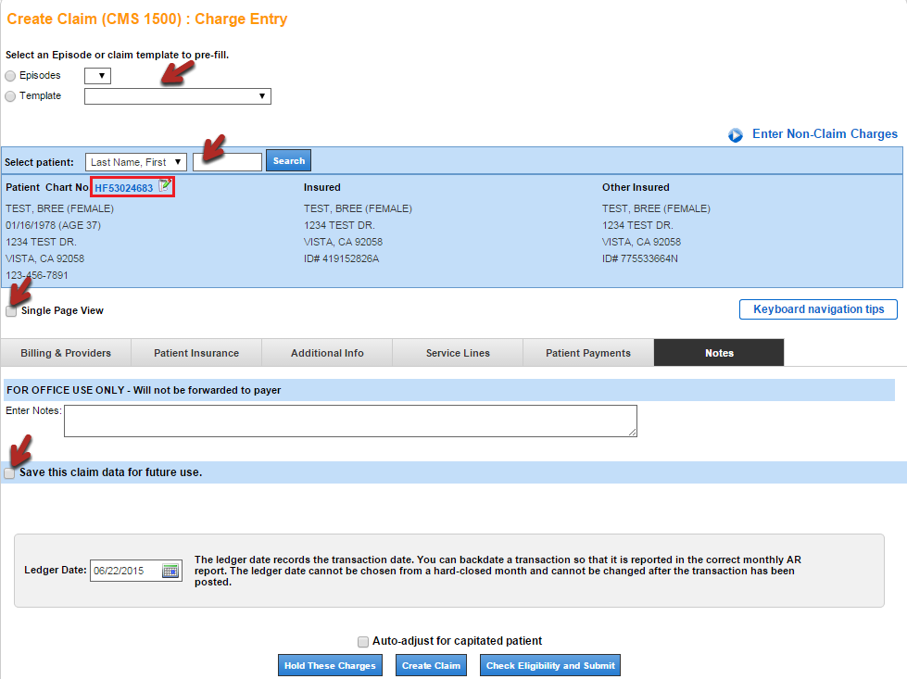
- Select an episode or template to prefill information (optional). These saved options are created whenever you save claim data for future use (available on every tab).
- Search for a patient by chart number, date of birth, name, phone number, or social security number.
- To edit the patient's chart information, click the chart number or .
- For more information on entering non-claim charges, refer to Non-Claim Charges.
- For the keyboard shortcuts, click Keyboard navigation tips.
- For single page view, select the Single Page View checkbox. To return to the tabbed view, deselect the checkbox. Note: Single page view does not include the detailed patient insurance information that is only available in the tabbed view.
- Every tab has the ledger date and the options to create the claim.

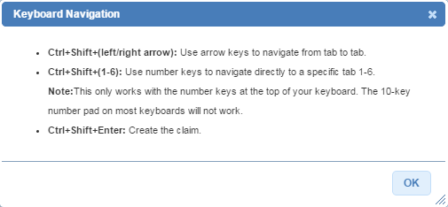
- The keyboard shortcuts help you quickly go from tab to tab.
- There is also a shortcut to create the claim.
The charge entry page contains six tabs that comprise the most important information.
- Billing & Providers
- Patient Insurance
- Additional Info
- Service Lines
- Patient Payments
- Notes
Note: If the rendering and billing providers are completed, the tab defaults to Service Lines when you land on the Charge Entry page; else, the tab defaults to Billing & Providers.

Billing & Providers

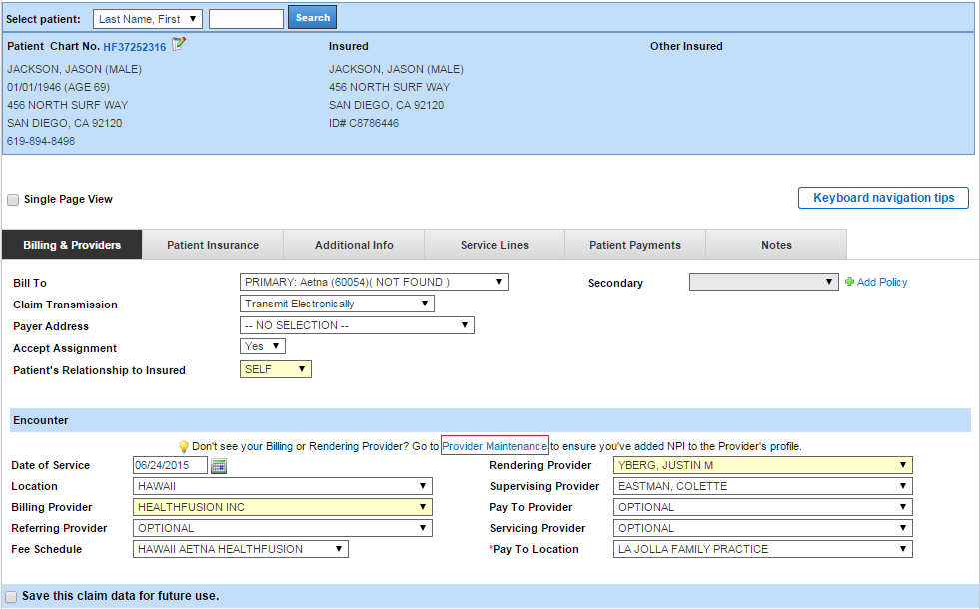
- Confirm the patient information.
- Confirm the Bill To and Secondary Payer information
- Select the Claim Transmission type.
- Select the Payer Address (applicable when printing a claim).
- Confirm the Patient’s Relationship to Insured.
- Confirm or enter the Date of Service (DOS). If the charge has originated from an appointment or encounter, the DOS is inherited from the appointment or encounter date.
- Confirm or select the Location. If the charge has originated from an appointment or encounter, the location is inherited from the appointment or encounter location.
- Confirm or select the Fee Schedule (optional). The fee schedule is defaulted based on the provider and location selected, but can be changed as needed.
Confirm or select the provider information. All data is pulled from the provider maintenance setup (click Provider Maintenance):
- Rendering Provider: Box 24 NPI and Box 31 Signature (2310B)
- Billing Provider: Box 33 Name, Address, and NPI (2010AA)
- Supervising Provider: Optional (2310D)
- Pay to Provider: Optional (2010AB)
- Servicing Provider: Optional. For reporting purposes only and does not appear on the claim.
- Referring Provider: Optional. Box 17 Name and NPI (2310A).
Note: Complete the optional selections only if directed by the payer. The referring provider can be defaulted on every claim and appointment by selecting the provider in Associations during registration (Patients > Register a New Patient).

Patient Insurance
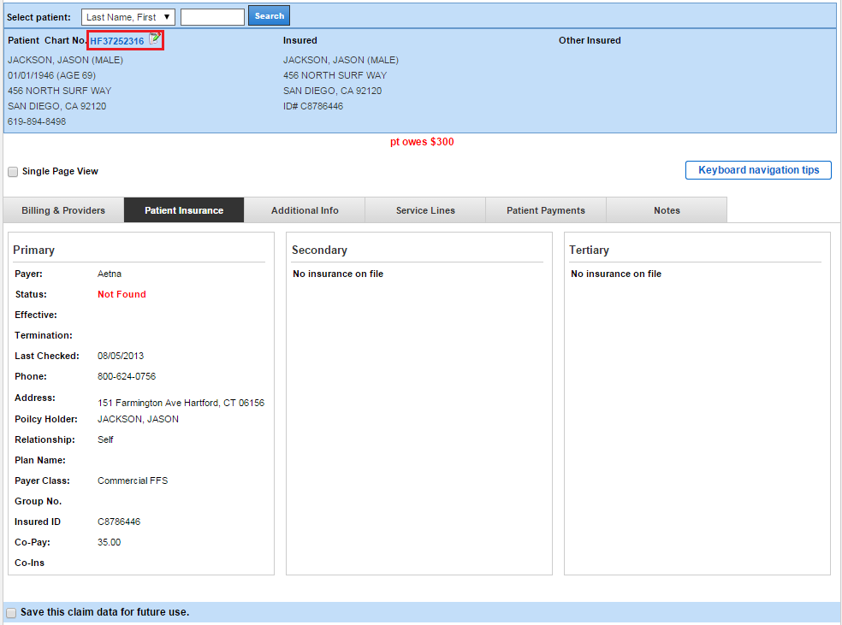
- Confirm the patient's insurance information.
- To edit insurance information, click the chart number or , which takes you to the patient registration page.
- On the Registration page, click Insurance Information.

Additional Info
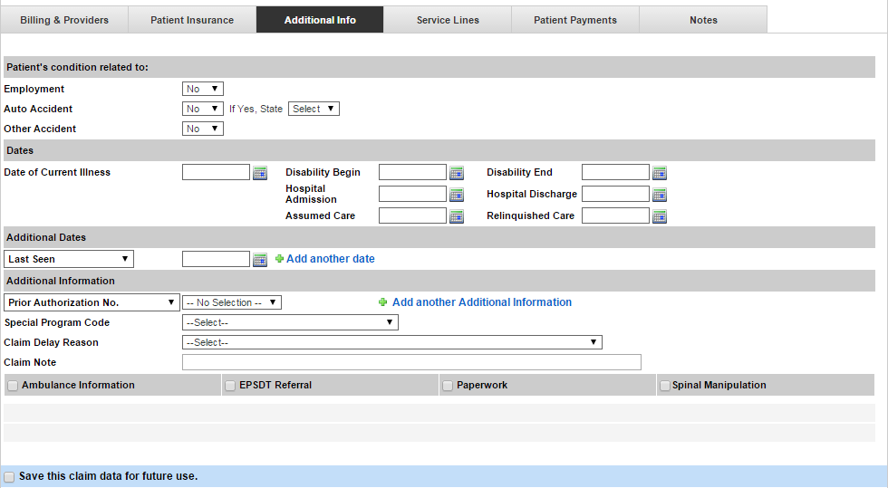
- Enter additional claim information, as required.

Service Lines
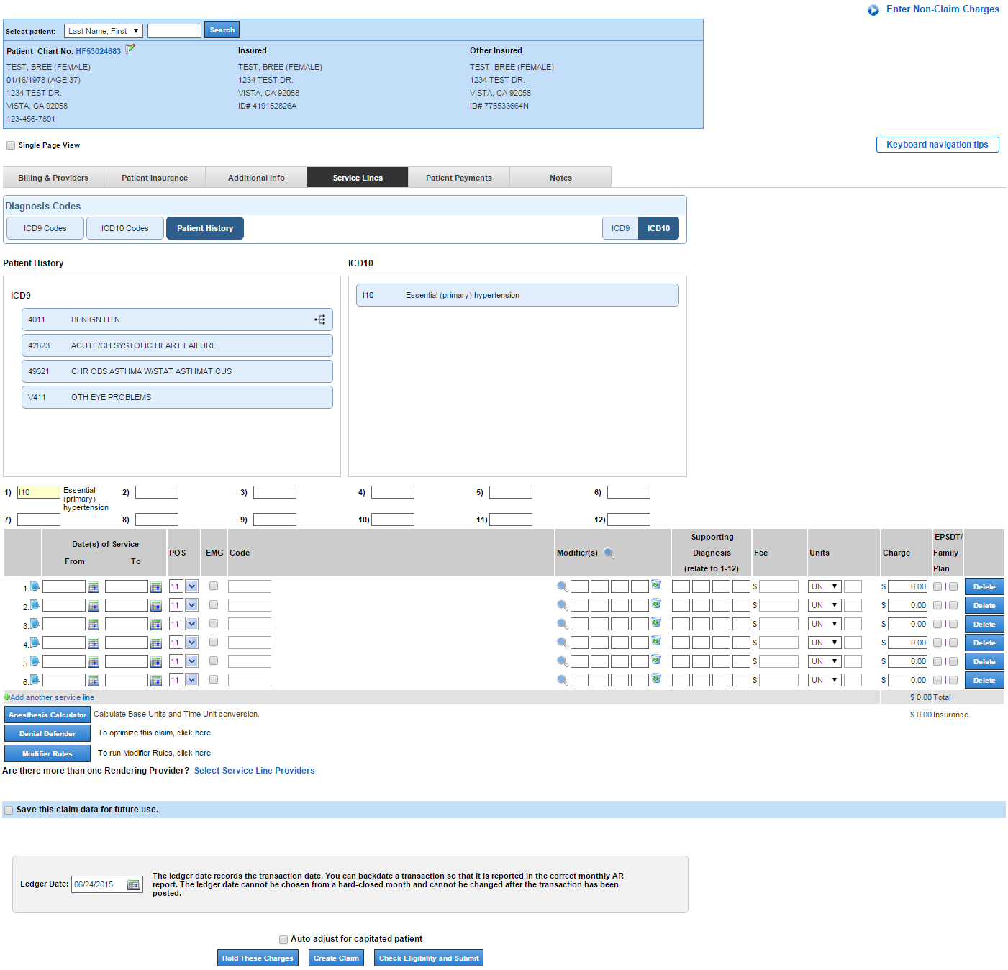
- Diagnosis Codes: Use the diagnosis coding tool to select a diagnosis code.
- Date of Service From/To: Clicking into the blank field fills in the DOS previously selected.
- POS: Place of Service. This is defaulted based on the location selected.
- EMG: Optional
- Code: Must be a valid CPT code.
- Modifier: Optional. Must be a valid modifier. Click the magnifying glass icon to look up modifiers and their descriptions.
- Supporting Diagnosis: Enter 1-12 as applicable to associate to the procedure code to the supporting diagnosis code(s).
- Fee: Prefilled based on the fee schedule selected, but can be entered or changed manually.
- Units: Select the unit qualifier and enter the number of units.
- Charge: The service line charge is calculated by multiplying the fee by the units.
- EPSDT/Family Plan: Optional
- To delete a service line, select the associated radio button and click Delete.

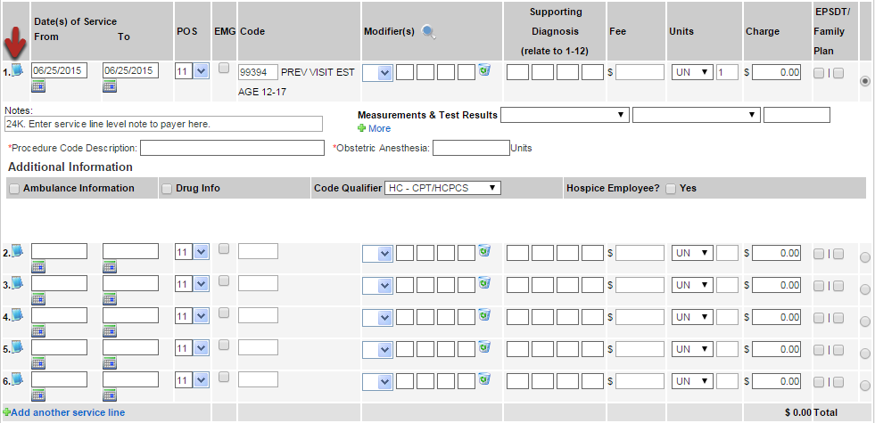
- Click to display service line-level notes (optional):
  - Box 24K: The shaded area above a service line on a CMS 1500 (2300 NTE)
  - Measurements & Test Results
  - Ambulance Information: Select the checkmark to generate the information fields.
  - Drug Info: Select the checkmark to generate the information fields.
  - Code Qualifier
  - Hospice Employee

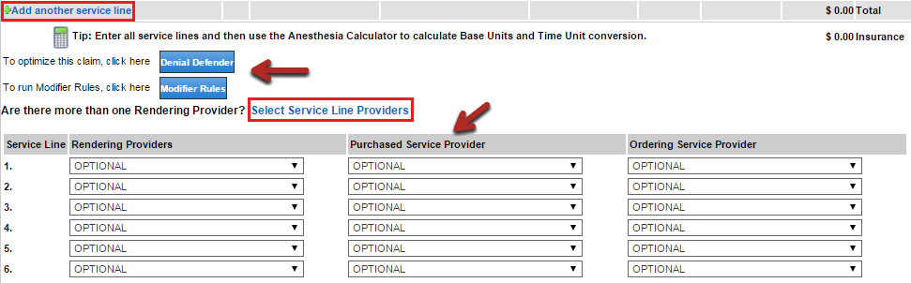
- If more than six diagnosis codes are needed, click Add another service line.
- If you have a service line that corresponds to an anesthesia service, click the calculator to calculate base units and time unit conversion.
- To optimize the claim, click Denial Defender.
- To run modifier rules, click Modifier Rules.
- To select a purchased service provider, ordering service provider, and/or different rendering provider (optional), click Select Service Line Providers.

Patient Payments
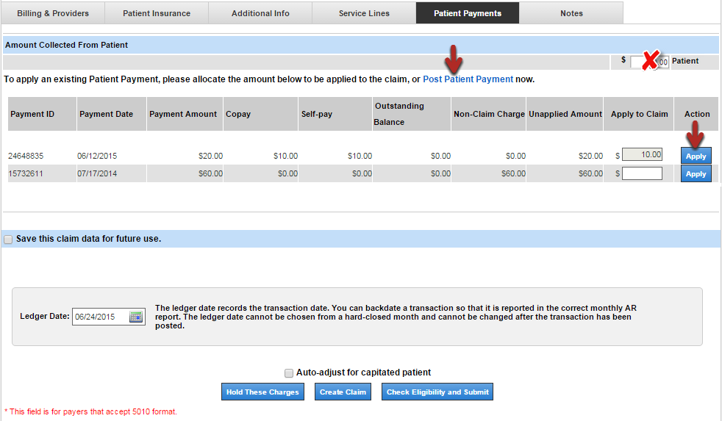
- To enter a payment, click Post Patient Payment. After the payment is posted, click Apply to apply the payment to the claim (the dollar amount must be entered).
- Do not enter information in the box marked with an X unless the data is to be sent on the claim in box 29. Entering a value in that box does not apply the payment to the claim and does not post the payment in the system.
- A list of all unapplied payments for the patient is automatically displayed. If the payment was entered during check-in or check-out, the payment is available to be applied to the claim.

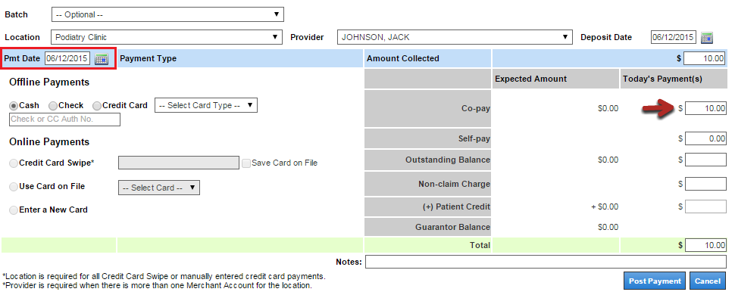
- If the payment is posted on the same date as the claim’s date of service (found on the Billing & Providers tab) and the unapplied amount is greater than or equal to the copay amount, MediTouch automatically applies the copay payment to the claim.

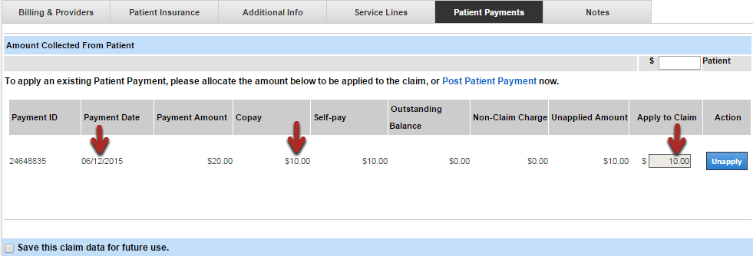
- The copay payment is automatically applied to the claim.

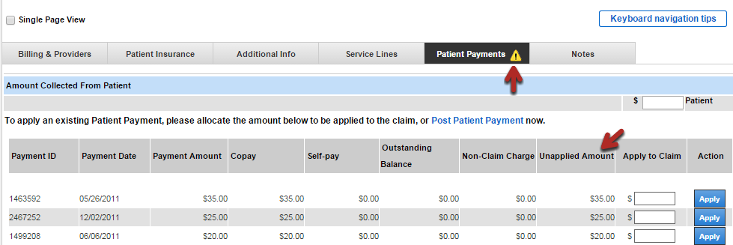
- Indicators display on the Patient Payments tab to notify billers of new activity.
- If there are unapplied payments present, an alert icon displays on the Patient Payments tab.

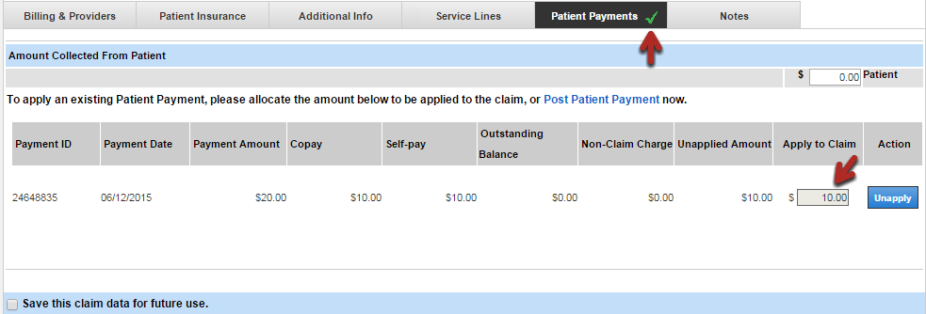
- If the copay payment was automatically applied to the claim, the Patient Payments tab displays a green check mark.

Notes
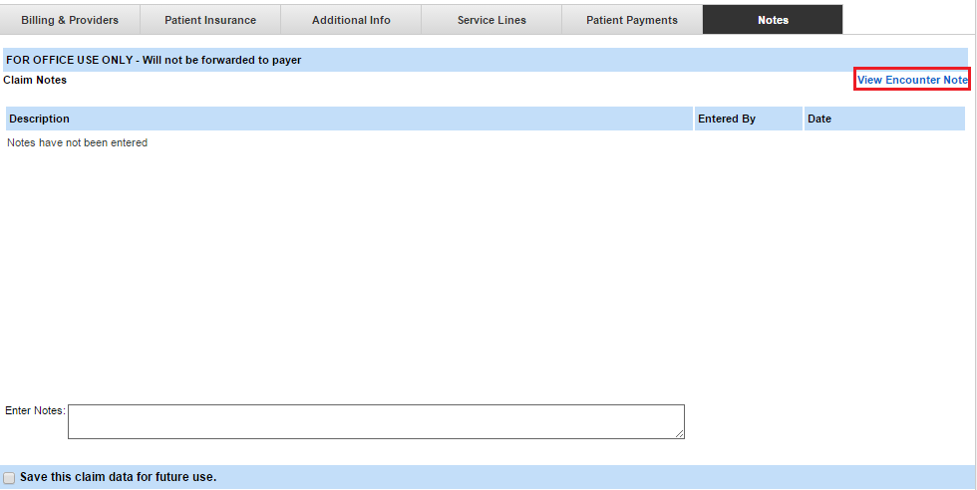
- Enter a note for internal use.
- To view the encounter summary, click View Encounter Note. A new browser tab will open with the encounter summary. Note: This link is only available to those who have EHR encounter access.
Save Claim for Future Use
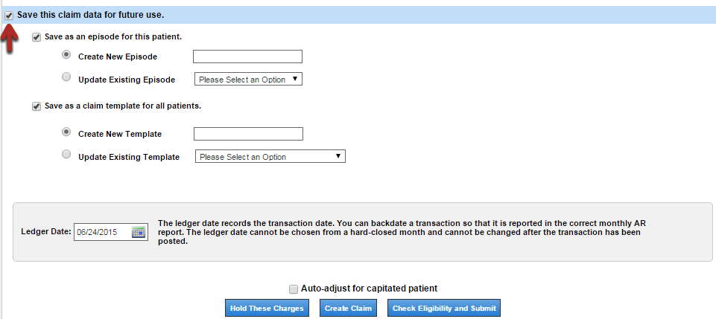
- Before creating the claim, determine if the data should be saved as an episode and/or as a template for future use.
- Select the Save this claim data for future use checkbox.
- Select the Save as an episode for this patient and/or Save as a claim template for all patients checkbox.
- Select the appropriate radio button for whether you want to create a new episode/template or update an existing episode/template.
- Enter the new episode/template name or select the existing episode/template you want to update.

Create a Claim
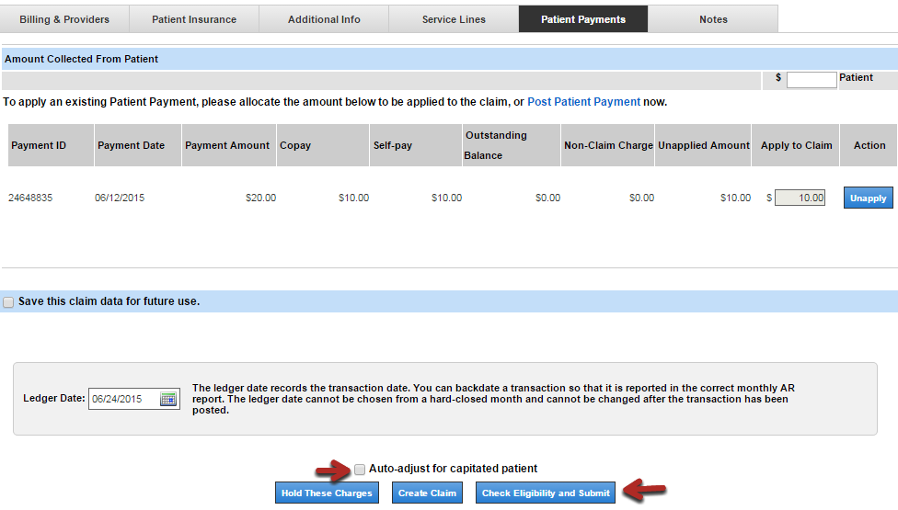
- If the patient is an HMO participant, select the Auto-adjust for capitated patient checkbox.
- Click Create Claim. Note: You can create the claim from any tab.
- If there are no errors, the claim is queued for processing. Any queued claim is automatically accepted. If the claim is electronic, the file is sent by HealthFusion around 6:00 PM PST on the same day. Paper claims can be printed in a batch after all charges have been entered.
- If errors are returned, fix the errors and then click Create Claim again to process.
- You can also place the claim in User Hold (Hold These Charges) or verify the claim's eligibility prior to creating the claim (Check Eligibility and Submit).

Reports:

Report Data
Data for the majority of Practice Management reports is updated within one hour behind real-time data. This means that report data may be up to an hour old. We provide when data is updated in the report (shows after you select the report name). For more information about each report's data, refer to Reports Reporting Suite Data.
Note: While a one hour delay behind real time is not guaranteed, our goal is 30 minutes to one hour behind real-time data. Check Success Community for any known issues with report data delays.

Report Formats
- Formatted reports
- Data tables
- Analysis grids

Select a Report
- On the NextGen Office Reports page, select a Report Type.
- Select a Report Name. The filters that appear below depend on which report is selected.
- Report description: Shows next to the Report Type after you select a Report Name.
- Data source/Report purpose: Shows next to the Report Name.
- Note: Reports from different sources will not necessarily align. For example, the charge amount in charge ledger reports by created date will not always match the charge amount in ledger transaction reports.
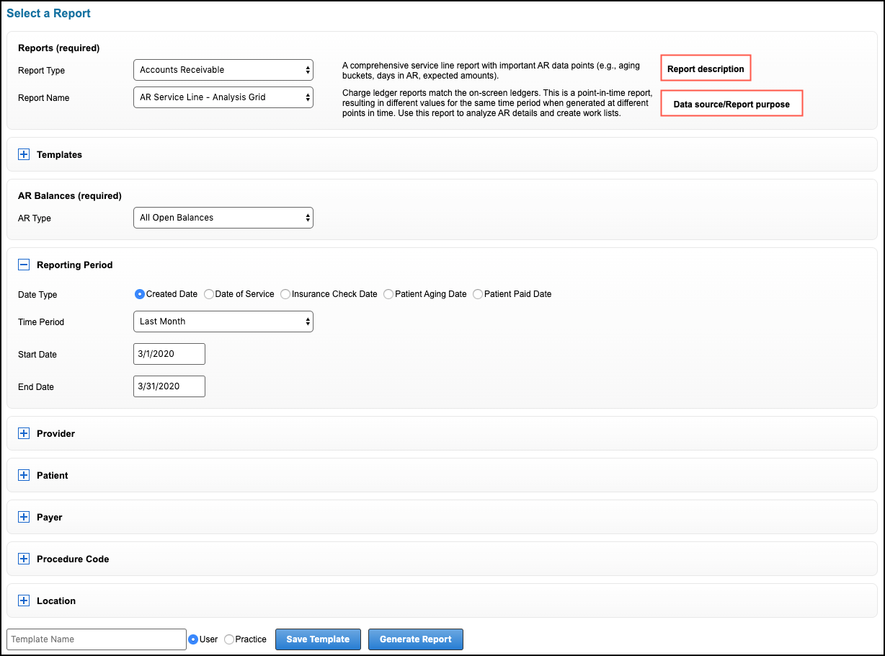

Time Zone in Reports Generated by Created Date
In reports run by created date, the created date reflects the user’s computer’s time zone. In cases where a different time zone leads to a different day (for example, biller and practice are in different time zones), you must change the user’s computer’s time zone to generate the correct date.

Save Bookmark
To save the report as a bookmark, click Save Bookmark.

Export Options and Notes
- There are two areas where you can export data to Excel, CSV, or PDF.
- Formatted reports do not have the CSV option.
- Only analysis grids have the Table export options.
- Export Report: You must use these options at the top of the page if charts or other graphics are needed during export. You can export everything that is on the page. Since this export option involves additional logic, it is more likely to have data loss if a large number of rows are exported.
- Excel export limit: Roughly 200,000 rows
- CSV export limit: 500,000 rows
- Exporting large datasets can lead to time-out issues and thus data loss during export. Issues are more likely to occur from enterprise reports when they exceed 200,000 rows.
- Table export options: You can only export the data table. No graphics are exported. This export is more reliable with large datasets, but data loss could still occur.
- To validate that the expected number of rows are exported, we recommend using Aggregate to validate the values that should be exported. Sum financial columns or count rows.
- Note: Aggregates or any table customization do not export to CSV.
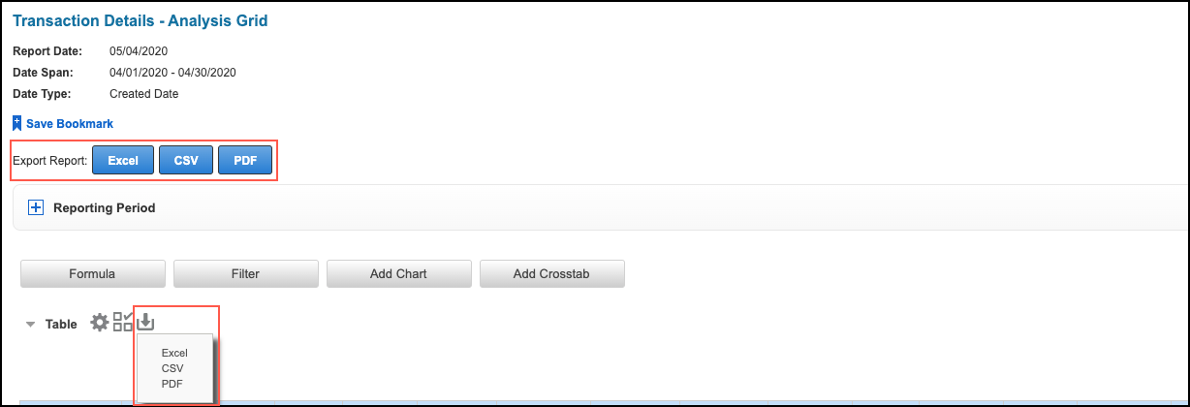

Formatted Reports:
All accounts receivable (AR) summary reports (Report Type = Accounts Receivable) are formatted reports. Formatted reports are printable and not designed to be manipulated in Excel.
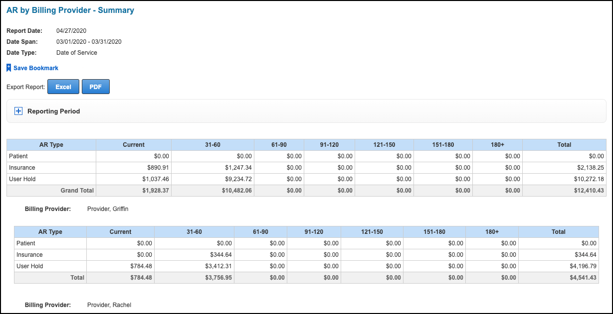

Reporting Period
- You can select a different Reporting Period and regenerate data.
  - Click to expand the Reporting Period section of the page.
  - Select the new Time Period or Start Date and End Date.
  - Click Generate Report.
- The reporting period is not required on the Reports home page for AR summary reports; therefore, if you do not select a reporting period on the home page, this option is not available on the selected report's page.
- Date Type remains the same as what was previously selected.

Data Tables:
Data tables are read-only, on-screen spreadsheets that can only be exported.
- Contain a limited number of columns so that they are printable.
- Have predetermined grouping and totaling (for example, charge amount).
For greater control over the data generated into a report, select the analysis grid equivalent of the report. For example, use the Transaction Details – Analysis Grid instead of the various transaction summary data tables.
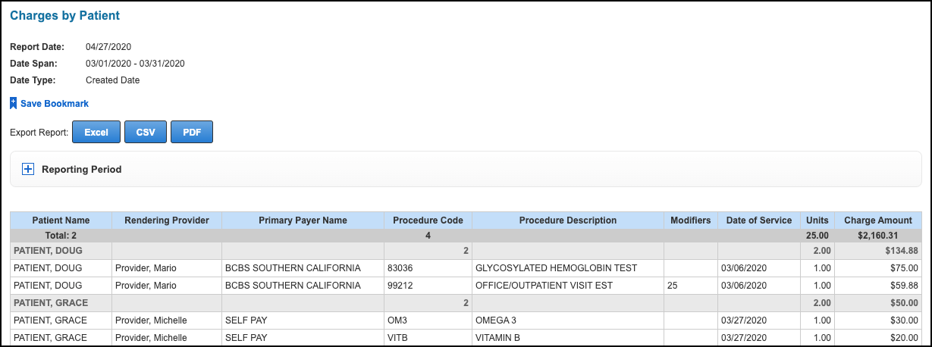

Reporting Period
- You can select a different Reporting Period and regenerate data.
- Click to expand the Reporting Period section of the page.
- Select the new Time Period or Start Date and End Date.
- Click Generate Report.
- Date Type remains the same as what was previously selected.

Analysis Grids:
The advantage of an analysis grid over a data table is the ability to manipulate the data to customize the reports.
- Analysis grids have more column options.
- Columns are movable.
- Includes tools to customize the data

Save Bookmark, Table Tools, and Export Options
For more information on exporting data, see Export Options and Notes.
- Save Bookmark: Click to save the report as a bookmark.
- Export Report: Click Excel, CSV, or PDF to export everything that is on the page (for example, table and chart). Use this option if you want to include graphics.
- : Shows or hides the basic table configuration options.
- : Adds a dashboard panel derived from table content.
- : Exports only the data table to an Excel, CSV, or PDF file. No graphics are exported.

Reporting Period
- You can select a different Reporting Period and regenerate data.
  - Click to expand the Reporting Period section of the page.
  - Select the new Time Period or Start Date and End Date.
  - Click Generate Report.
- Date Type remains the same as what was previously selected.
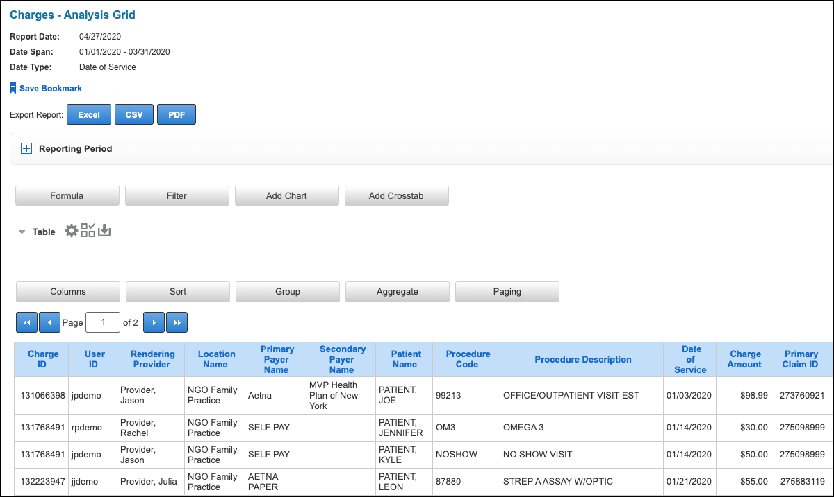

Table Configuration Tools
There are two sets of table configuration tools, enabling you to customize reports.

Basic Configuration Tools
Click to show the tools.
Option | Description
Column | Shows or hides columns.
Sort | Sorts the table.
Group | Organizes the rows by grouping columns
Aggregate | Calculates multiple data rows based on specific criteria to form a single value
Paging | Sets the number of rows that show per page

Advanced Configuration Tools
Option | Description
Formula | Adds columns using formulas
Filter | Filters the rows by the cell values
Add Chart | Creates a chart based on the report's data
Add Crosstab | Create a pivot table by pivoting columns of data into rows of data

Columns
When you click , Columns is selected by default.
- Select the check boxes for the table columns you want to show.
- Click OK.
Note: We have set default columns for each analysis grid. The default columns depend on which analysis grid you generate.
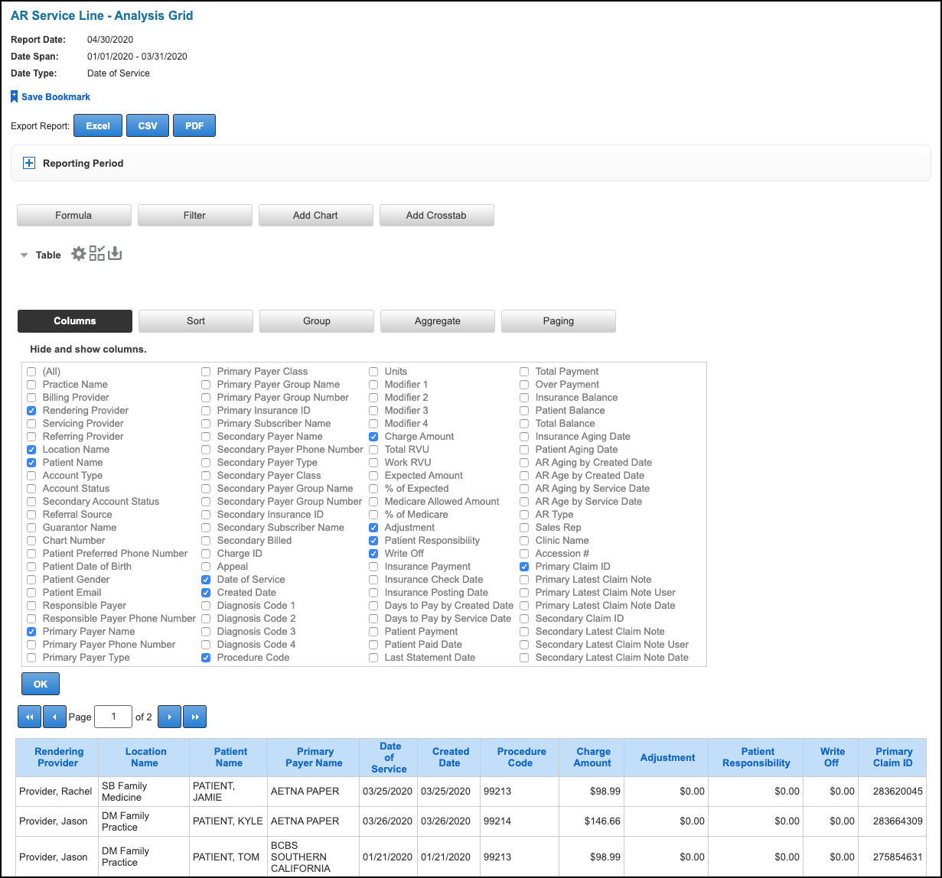

Sort
- Click Sort.
- Select the Data Column.
- Select the Order Direction.
- Click Add.
- To replace an existing sort with a new sort, click Replace instead of Add.
- To remove a sort, click Remove.
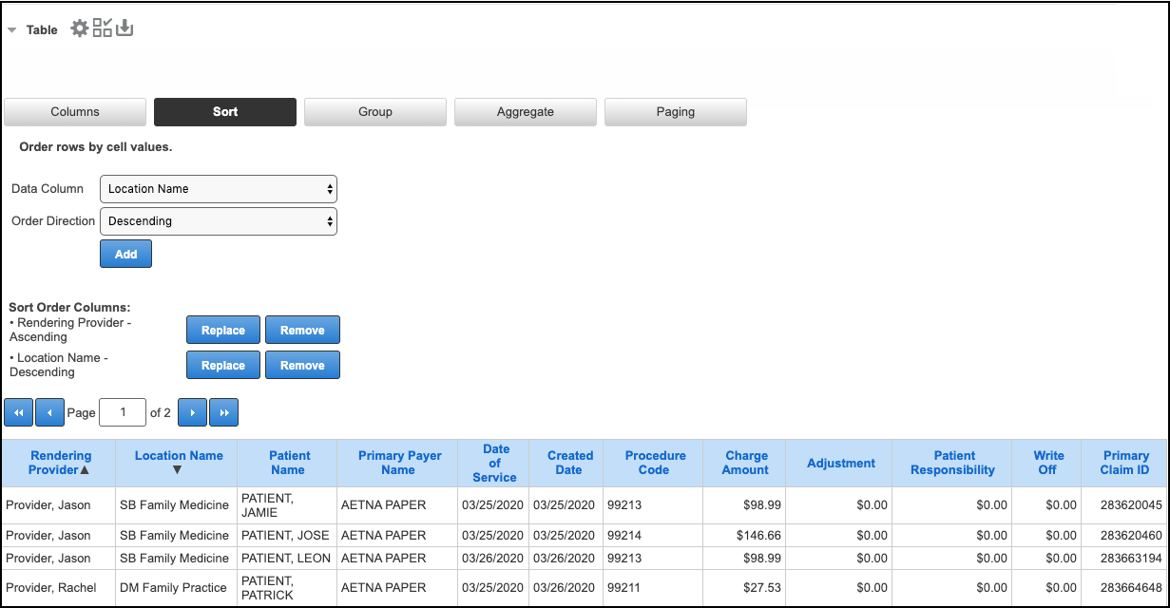

Group
- Click Group.
- Select the Grouping Column. In this example (Date of Service), select year, quarter, month, or day; else, it will group by day.
- Click Add.
- To replace an existing group with a new group, click Replace instead of Add.
- To remove a group, click Remove.
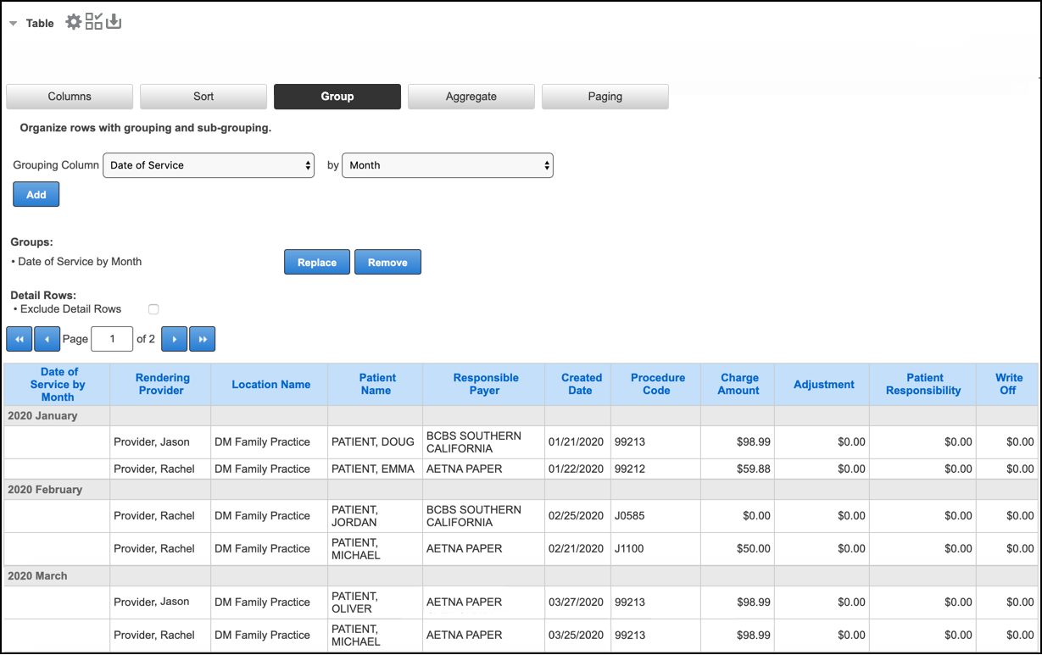

Aggregate
- Click Aggregate.
- Select the Data Column to calculate for.
- Select the Aggregate Function (calculation to perform). Depending on which data column is selected, the aggregate function options change.
- Select the Results Positioning (where the result shows). If you have more than one aggregate, the last position you selected applies.
- Click Add.
- To replace an existing aggregate with a new aggregate, click Replace instead of Add.
- To remove an aggregate, click Remove.
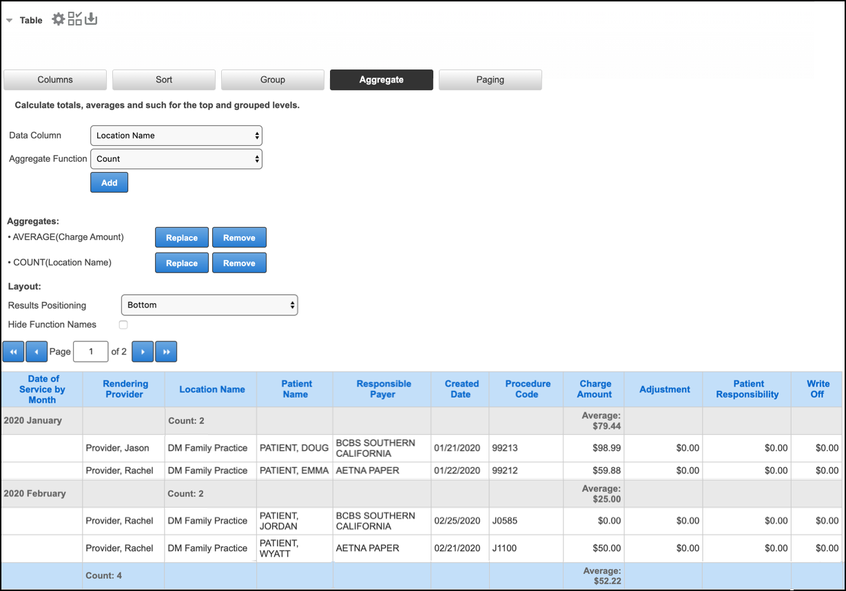

Paging
- Click Paging.
- Enter the number of Rows per Page to show.
- Click OK.
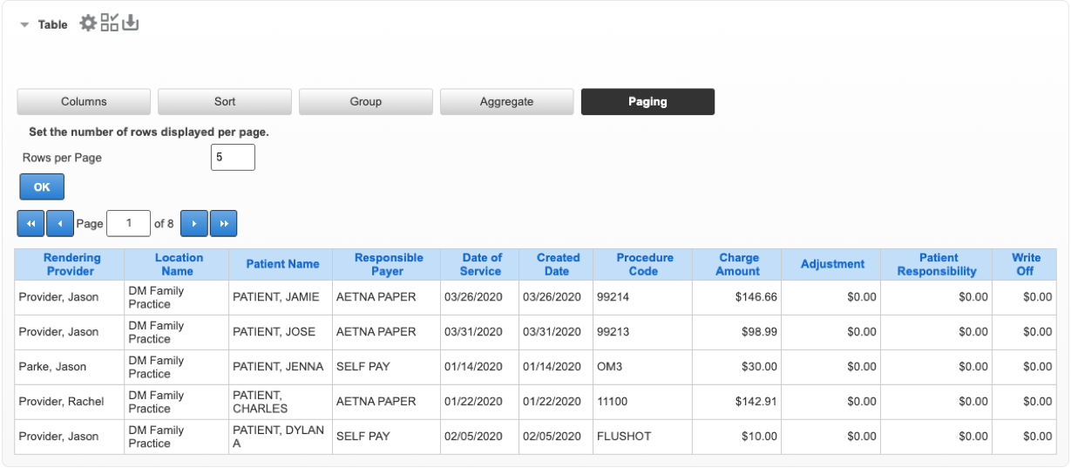

Column Heading Configuration and Formatting Options
There are a limited number of configuration options accessible from the column heading. Formatting options are only available here.
Note: For illustrative purposes, both the Aggregate and Format select menus are shown. They are normally shown individually upon selection.
- Click the column heading.
- Select an option from the pop-up menu.
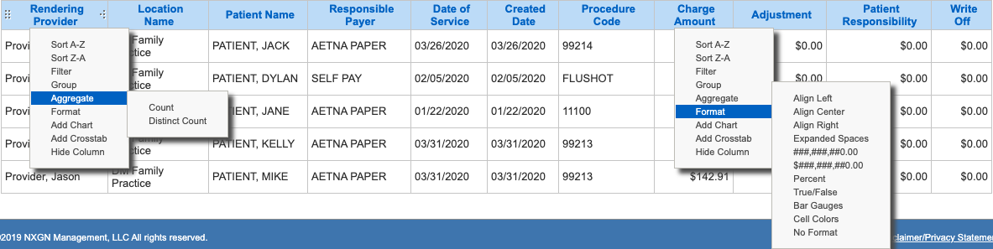

Formula
- Click Formula.
- Enter the column Name.
- From the Insert a column menu, select the individual column names that you want to enter into the formula and then click Insert.
- Enter mathematical symbols to complete the formula.
- Select the Data Type.
- Select the Data Format.
- Click Add.
The new column appears in the right-most column position.
- To replace an existing formula with a new formula, click Replace instead of Add.
- To remove a formula, click Remove.
Note: If you replace or remove a formula, the column is deleted from the report.
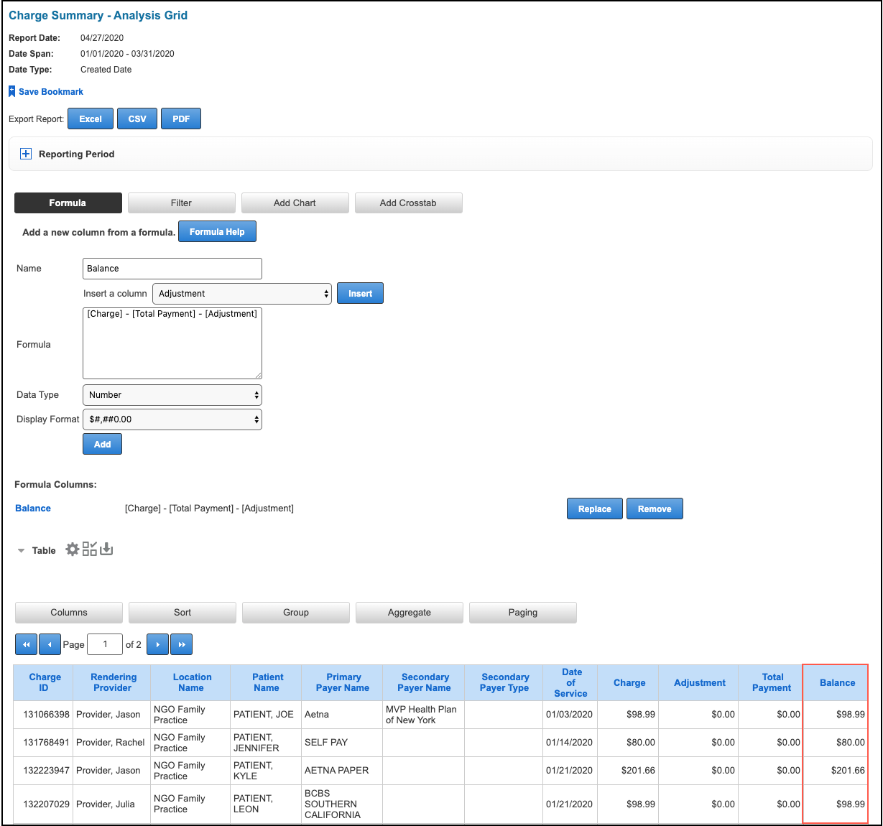

The new column also displays under Columns.
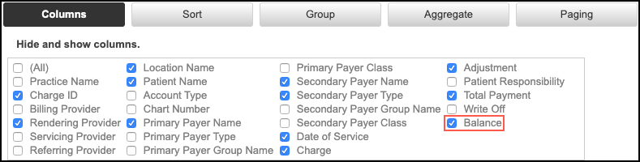

Filter
- Click Filter.
- Select the Filter Column.
- Select the Comparison.
- Select the Value.
- Click Add.
- : Shows applied filters.
- To switch the Add or Or to the filter equation, click the Add/Or toggle button.
- To replace an existing filter with a new filter, enter the new filter values and then click Replace instead of Add.
- To remove a filter, click Remove.
- If you have more than one filter, additional options appear.
- To reorder the filters, click the up and down arrows.
- To remove parentheses from, or add parentheses to, the filter equation, click the minus or plus icons.
- To remove all of the filters, click Remove All.
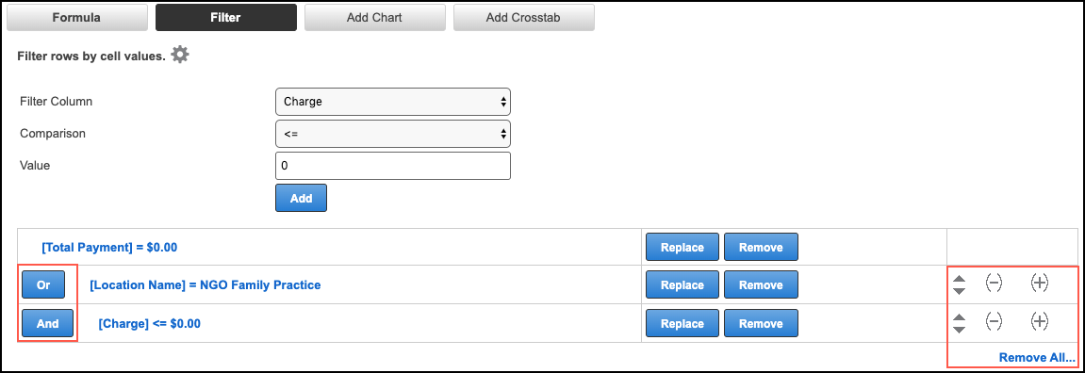

Add Chart
You can create (or edit) a chart based on the reporting data in the table.
- Click Add Chart.
- Click the desired chart type.
- Select the Label Column.
- Select the Data Column and select whether to show percentage or value.
- Select the Data Aggregation.
- Select the Relevance.
- Click OK.
- : Shows or hides the chart menu panel.
- : Adds a dashboard panel derived from the chart content.
- : Removes the chart.
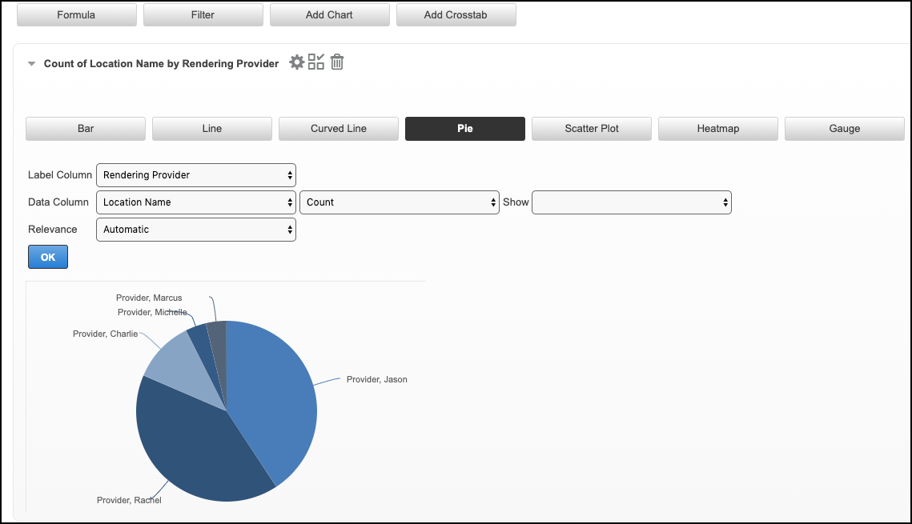

Add Crosstab
Like in a chart, you can create (or edit) a crosstab based on the reporting data that appears in the table.
- Click Add Crosstab.
- Sek the Header Values Column.
- Select the Label Values Column.
- Select the Aggregate Values Column.
- Select the Aggregate Function.
- Select the Summary Function.
- Click OK.
- : Shows or hides the crosstab menu panel.
- : Adds a dashboard panel derived from the crosstab content.
- : Exports the crosstab into an Excel or CSV file.
- : Removes the crosstab.
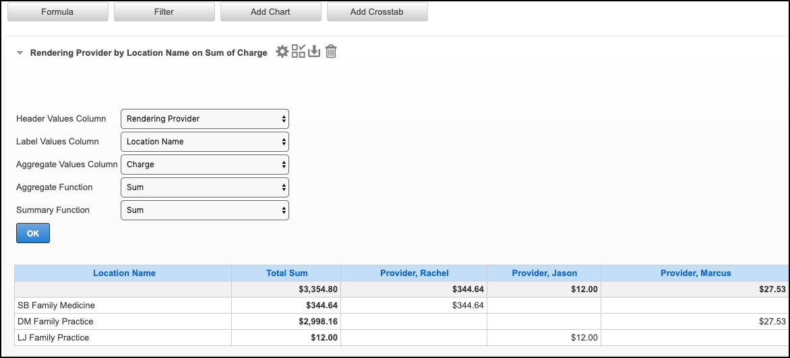

Post Payments:

The Center for Health and Wellbeing Credit Card Policy:

The Center for Health and wellbeing does not save credit card information for the safety and privacy of its patients.

Patient Payment: This page describes how to post a patient payment from a patient’s chart. Payment posting is the process of entering the payment into the system. After the payment is posted, the funds can be applied to charges on the patient’s ledger.
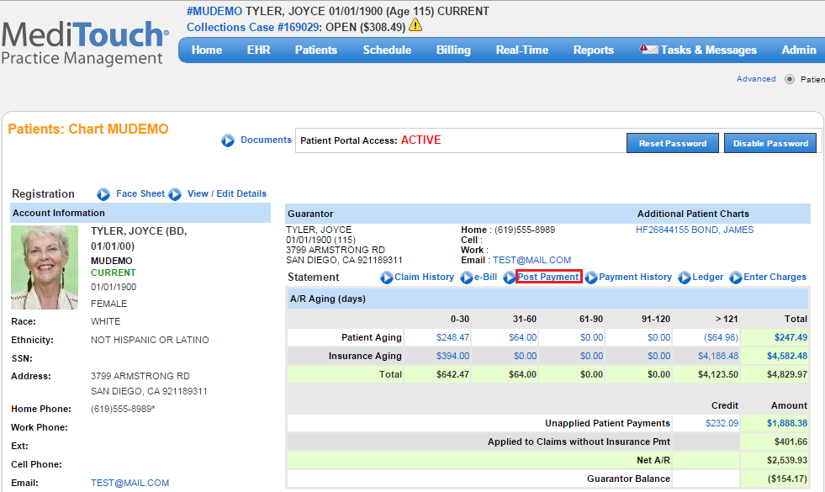
- Navigate to the patient’s chart.
- Click Post Payment.
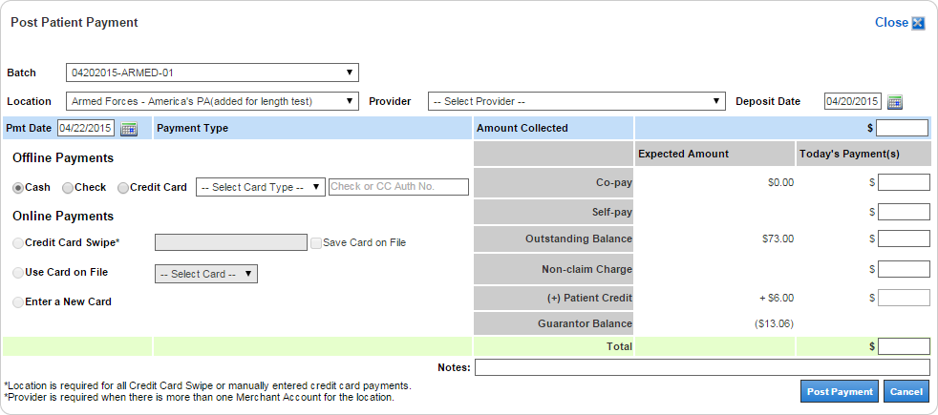
- Select Batch (optional). If the batch has a location and/or deposit date, they will be used to populate those fields.
Note: The batch’s location and deposit date overwrites anything that is currently in the Location and Deposit Date fields.
- Select Location and Provider (optional).
- Enter Deposit Date (optional). This defaults to today’s date and is used for payment search criteria and for deposit date custom reporting.
- Click Post Payment.
Post an Insurance Payment:
This page explains the steps involved in manually posting an insurance payment. Follow these steps whenever a paper check is received from an insurance company.
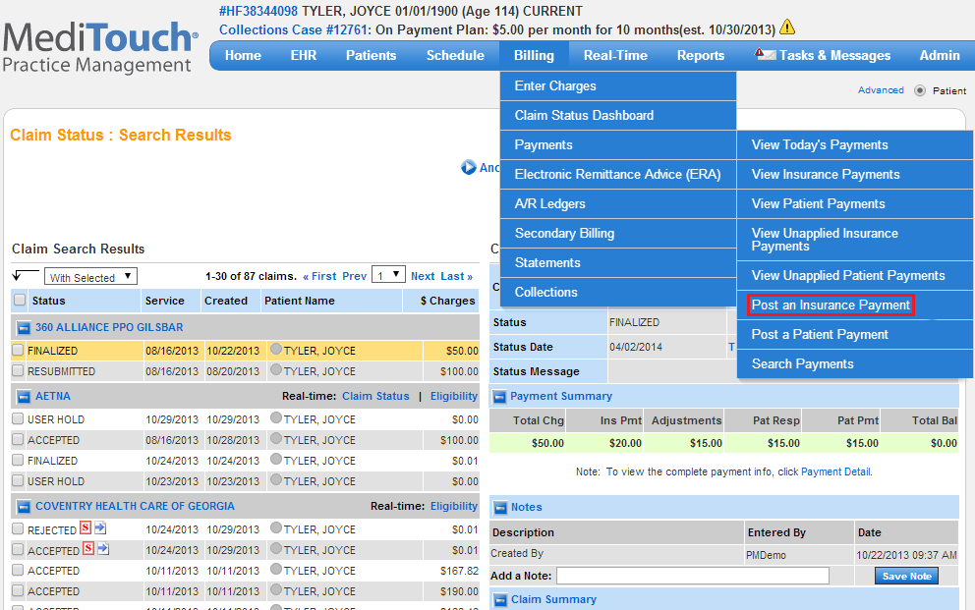
- Hover over Billing, select Payments, and then click Post an Insurance Payment.
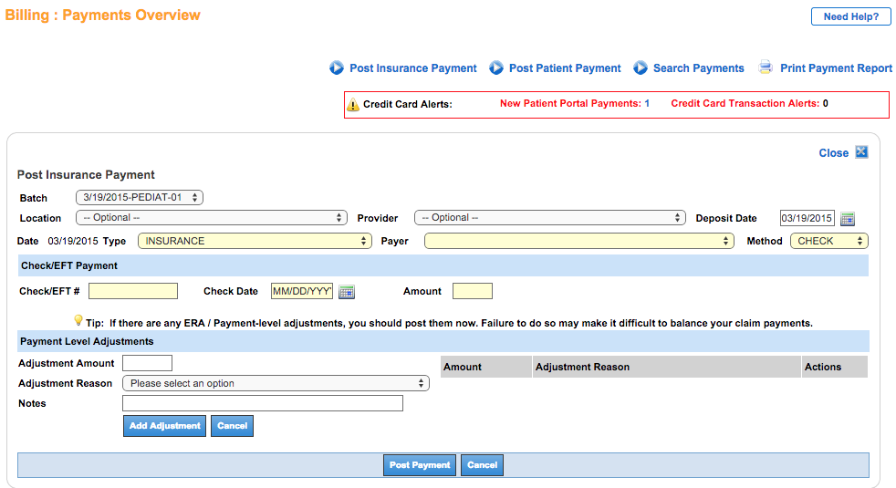
- Select Batch (optional). If the batch has a location and/or deposit date, they will be used to populate those fields. Note: The batch’s location and deposit date overwrites anything that is currently in the Location and Deposit Date fields.
- Select Location and Provider (optional).
- Enter Deposit Date (optional). This defaults to today’s date and is used for payment search criteria and for deposit date custom reporting.
- Select Type, Payer, and Method.
- Enter Check/EFT #, Check Date, and Amount.
- Enter Payment Level Adjustments (optional): Increase or decrease the paid amount at the check level. This option is used to change the unapplied balance. A negative adjustment decreases the balance (e.g., interest owed), while a positive adjustment increases the balance (e.g., overpayment recovery).
- Click Post Payment.

Payment Type
Offline Payments is used for posting payments collected outside of the MediTouch system. Offline payments include cash or check payments, and credit card payments collected via a third-party system.
Online Payments is used for posting payments collected using the MediTouch integrated credit card processing service.

Offline Payments
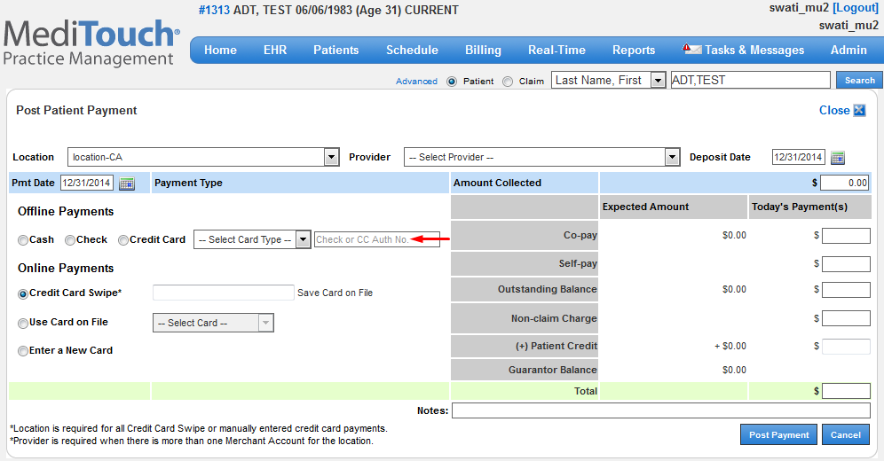
- Select the type of payment: Cash, Check, or Credit Card.
- If Check is selected, enter the check number.
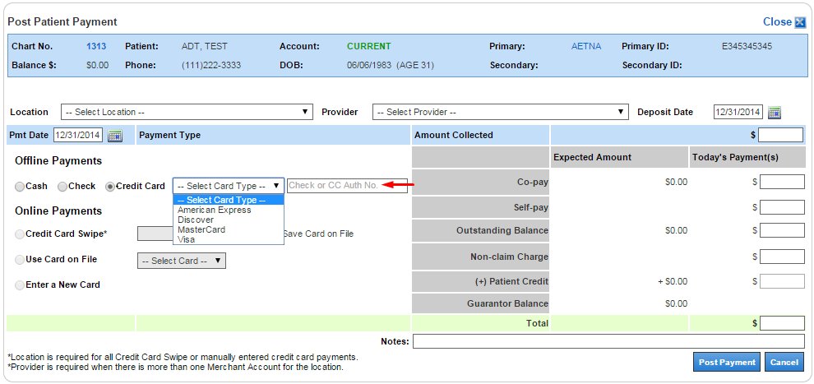
- If Credit Card is selected, select the Card Type from the menu.
- Enter the credit card authorization number.

Online Payments
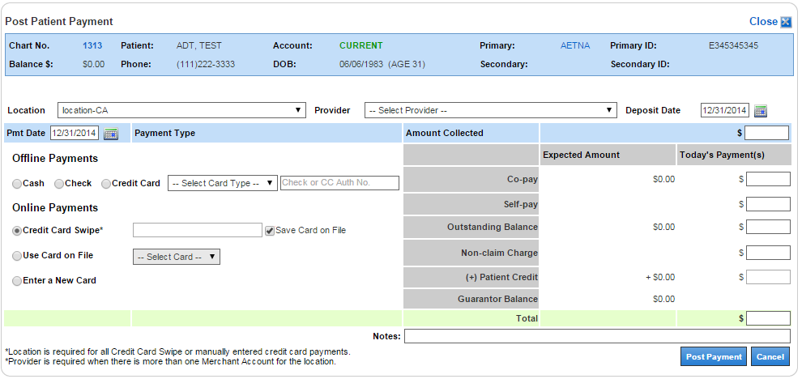
- Select the mode of processing:
  - Credit Card Swipe uses a USB card reader to record the card information for processing.
  - Use Card on File allows you to use a previously saved card for processing.
  - Enter a New Card allows you to enter new card information for processing.

Credit card swipe
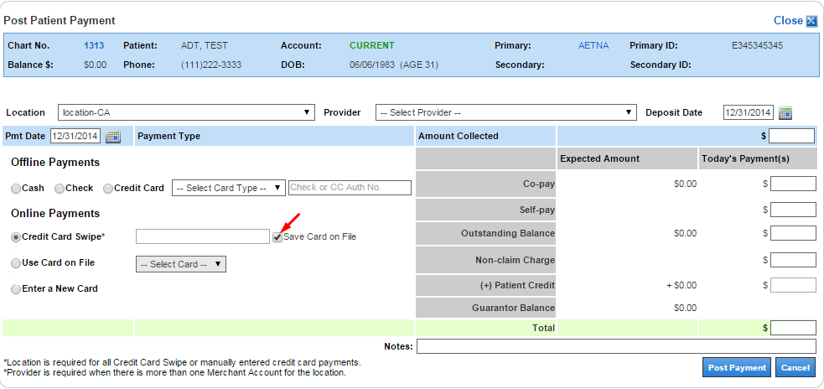
- If using a credit card swipe reader, select Credit Card Swipe and then swipe the card.
- To save the card for future use, select Save Card on File.

Use Card on File
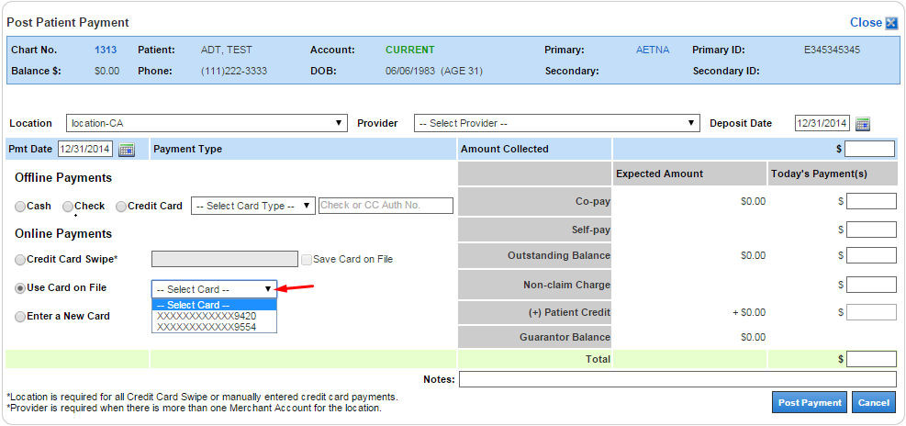
- To select from saved cards, select Use Card on File and select a card from the menu.
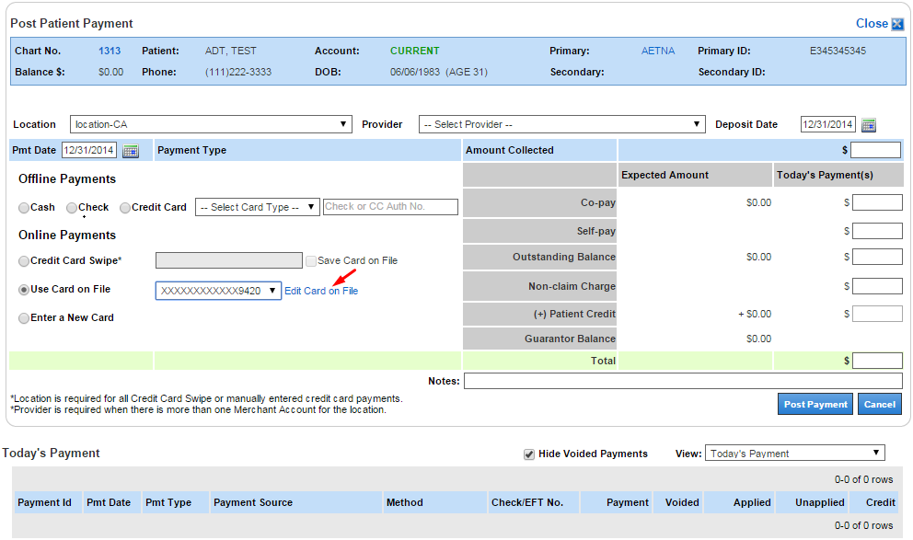
- To edit the selected card, click Edit Card on File.
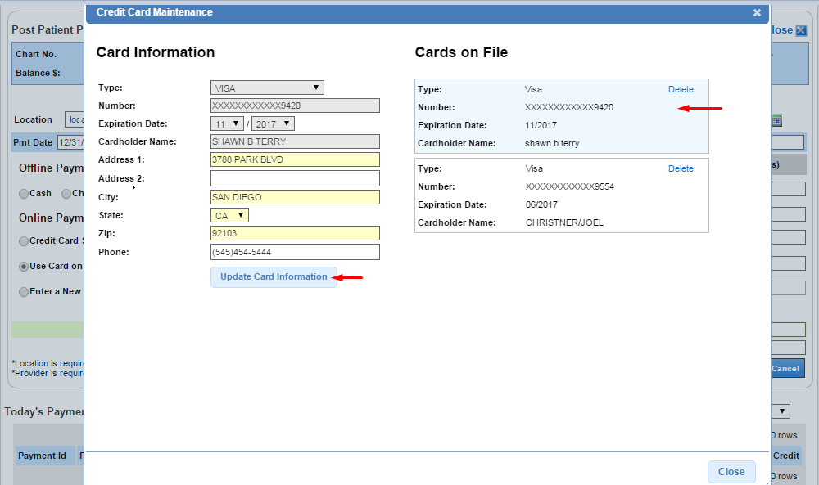
- On the right side, select the card on file you want to use.
- Information regarding the highlighted card is populated to the left side.
- Update the card information and then click Update Card Information.

Enter a New Card
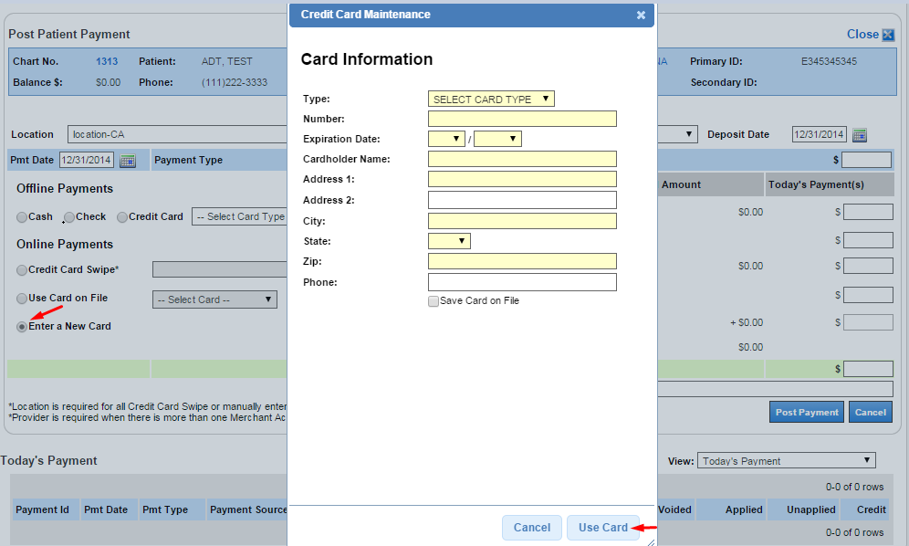
- To enter new card information, select Enter a New Card.
- Enter the new card information and then click Use Card.
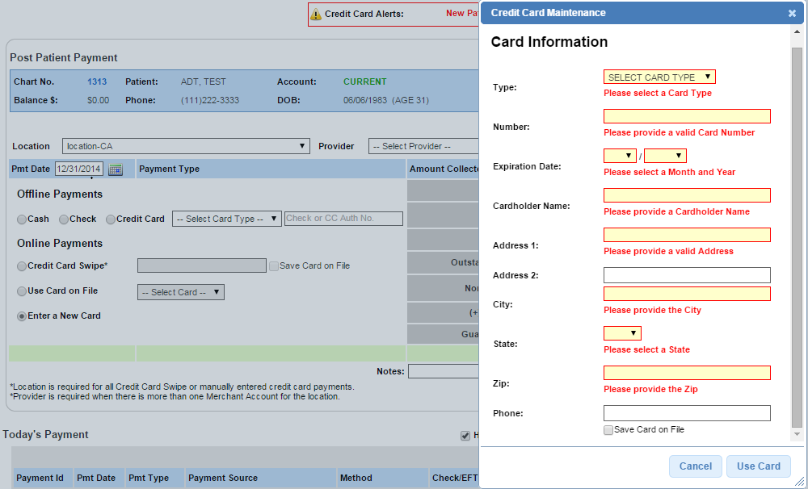
- When adding/editing card information, the required boxes appear red if left blank or if invalid information is provided.
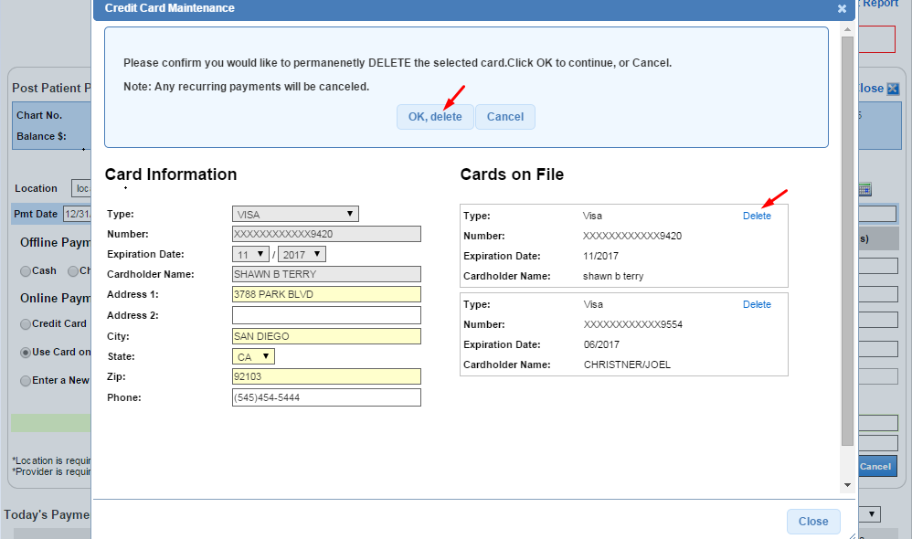
- To delete the selected card, click Delete.
- To confirm the deletion click OK, delete.

Enter Amount Collected
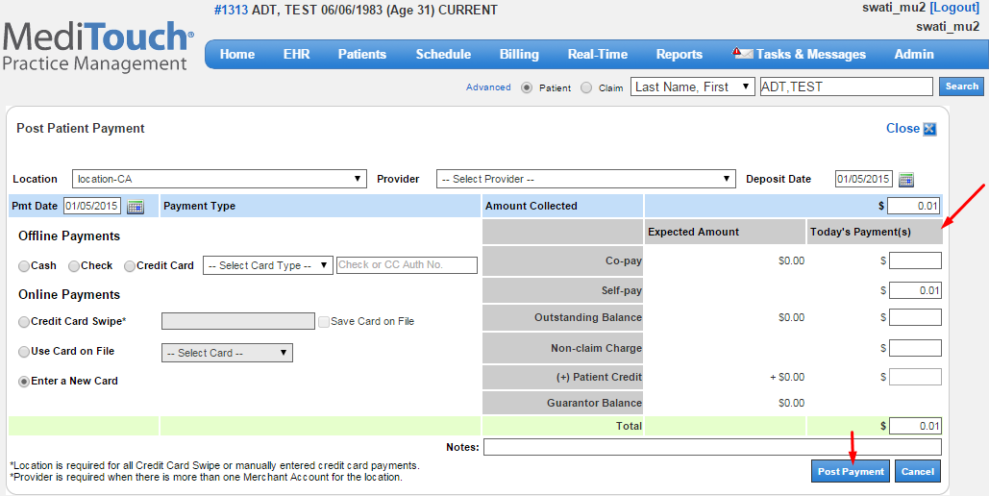
- Enter the amount collected.
- Disperse the amount collected to the applicable fields, e.g., Co-pay, Self-pay, Outstanding Balance, etc.
- Enter note (optional).
- Click Post Payment.

Autoapply Outstanding Balance
When a payment is dispersed to the Outstanding Balance field, the amount entered is automatically applied to the service line charges that make up that balance. Service lines are applied from oldest to newest. You have the option to accept this automatic application of funds or to post the payment without autoapplying.
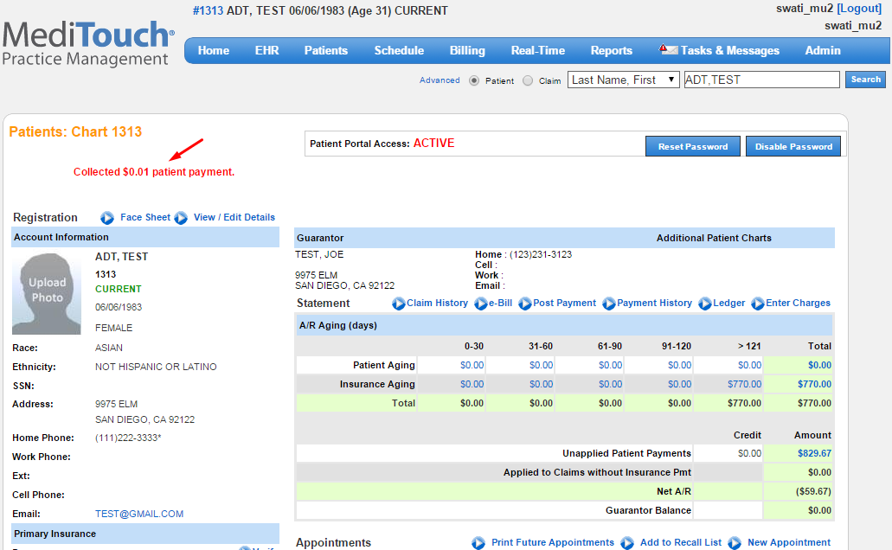
- After the payment is posted, it displays on the patient’s chart.

Billing codes/Fee schedule:
DSME: Diabetes Self-mangement Education(30min per unit)
- Induvidual appointment: G0108 | $55.33
- Group/Class: G0109 | $15.26
MNT: Medical Nutrition Therapy (15min per unit)
- Initial appointment: 97802 | $28.94
- Follow up appointment: 97803 | $24.71
- Group/Class: 97804 | $13.57
MDPP: Medicare Diabetes Prevention Program-Medicare only
- 1st session: G9873 | $26.00
- 4th session: G9874 |
- 9th session: G9875
- 5% goal: G9880
- Reporting session: G9891

Practice Management
- New Summary Applied Payment Report
- Added AR Balances Filter, Reporting Periods, and Responsible Payer to AR Analysis Grid Report
- Added AR Balances Filter to AR Summary Reports
- Added KPIs to Provider Month End Report

EHR Enhancements

New Wallboard Mode
Room Tracker is now available in a full-screen view called Wallboard Mode. Medical staff can quickly view patient and room statuses and wait times on a wall-mounted monitor or television. Wallboard Mode is view-only. The only action that can be performed in this view is selecting which columns to display. We recommend that you create a separate user dedicated to Wallboard Mode.

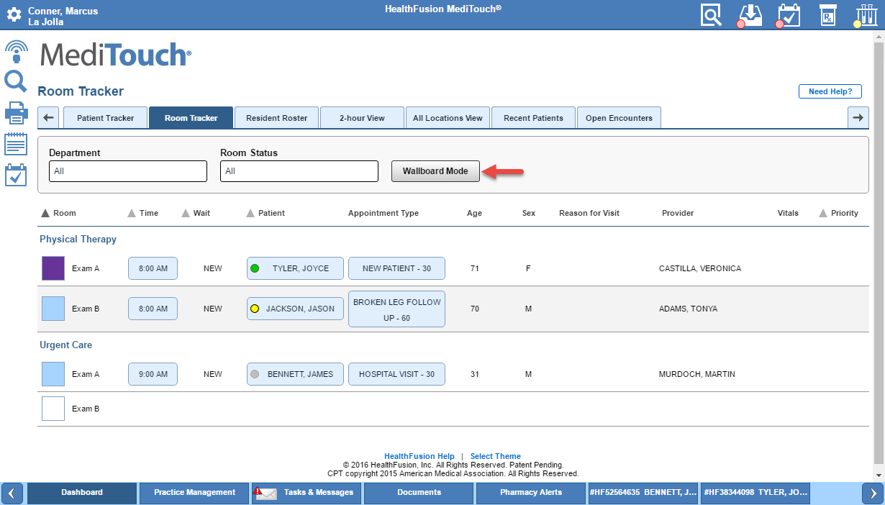

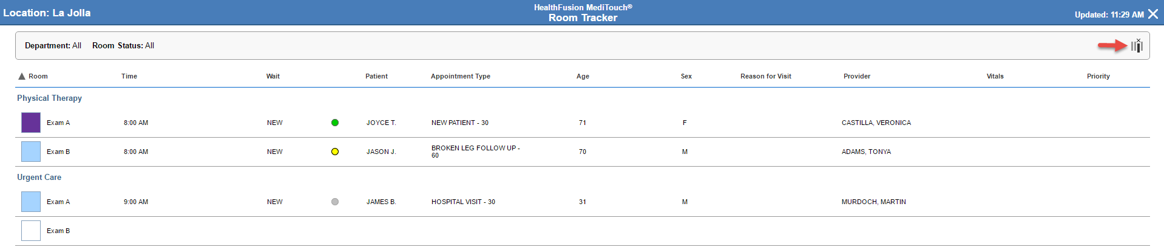

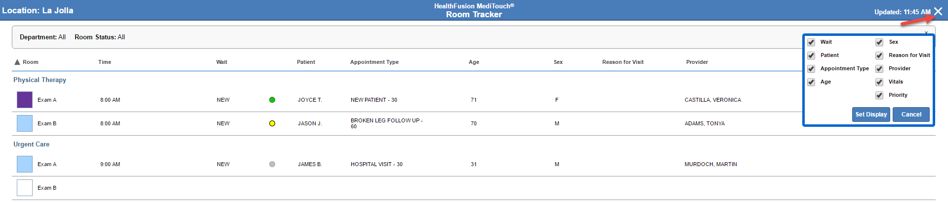

- From Room Tracker, click Wallboard Mode.
- Wallboard Mode displays. To select which columns to display in this view, click .
- Select the checkboxes for the columns you want to display (or deselect the checkboxes for the columns you do not want to display) and then click Set Display.
- To exit Wallboard Mode, click the X. Note: For security reasons, when you exit out of Wallboard Mode, you are also logged out of MediTouch.

Added Show/Hide Option for Pediatric Percentiles
On the Vital Signs page, we added the option to show or hide the percentiles for pediatric patients aged 0 to 20.
To hide percentiles for a pediatric patient, select the Suppress percentiles for this patient checkbox on the Vital Signs page. Percentiles will no longer display on the following pages/areas:
- Vital Signs page in the patient's chart
- Vital Signed section of the Encounter Summary Preview
- Vital Signs content block in the Document Library
- Vital Signs section of medical record in the Patient Portal
- Growth Chart submenu of Review Medical Record in the Patient Portal
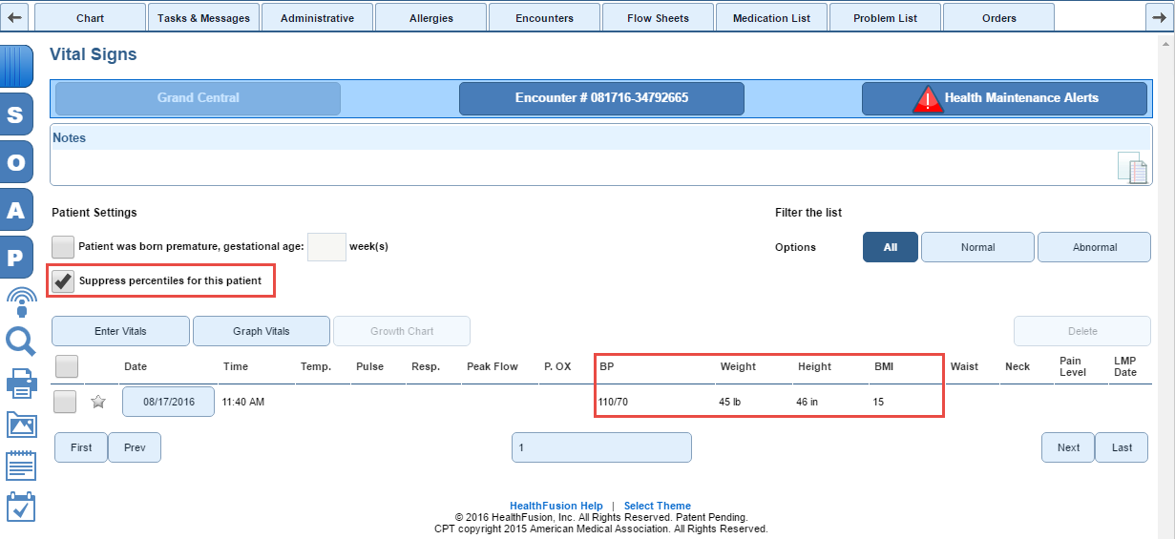

Updated Encounter Preview with Links to SOAP Pages, Create New Encounter Task, and Edit Patient Demographic Information
The Encounter Preview slide out panel now has links to the SOAP headers in the patient's encounter, enabling you chart more efficiently. To display the SOAP header link icons and the icon to create an encounter task, you must open an encounter.
Click to navigate to the respective page in the patient's encounter. In this example, we need to enter vital signs.
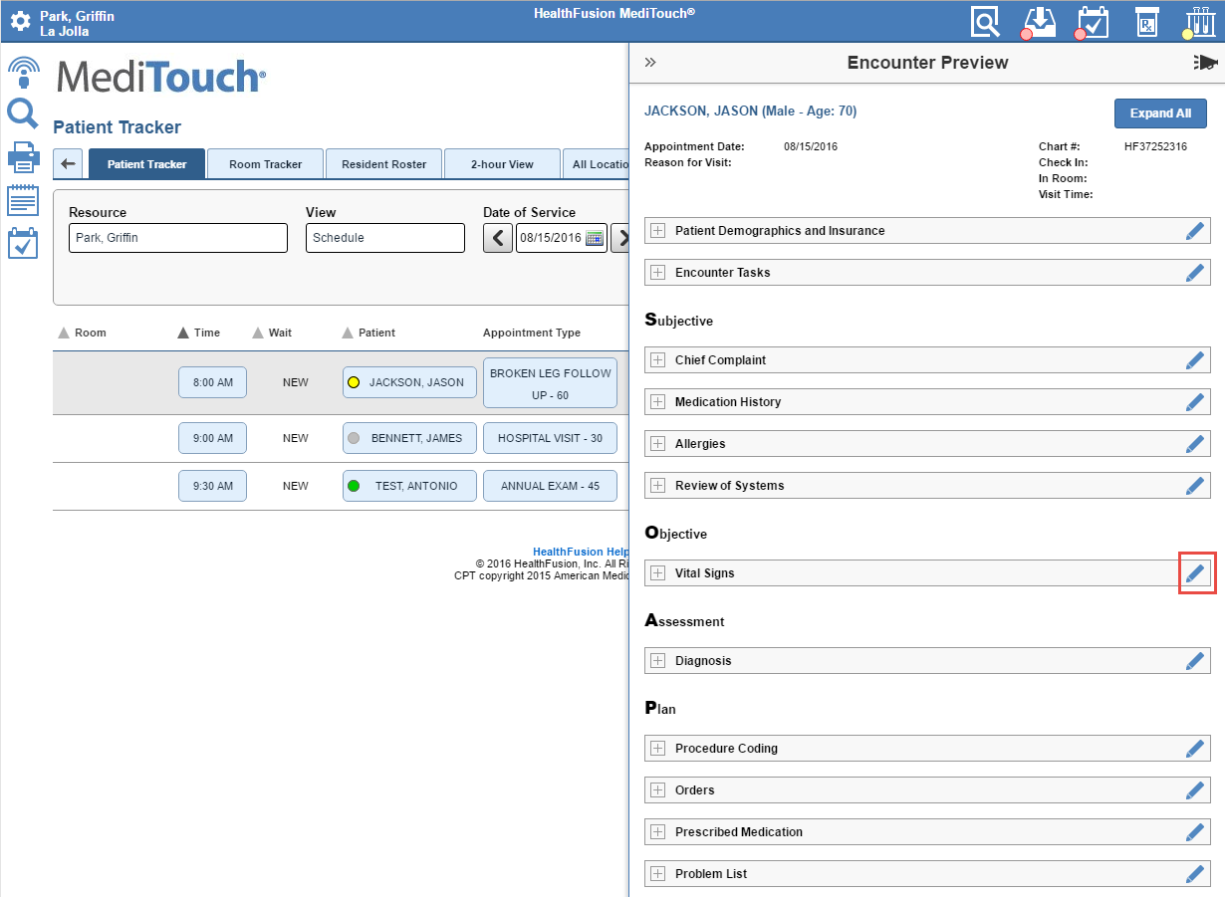

You are navigated to the Vital Signs page.
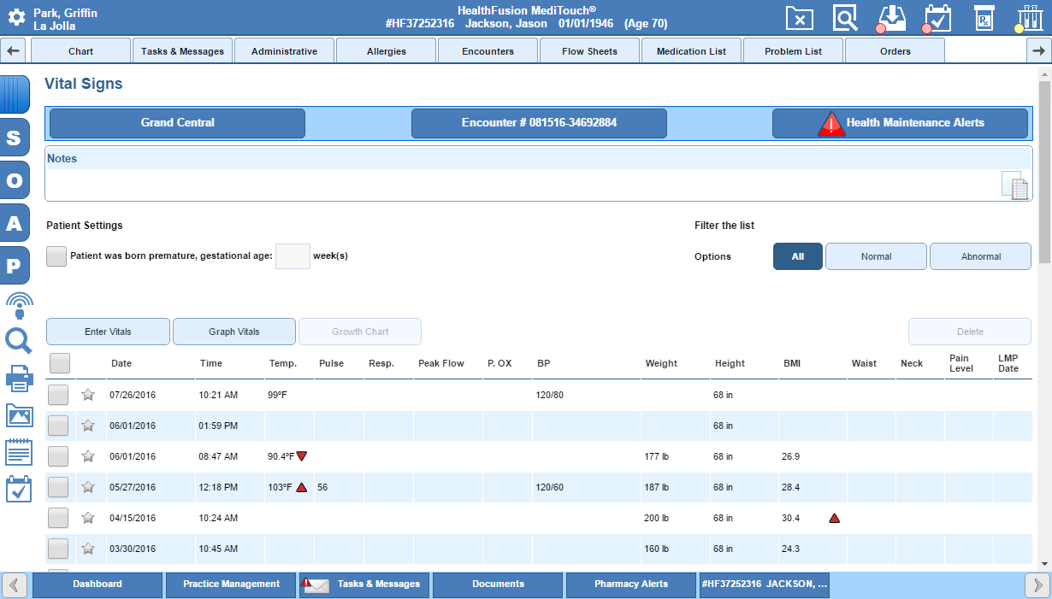

After the encounter is signed, no longer displays. If you reopen the encounter, the icon will display again. The ability to edit the patient demographic information in the patient's chart and create an encounter task are always available regardless of whether the encounter is signed.
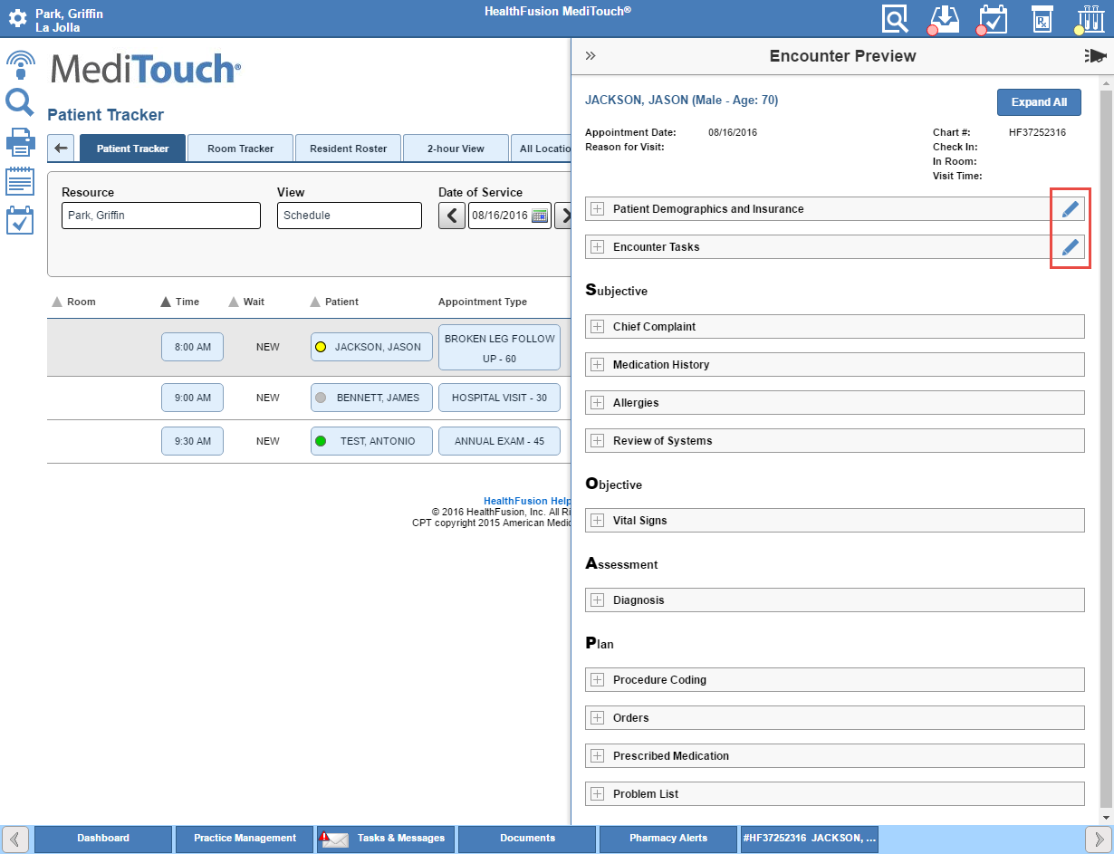

Practice Management Enhancements

New Summary Applied Payment Report
The Summary Applied Payment report analyzes summary applied payment information.
- Report Type: Production
- Report Name: Summary Applied Payment - Analysis Grid
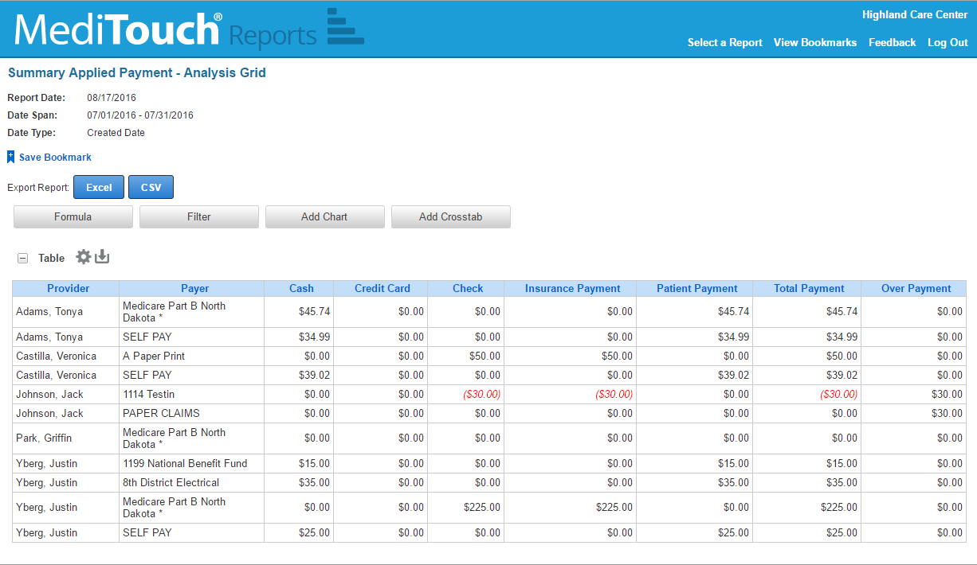

Added AR Balances Filter, Reporting Periods, and Responsible Payer to AR Analysis Grid Report
We made several updates to the AR Analysis Grid report. It now has the required AR Balances filter, which help users identify which the specific balances to follow up on and which recently posted items should be reviewed.
- All Open Balances: All charges where the charge-level insurance or patient balance is not equal to $0.00 (includes Open Insurance, Open Patient, and Patient Ledger Credits).
- Open Insurance Balance: The insurance balance at the charge level is not equal to $0.00.
- Open Patient Balance: The patient balance at the charge level is greater than $0.00.
- Patient Ledger Credits: The patient balance at the charge level is less than $0.00 and the insurance balance is $0.00 at the charge level.
- All $0.00 Balances: The charge-level insurance and patient balance = $0.00 (or total balance = $0.00)
- All Service Lines: All service lines are exported regardless of the balance.
The Reporting Period is no longer required and now has three new options: insurance paid date, patient aging date, and patient paid date.
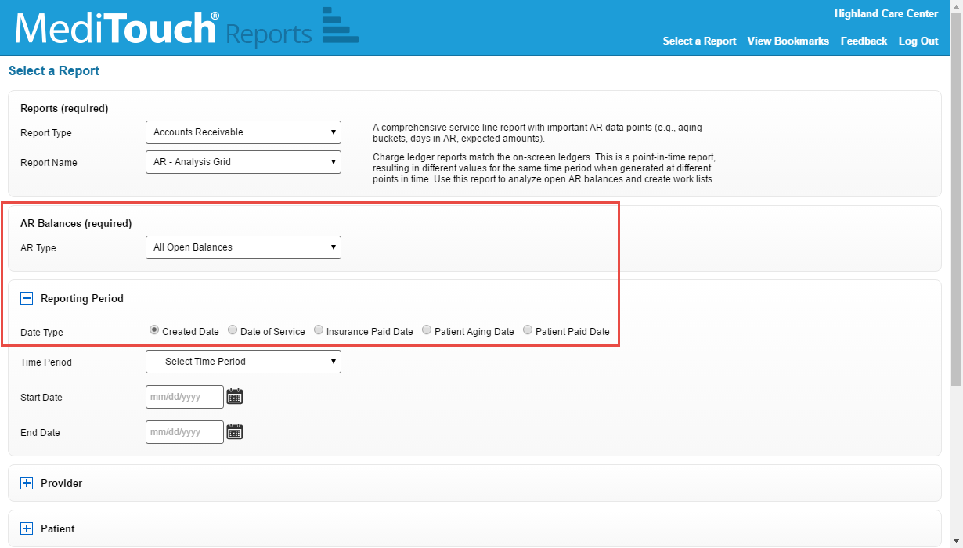

Responsible Payer is added to the table by default. This column indicates which payer is responsible for the outstanding balance (primary or secondary payer). You can also choose to display the responsible payer's phone number (click to select the columns to enable). The responsible payer is the secondary payer if the secondary payer has been billed; else, the responsible payer is the primary payer.
The Primary Payer Name, Secondary Payer Name, and Secondary Billed columns have been selected to display in the example below to illustrate the logic.
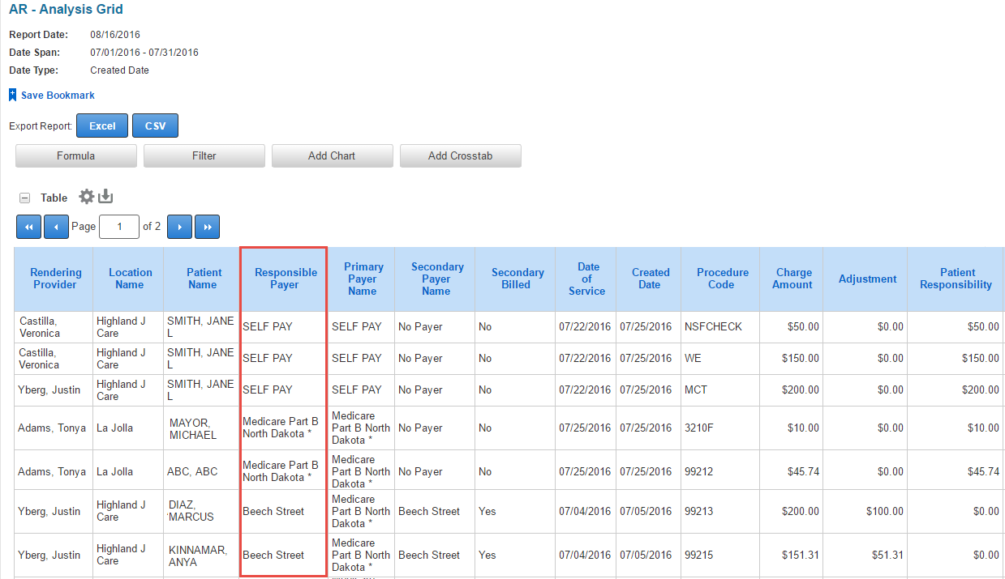

Added AR Balances Filter to AR Summary Reports
AR Summary reports now have the required AR Balances filter with these options: all open balances (default), open insurance balance, open patient balance, and patient ledger credits.
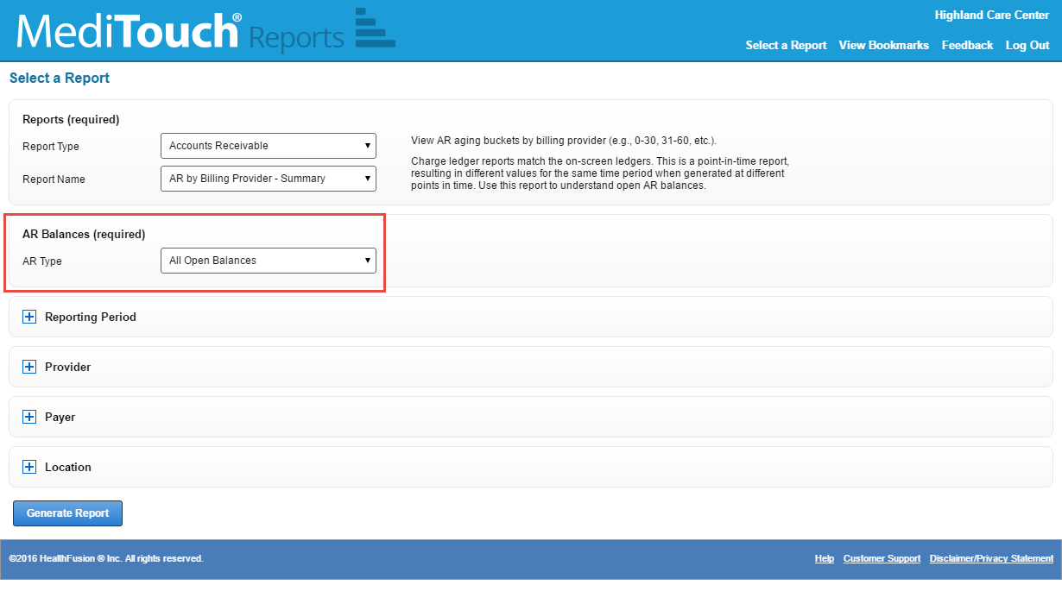

Added KPIs to Provider Month End Report
We added the following key performance indicators (KPIs) to the Provider Month End Report:
- % of AR > 120 Days
- Days to Pay
- Patient Days to Pay
- Primary Insurance Days to Pay
- Secondary Insurance Days to Pay
- Total Claims
- Primary Insurance Claim Count
- Secondary Insurance Claim Count
- Primary Insurance Resubmitted Claim Count
- Secondary Insurance Resubmitted Claim Count
- Primary Insurance Resubmitted Claim %
- Secondary Insurance Resubmitted Claim %

Application Known Issues / Limitations
- No known issues at this time.

