  - APPLICATION:
Muscle and Motion
  - Document Release Date: <Release Date>
Reviewed Date: February 10, 2021
Approved Date: March 10, 2021
Version: 1.0

Table of Contents

Application Overview 2
Usage 2
Application Details and Ownership 2
Access 3
Permissions and Login 3
How to change your password 3
User Guide 4
Introduction 5
Purpose 5
Application Known Issues / Limitations 5

Application Overview
Muscle & Motion is a muscular anatomy index that allows for the visual display of various exercises and anatomical positions.

Usage
Sun Health uses this software for something that will be explained here

Application Details and Ownership
Application Manager: Alex Stark
Vendor: Muscle & Motion
Vendor POC Name: N/A
Vendor POC Contact Information: info@muscleandmotion.com
License Type: Annual Subcription
Subject matter expert(S): Alex Stark
Current Release of Software: 1.5.0.68
Application Location: Online/Cloud

Access

Permissions and Login
Sun Health has 1 subscription to Muscle & Motion. To request access contact SME for log in details
Application login is accessed via the url:
https://www.muscleandmotion.com/log-in_page_strength_training/

How to change your password
Password can be changed when logged in by visiting the my profile section
and selecting the change/forgot password or by selecting change/forgot password below login input.
Once selected a reset code will be sent to the Application manager which can be used to change the password by filling in the passcode and new password
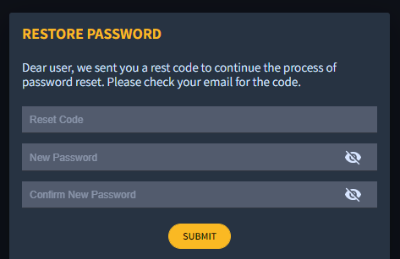
Please ensure that the Application Manager is aware of any password changes to ensure streamline access.
The password requires at least one capital when changing.

User Guide
Once logged in, the Muscle & Motion program contains various images and videos which can be accessed to help educated patients and members.
The contents can be browsed via the side tab
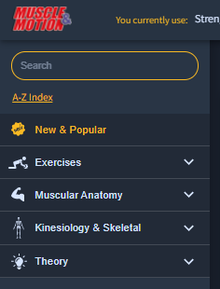
By selecting categories on the side bar more option will become available to filter content or direct search with the search bar above.
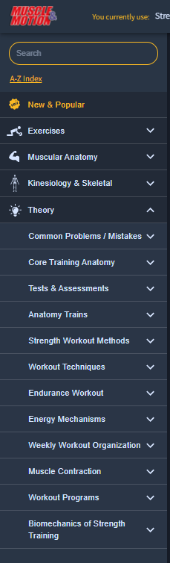
Introduction – Muscle & Motion is a muscular anatomy index that allows for the visual display of various exercises and anatomical positions. It can be used to display exercises and anatomical positions for both appointments and presentations.
Purpose- Sun Health uses this program as a resource in the Center for Health and Wellbeing and as a resource in Community Education Lectures.

Application Known Issues / Limitations
Muscle and motion is more easily navigated from the App available on both Android and iOS but can be accessed via PC and Mac all from the link provided under Permissions and Login.

