  - APPLICATION:
  - ZOOM
  - Document Release Date: October 1st, 2020
Reviewed Date: October 1st, 2020
(Q1&Q3 fiscal years)
Approved Date: October 14th, 2020
Version: V1.0

Table of Contents
Application Overview 5
Usage 5
Application Details and Ownership 5
Access 6
Permissions and Login 6
How to change your password 7
How to access a zoom meeting 8
Access from an Android Tablet or Phone 8
Access from a computer without client: 8
Downloading client for easier regular use 9
Access from an iPad or iPhone 9
Access from a Workstation Windows or MAC 10
Access from Workstation Linux 11
Modifications 12
Branding 12
For Meetings: 12
Title 12
Banner 12
Logo 13
Speaker information 13
Theme 14
Post webinar survey 14
Social media share description 14
Changing the language of the registration page 15
Overview of Zoom Profiles 15
Profile settings 15
User Guide 16
Introduction 16
Purpose 16
Zoom Resources for Users and Meeting Hosts 17
Integrations 26
Inputs 27
Polling 27
Breakout Rooms 31
Options for breakout rooms 32
Assigning participants to rooms 33
Preparing breakout rooms 33
Managing breakout rooms in progress 34
Responding to requests for help 35
Broadcasting a message to all breakout rooms 36
Controlling and disabling in-meeting chat 37
Controlling chat access 37
Disabling in-meeting chat 39
Muting and unmuting participants in a meeting 40
Mute All Participants 40
Ask All to Unmute 41
Enabling pre-approved consent to unmute 42
Account pre-approved consent to unmute feature for all users in account 42
Group pre-approved consent to unmute feature for all members of group 42
User pre-approved consent to unmute feature for your own use 42
Pre-approved consent to unmute 43
Revoking consent to be unmuted 44
Sharing your screen 45
Sharing your screen or content 46
Share screen menu 47
Showing Zoom windows during screen share 48
Using dual monitors while sharing screen 49
Using the whiteboard in Zoom Rooms for Touch 50
Starting a whiteboard session and using whiteboard controls 50
Using drawing tools (free-form and smart-recognition drawing) 51
Inviting participants to a whiteboard session 53
Saving a whiteboard session 56
Restrict sending whiteboard to internal users (admin) 57
Using annotation tools on a shared screen or whiteboard 58
Enabling annotation for meetings 58
Enabling annotation for all users in account 58
Enabling annotation for Group User 59
Enabling annotation for your own use (User) 59
Using annotation tools 59
Accessing annotation tools if you are viewing a shared screen 60
Annotation tools 60
Annotation settings 61
Annotation shortcuts 61
Requesting or giving remote control 62
Requesting remote control 62
Giving remote control 63
Virtual Background 63
Enabling Virtual Background 64
Group Virtual Background feature 65
User Virtual Background feature 66
Admin management of virtual backgrounds 67
Using Virtual Background 68
Enabling Virtual Background during a meeting 70
Troubleshooting Virtual Background issues 70
Outputs: 71
Generating Meeting Reports for Registration and Polling Webinar Reporting 72
Webinar Reporting Instructions 74
Dual monitors with slide show and presenter's views 76
Application Known Issues / Limitations 78
In-meeting security options 78
Scheduling a Zoom Meeting 79

Application Overview
Zoom is a LogMeIn product for Video Conferencing and Webinars.

Usage
Sun Health uses this software for internal and external meetings including presentations, trainings, fund raising functions, training recordings, Sun Health Board & Committee Meetings, and Webinar Session Recordings.

Application Details and Ownership
Application Manager: Gayle Korn
Vendor: LogMeIn
Vendor POC Name: Elda Peters
Vendor POC Contact Information: elda.peters@zoom.us
License Type: Basis, Licensed, Webinar 500, and Zoom Rooms
Subject matter expert(S): Gayle Korn, Montina Crosby, Alex Stark
Current Release of Software: 5.1.3
Application Location: SAS application available at www.zoom.us

Access

Permissions and Login
For Zoom Meetings: A Zoom License is not required to join a Zoom Meeting.
If you are a user: Your permissions will vary depending on the security settings by the host.
Permissions include:
- Turn camera and microphone on and off
- Chatting with others or the host
- Annotate a shared screen
- Leave Meeting
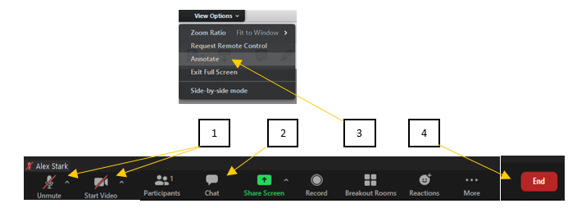
If you are a host:
As the host you can control the permission of those that will be attending the meeting or presentation, with many of these options available during the meeting.
- Turn camera and microphone on and off
- Chatting with others and change chat settings
- Adjusting permissions of attendees
  - Share Screen
  - Rename
  - Unmute
  - Chat
- End/Leave Meeting
  - (alternative host will be needed if leaving without ending)
- Create Room Breakout Sessions
- Enable Waiting Room or Lock Meeting
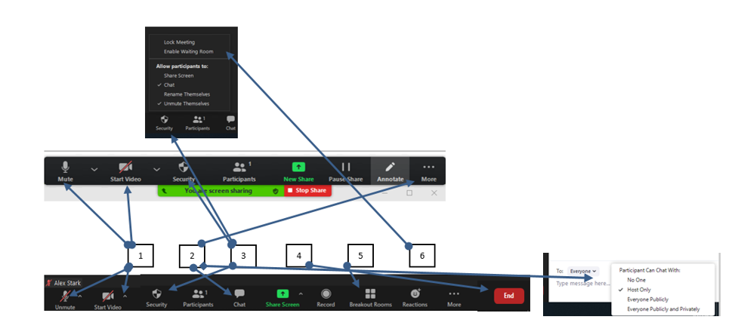
Zoom Basic License – for joining and scheduling meetings under 40 minutes and with up to 10 attendee is free and can be download via www.zoom.us
Zoom Client – for joining and scheduling Zoom meetings requires the Basic License and can be downloaded once a meeting invite is generated from a meeting host/organizer.
Zoom License (Pro Class) – allows for up to 10 schedulers, unlimited meeting time, and 300 attendees
Zoom Webinar – allows for Host, multiple co-hosts, panelists, Registrations process, and attendee reporting with up to 500 attendees.
The Zoom License download is by invitation only once a CAR form is approved and submitted. Once the Zoom License is purchased, user will receive an email invitation to download the client.
User should contact the Sun Health Service Desk to request the Microsoft Outlook Plugin for Zoom to enable Zoom / Outlook integration and simplify the scheduling of Zoom Meetings.
User should reach out to a Zoom SME for a scheduled training session.

How to change your password
- Go to Zoom.us/forgot_password.
- Enter your Email address. Click Send.
- You will receive an email with a link to reset your password.
- Enter your new password.
- Enter in the new password a second time for confirmation. Click Save.
- You have now reset your password and should be logged into the Zoom web portal.

How to access a zoom meeting

Access from an Android Tablet or Phone
- Open the Zoom mobile app. If you have not downloaded the Zoom mobile app yet, you can download it from the Google Play Store.
- Tap Join a Meeting
- Enter the meeting ID number and your display name
- Select join audio in order hear presentation and tap Join Meeting.

Access from a computer without client:
- Open Web Browser and go to Join.Zoom.us
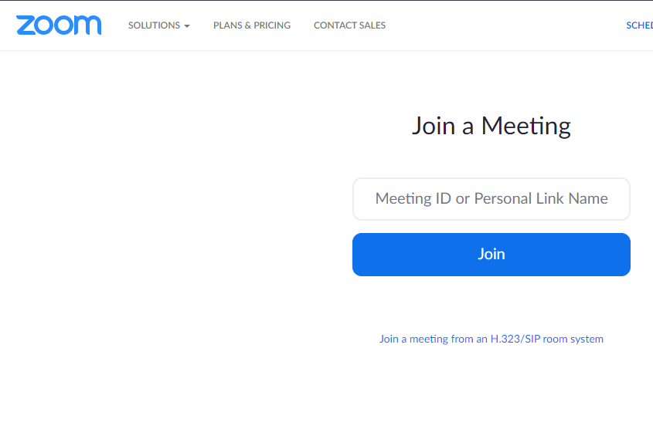
- provided Meeting Id Followed by the password if given
- If you have received a direct link or email, click Join and the scheduled time.
- Select Join audio in order hear presentation

Downloading client for easier regular use
- Open Web Browser and go to www.Zoom.us/download
- Download “Zoom Client for Meetings”
- Open Zoom App after download
- Click Join
- Enter display name and provided Meeting Id Followed by the password if given
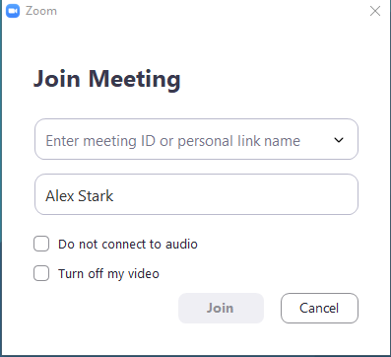
- If you have received a direct link or email, click Join and the scheduled time.
Select join audio in order hear presentation

Access from an iPad or iPhone
- Open the Zoom mobile app. If you have not downloaded the Zoom mobile app yet, you can download it from the App Store.
- Tap Join a Meeting
- Enter the meeting ID number and your display name
- Select join audio in order hear presentation and tap Join Meeting. 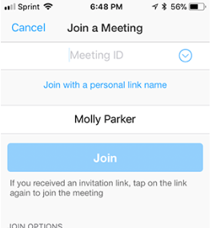

Access from a Workstation Windows or MAC
- Open the Zoom desktop client
- Join a meeting using one of these methods:
- Click Join a Meeting if you want to join without signing in.
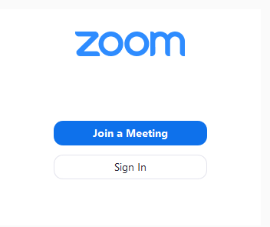
- Sign in to Zoom then click Join
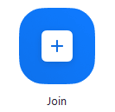

- Enter the meeting ID number and your display name.
- If you are signed in, change your name if you do not want your default name to appear.
- If you are not signed in, enter a display name.

Access from Workstation Linux
- Open the Zoom desktop client.
- Join a meeting using one of these methods:
- Click Join a Meeting if you want to join without signing in
- Sign in to Zoom then click Join.

- Enter the meeting ID number and name.
  - If you are signed in, change your name if you do not want your default name to appear.
  - If you are not signed in, enter a display name.
- Select if you would like to connect audio and/ or video and click Join.
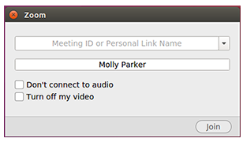

Modifications

Branding

For Meetings:
For Webinars: You can customize your webinar registration page with a color scheme, title, banner, logo, and speaker information, including descriptions and profile pictures for up to three speakers. The speaker information is also included in the webinar invitation email and webinar attendee confirmation email.
You can also designate a post attendee URL that users will be redirected to from the Zoom launcher page and customize the social media description that will be included when your registration link is shared on Facebook or LinkedIn.
Users can customize these settings when you schedule a webinar that requires registration. Admins can customize account-level webinar branding settings. Admins can also customize webinar email settings.

Title
By default, the title for your webinar registration is Webinar Registration. Click Edit to change the webinar title, then click Save.

Banner
You can add a banner which will be displayed at the top of your invitation page. It needs to meet the following requirements:
Format: GIF, JPG/JPEG, or 24-bit PNG (alpha/transparency allowed)
Dimensions: 640px by 200px (suggested), 1280px by 400px (maximum)
Maximum file size: 1024KB
In the Banner section, click Upload.
Locate and select a banner image on your computer.
It will automatically upload and appear on the registration page. If it does not, please ensure that it meets the requirements.

Logo
You can add a logo which will be displayed on the right side of your registration page. It needs to meet the following requirements:

Format: GIF, JPG/JPEG, or 24-bit PNG (alpha/transparency allowed)
Dimensions: 640px by 200px (suggested), 1280px by 400px (maximum)
Maximum file size: 1024KB
In the Logo section, click Upload.
Locate and select the logo on your computer.
It will automatically upload and appear on the registration page. If it does not, please ensure that it meets the requirements.

Speaker information
In the Speakers section, click Add a speaker.
Click Upload, navigate to portrait of the speaker, and click Open to upload the image.
Enter the speaker’s full name, title, organization, and a biography of up to 400 characters.
Click Save.
If you want to add more speakers, click Add another speaker, then repeat steps 1-4.
You can information for up to 3 speakers. If you already have 3 speakers listed, the Add another speaker link does not display.
The webinar invitation email and webinar attendee confirmation email also include information about the speakers.
Note: If your account administrator has edited the Invite Attendee Email template or the Registrants Confirmation Email template on the Webinar Settings page, the speaker information is not included in these emails. To show the speaker information in these emails, the administrator must edit these email templates and use the Restore button.

Theme
In the Theme section, click Change Theme.
Choose one of the predefined themes or click Custom to create a theme with your own colors.
If you click Custom, the Change Theme dialog opens, where you can use the color controller to choose your own colors for the Background, Header Text, and Button Color.
Click Save.
Post attendee URL
Attendees who access the webinar from the join link and do not close the launcher window will be redirected to the post attendee URL after 10 minutes. These instructions explain how to set the post attendee URL for an individual webinar. You can also designate a post attendee URL for all webinars or all meetings on your account. Learn more.
In the Post Attendee URL section, click Edit.
Enter the URL that you want attendees redirected to.
Click Save.

Post webinar survey
The Post Webinar Survey field allows you to set a URL that opens in a new browser window or tab in for attendees at the end of the webinar.
Toggle the Post Webinar Survey option to on (blue).
Enter the URL of your survey or the page that you would like to open at the end.
Click Save.

Social media share description
In the Social Media Share Description section, click Edit.
Customize your social media share description:
Enter the description that you would like to be included when the webinar is shared on Facebook or LinkedIn.
Check if you would like the banner to be included on Facebook or LinkedIn.
Click Save.

Changing the language of the registration page
The webinar registration page will be shown in the language of the registrant's Zoom profile, if available. Otherwise, the page will be shown in the language of the user's browser/operating system. Learn how to change your language on the Zoom website.

Overview of Zoom Profiles
Your Zoom profile allows you to update your user information, including your name, personal meeting ID, email address, and more. Some of this information is displayed to other users in the account, such as your name, department, and job title.
Note: Some settings can only be changed by an account owner or admin.

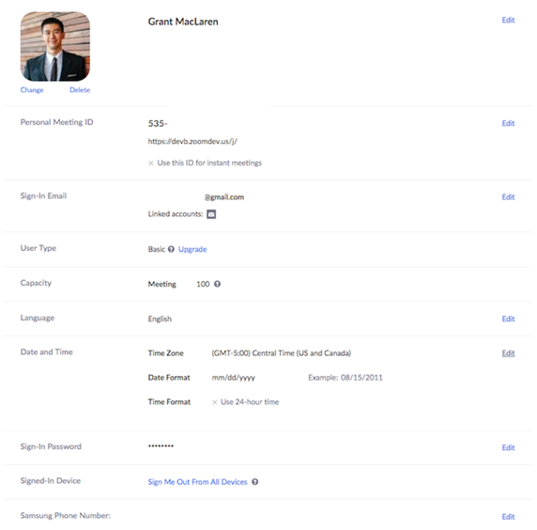
Profile settings
To access your Zoom profile, sign into the Zoom web portal and click Profile. You can view and edit the following settings:

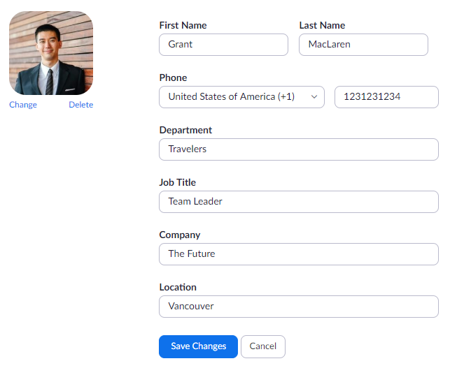
Profile Picture: To add or change your profile picture, click Change, then adjust the crop area on your current picture or upload a new one. You can also delete your profile picture by clicking Delete.
Name: To change your name, click Edit on the right side. You can also add other profile information including Department, Job Title, Company, and Location.

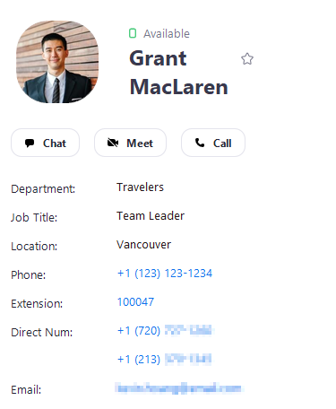
Your profile picture, name, phone, department, job title, and location are displayed to other users when they hover over your profile picture in the Zoom desktop client. Here is an example of the profile information other users see:

User Guide
This will be where we can create the quick notes or provide links to videos, screenshots, or other resources to help learn basic usage of above software or application.
Break down of Application Modules: This will capture each of the applications modules and give explanation of how each module is utilized.
Introduction
Zoom provides videotelephony and online chat services through a cloud-based peer-to-peer software platform and is used for teleconferencing, telecommuting, distance education, and social relations.
Purpose
To enable all users access to the Zoom Application in a consistent manner. To coordinate the communication of updates for Zoom practices, procedures, security, and or utilization.

Zoom Resources for Users and Meeting Hosts
Go to www.zoom.usa
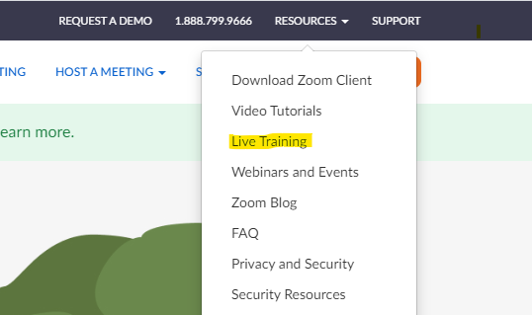
On the landing page Click “Resources” link located in the upper right-hand corner then click “Live Training”

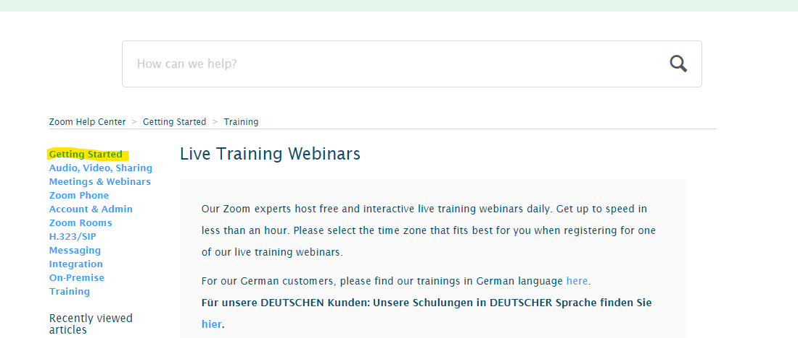
On the left-hand side of the “Live Training Webinars” screen are links to various training options click “Getting Started”

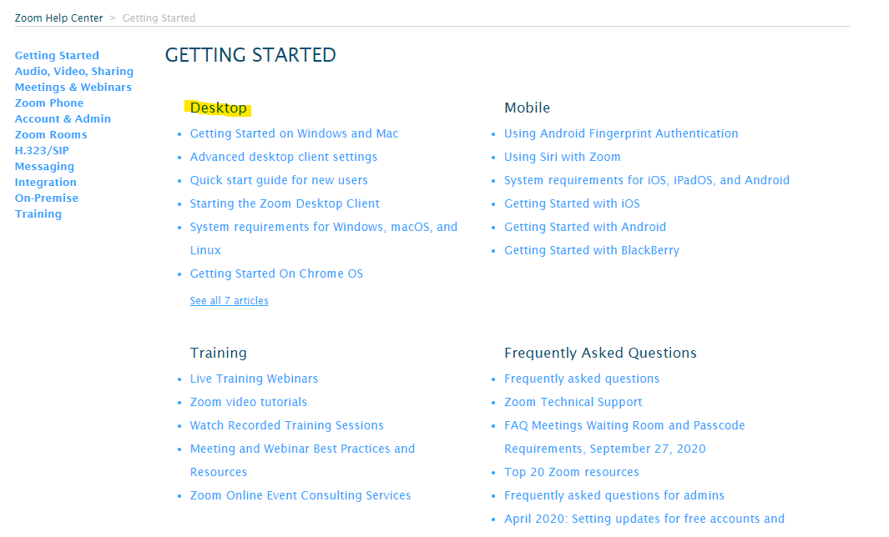
On the “Getting Started” page go to “Desktop” section of the screen

Resource modules a “User” or “Staff/Presenters/Meeting Host” should view
Users
- Getting Started on Windows and Mac
Staff/Presenters/Meeting Host
- Advanced desktop client settings
- Quick start guide for new users
- Starting the Zoom Desktop Client
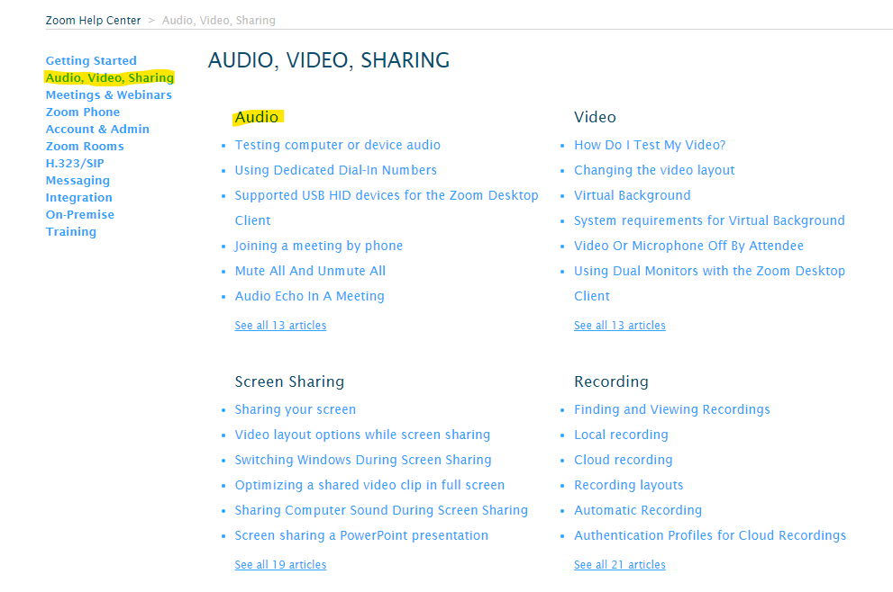
On the left-hand side of the screen are links to various training options click “Audio, Video, Sharing” go to “Audio” section of the screen

Resource modules a “User” or “Staff/Presenters/Meeting Hosts” should view
Users
- Testing computer or device audio
- Using Dedicated Dial-In Numbers
- Joining a meeting by phone
- Using telephone call-out
- Push to Talk
- Audio settings for iOS
Staff/Presenters/Meeting Hosts
- Mute All and Unmute All
- Audio Echo in A Meeting
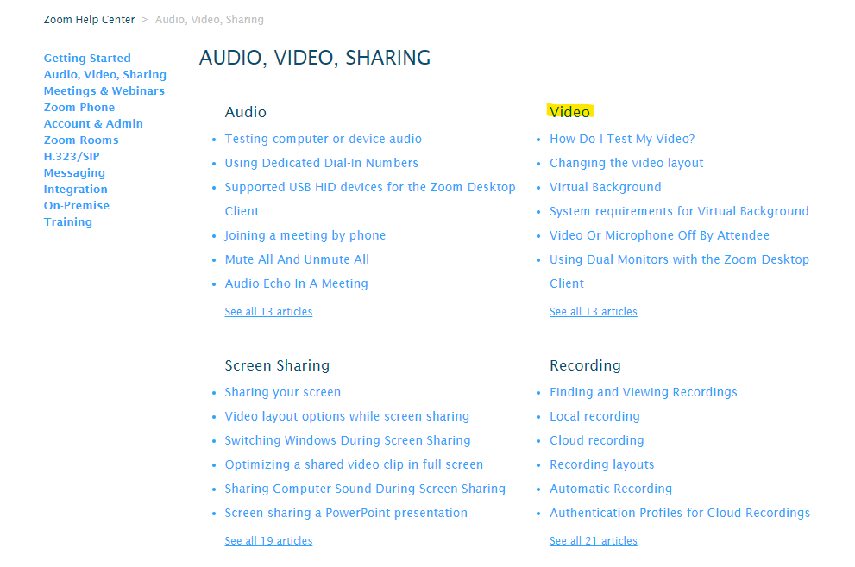
On the “Audio, Video, Sharing” page go to “Video” section of the screen

Resource modules a “User” or “Staff/Presenters/Meeting Hosts” should view
Users
- How Do I Test My Video?
- Changing the video layout
- Virtual Background
- Video Or Microphone Off By Attendee
- Active Speaker (Video Layout)
- Supported virtual cameras for macOS
- Camera Video is Unavailable on Mac running 10.7
Staff/Presenters/Meeting Hosts
- Using Dual Monitors with the Zoom Desktop Client
- Pin Video
- Active Speaker (Video Layout)
- Supported virtual cameras for macOS
- Camera Video is Unavailable on Mac running 10.7

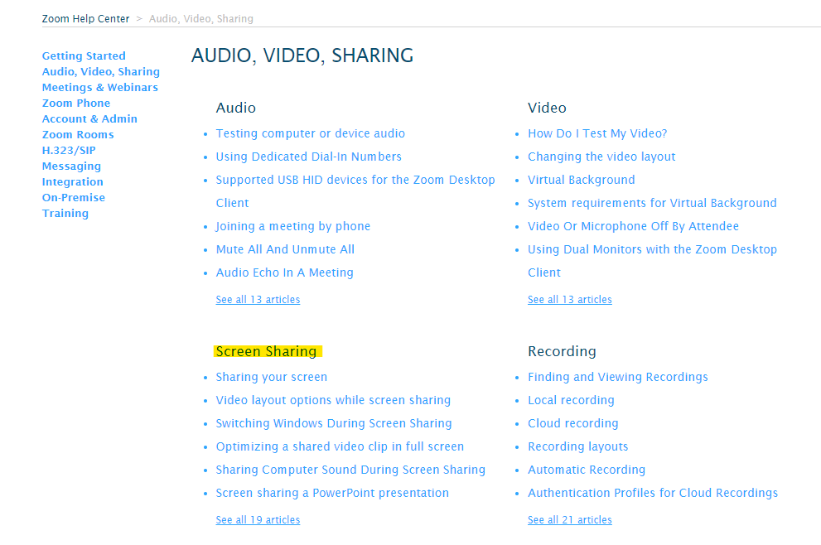
On the “Audio, Video, Sharing” page go to “Screen Sharing” section of the screen

Resource modules a “User” or “Staff/Presenters/Meeting Hosts” should view
Users
- N/A

Staff/Presenters/Meeting Hosts
- Sharing your screen
- Video layout options while screen sharing
- Switching Windows During Screen Sharing
- Optimizing a shared video clip in full screen
- Sharing Computer Sound During Screen Sharing
- Screen sharing a PowerPoint presentation
- Screen Share A Keynote Presentation
- Requesting or giving remote control
- Sharing a whiteboard
- Side-by-side Mode for screen sharing
- Sharing multiple screens simultaneously
- Using annotation tools on a shared screen or whiteboard
- iOS Screen Sharing
- Sharing your screen (iOS) with the Zoom Desktop Client
- Share an iOS Device Screen Using a Cable
- Adding a Watermark
- Follow presenter’s pointer during screen sharing
- Black Screen During Screen Sharing
- Protocols for iOS Airplay Screen Sharing

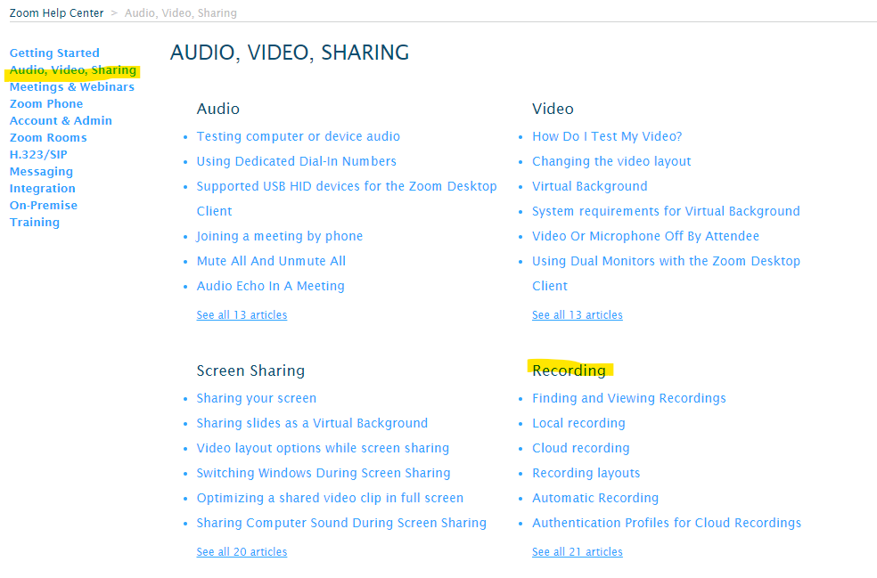
On the “Audio, Video, Sharing”, page go to “Recording” section of the screen

Resource modules a “User” or “Staff/Presenters/Meeting Hosts” should view
Users
- N/A

Staff/Presenters/Meeting Hosts
- Finding and viewing recordings
- Local recording
- Cloud recording
- Recording layouts
- Enabling the recording disclaimer
- Frequently asked questions about local and cloud recording
- Managing cloud recordings
- Recording on iOS and Android
- Using audio transcription for cloud recordings
- Recording Good Quality Audio to Ensure Accurate Transcripts
- Cloud Recording Playback
- Recover a Deleted Cloud Recording
- Sharing a Local Recording
- Recording Formats
- Windows 7 Media Player Cannot Play Recording

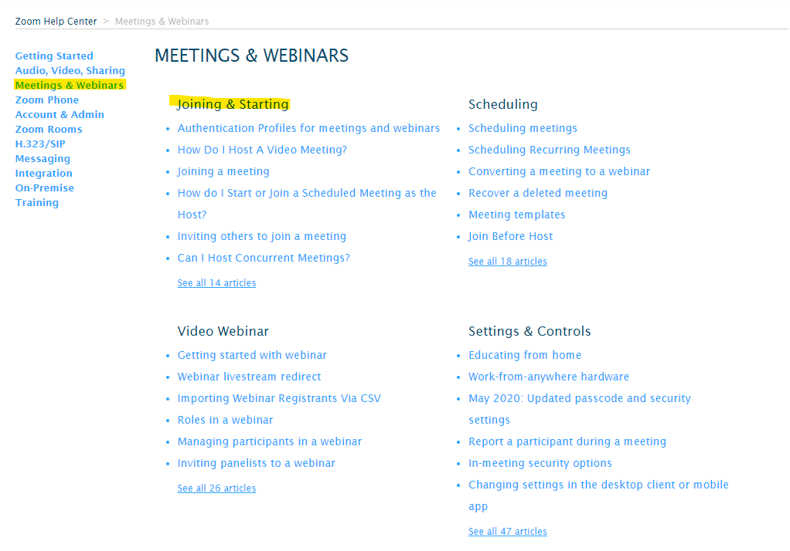
On the left-hand side of the screen are links to various training options click “Meetings & Webinars”, go to “Joining & Starting” section of the screen

Resource modules a “User” or “Staff/Presenters/Meeting Hosts” should view
Users
- Joining a meeting
Staff/Presenters/Meeting Hosts
- How Do I Host a Video Meeting?
- How do I Start or Join a Scheduled Meeting as the Host?
- Inviting others to join a meeting
- Can I Host Concurrent Meetings?
- Joining multiple meetings simultaneously on desktop
- Synced Calendars
- Show a “Join from your “browser” Link

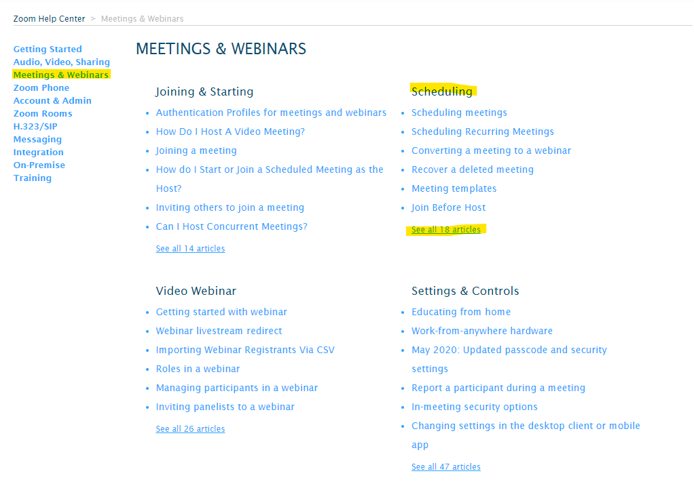
On the “Meeting & Webinars”, page go to “Scheduling” section of the screen click the “See all 18 articles” hyperlink

Resource modules a “User” or “Staff/Presenters/Meeting Hosts” should view
Users
- N/A
Staff/Presenters/Meeting Hosts
- Scheduling meetings | - Scheduling Recurring Meetings | - Converting a meeting to a webinar
- Recover a deleted meeting | - Meeting templates | - Join Before Host
- Using Personal Meeting ID (PMI) | - Meet Now vs Scheduled Meetings | - How Do I Update a Scheduled Meeting?
- Alternative host | - Scheduling privilege | - Desktop Client Calendar and Contacts Integration
- Setting up registration for a meeting | - Polling for meetings | - Hosting a Personal Audio Conference meeting
- Calendar of Public Meetings and Webinars | - Meeting Details Do Not Show Up in Outlook when using Schedule Feature | - Disable Google Hangout on Google Calendar

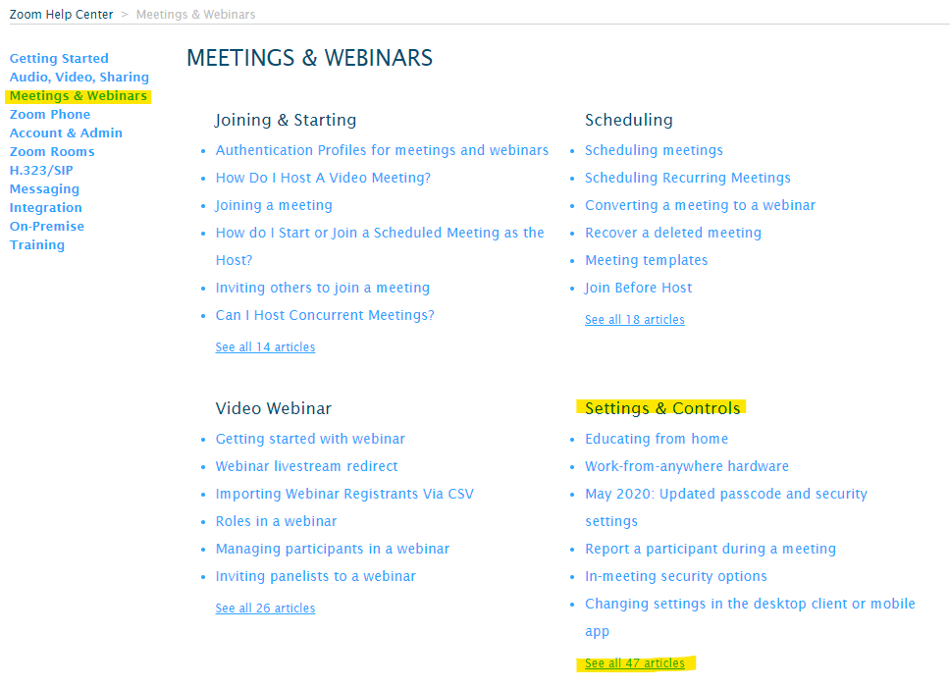
On the “Meeting & Webinars” page go to “Setting & Controls” section of the screen, click the “See all 47 articles” hyperlink

Resource modules a “User” or “Staff/Presenters/Meeting Hosts” should view
Users
- N/A
Staff/Presenters/Meeting Hosts
- Educating from home | - Work-from-anywhere hardware | - May 2020: Updated passcode and security settings
- Report a participant during meeting | - In-meeting security options | - Changing settings in the desktop client or mobile app
- Roles in a meeting | - Attendee controls in a meeting | - Host and co-host controls in a meeting
- Managing participants in a meeting | - Displaying participants in Gallery View | - Managing breakout rooms
- In-meeting chat | - Controlling and disabling in-meeting chat | - Saving in-meeting chat
- In-meeting file transfer | - Enabling and adding a co-host | - Meeting reactions
- Language interpretation in meetings and Webinars | - Meeting and webinar passcodes | - Pre-assigning participants to breakout rooms
- Streaming a Meeting or Webinar on YouTube Live | - Streaming a meeting or webinar on Facebook Live | - Upcoming Meeting Reminders
- Using closed captioning | - Viewing Closed Captions | - Waiting Room
- Hiding or showing my video on my display | - Spotlight Video | - Identify Guest Participants
- End of Meeting Feedback Survey | - Custom live streaming watermark | - Post attendee URL
- Remote support session | - Nonverbal feedback during meetings | - Adding phone statistics
- Hot Keys and keyboard shortcuts | - Meeting and phone statistics | - Attendee attention tracking
- Showing the meeting duration (connected time) | - Allowing Removed Participants or Panelists to Rejoin | - MacBook Pro Touch Bar Controls
- Live Stream Meetings or Webinars on Workplace by Facebook | - CarPlay Meeting Controls | - What is Safe Driving Mode?
- Passing host controls and leaving the meeting | - Attendee on hold
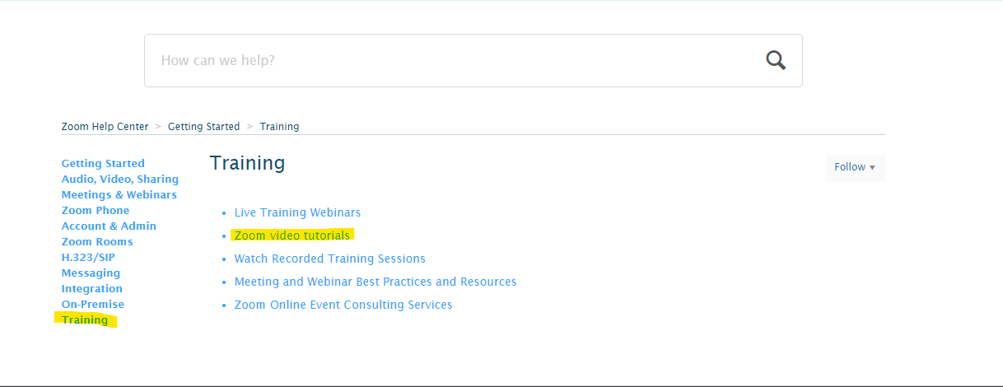
On the left-hand side of the screen are links to various training options click “Training” go to “Zoom video tutorials” on the “Training” page

Resource modules a “User” or “Staff/Presenters/Meeting Hosts” should view
Users
- Zoom Meetings and Webinars /Join a Meeting
Staff/Presenters/Meeting Hosts
Zoom Meetings and Webinars | Audio, Video & Sharing | Zoom Rooms | Zoom Messaging
- Scheduling a meeting with Zoom Website | - Recording a Zoom Meeting | - All About Zoom Rooms | - All About Group Collaboration
- Meeting Controls | - Joining & Configuring Audio & Video | - Zoom Rooms Direct Sharing
- Scheduling a Meeting with Google Calendar | - Sharing Your Screen | - Zoom Room Feature Enhancements
- Scheduling a Meeting with Outlook | - Sharing Multiple Screens Simultaneously
 | - All about Recording
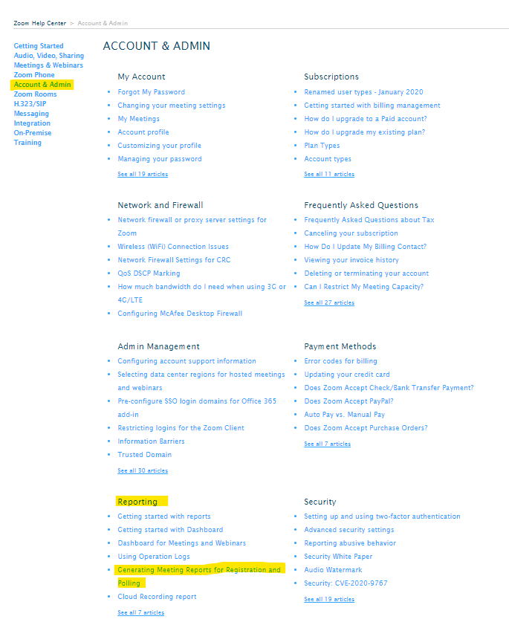
On the left-hand side of the screen are links to various training options click “Account & Admin” scroll down to the “Reporting” section of the screen
Users
- N/A
Staff/Presenters/Meeting Hosts
- Generating Meeting Reports for Registration and Polling

Integrations
With other Sun Health Applications:
Microsoft Outlook is integrated with Zoom, there is a special Zoom Download available for employees who have Zoom Licenses to take advantage of this integration. To access the download, call the Sun Health Service Desk at: (623) 975-8007 and request the Zoom Outlook integration download.
Board Effect is integrated with Zoom in support of our Sun Health Board and our Executive Admins who utilize Board Effect.

Inputs

Polling
The polling feature can be used for webinars and meetings polling allows you to create single choice or multiple-choice polling questions for your webinars and meetings. You can launch polls during your meeting and gather the responses from your attendees. You also can download a report of the polling after the meeting. Polls can also be conducted anonymously, if you do not wish to collect participant information with the poll results.

Creating a Poll
- Go to the Meetings page and click on your scheduled meeting. If you do not have a scheduled meeting, schedule a meeting now.
- From the meeting management page, scroll to the bottom to find the Poll option. Click Add to begin creating the poll
- Enter a title and your first question.
- (Optional) Check the Anonymous box to make the poll anonymous, which will keep the participant's polling information anonymous in the meeting and in the reports.
- Select whether you want the question to be single choice (participants can only choose one answer) or multiple-choice question (participants can choose multiple answers).
- Type in the answers to your question and click Save at the bottom.
- If you would like to add a new question, click Add a Question to create a new question for that poll.
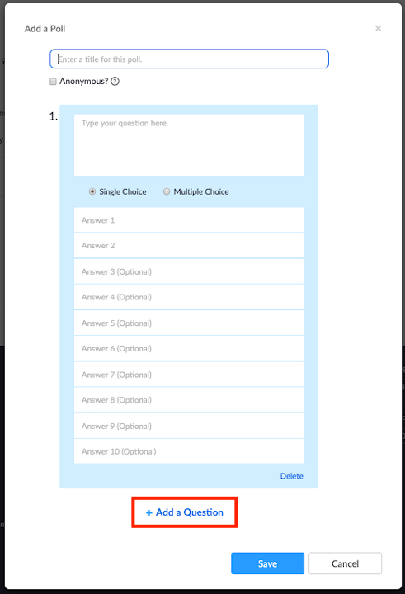
- You can add more polls by repeating Step 2.
You can also create a poll by clicking Polling during the meeting. This will open your default web browser where you can add additional polls or questions.
Note: You can only create a max of 25 polls for a single meeting.

Launching a Poll
- Start the scheduled Zoom meeting that has polling enabled.
- Click Polls in the meeting controls.
- Select the poll you would like to launch.

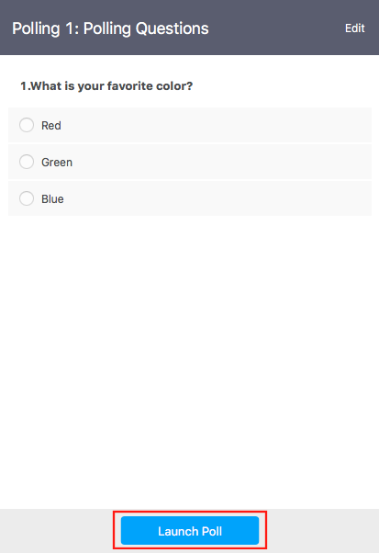
- Click Launch Poll.

- The participants in the meeting will now be prompted to answer the polling questions. The host will be able to see the results live.
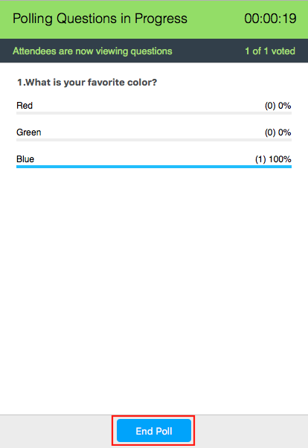
- Once you would like to stop the poll, click End Poll.
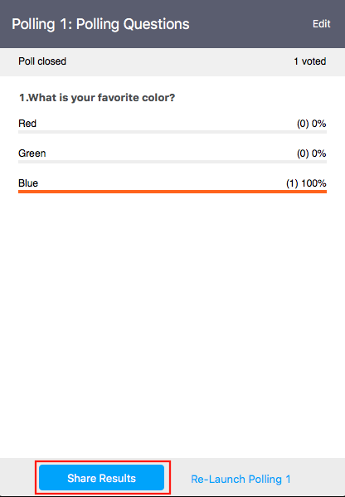
- If you would like to share the results to the participants in the meeting, click Share Results.

- Participants will then see the results of the polling questions.
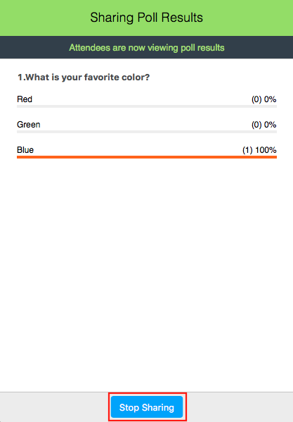

Breakout Rooms
Breakout rooms allow you to split your Zoom meeting in up to 50 separate sessions. The meeting host can choose to split the participants of the meeting into these separate sessions automatically or manually and can switch between sessions at any time.
Creating breakout rooms
Note: You can also pre-assign participants to breakout rooms when you schedule the meeting instead of managing them during the meeting.
- Start an instant or scheduled meeting.
- Click breakout rooms.
- Select the number of rooms you would like to create, and how you would like to assign your participants to those rooms:
  - Automatically: Let Zoom split your participants up evenly into each of the rooms.
  - Manually: Choose which participants you would like in each room.
- Click Create breakout rooms.
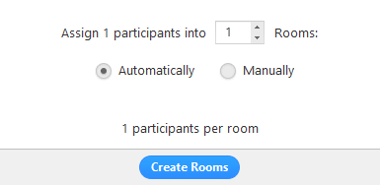
- Your rooms will be created but will not start automatically. You can manage the rooms prior to starting them by following the instructions below.

Options for breakout rooms
- After creating the breakout rooms, click Options to view additional breakout rooms options.
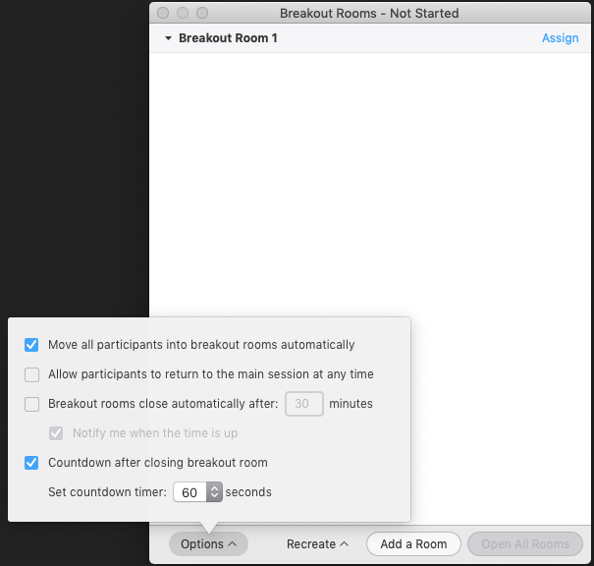
- Check any options that you would like to use for your breakout rooms.
  - Move all participants into breakout rooms automatically: Checking this option will move all participants into the breakout rooms automatically. If this option is unchecked, the participants will need to click Join to be added to the breakout room.
  - Allow participants to return to the main session at any time: If this option is checked, the participants can move back to the main session from their meeting controls. If this is disabled, they need to wait for the host to end the breakout rooms.
  - Breakout rooms close automatically after x minutes: If this option is checked, the breakout rooms will automatically end after the configured time.
  - Notify me when the time is up: If this option is checked, the host will be notified when the breakout room time is up.
  - Countdown after closing breakout rooms: If this option is checked, the participants will be given a countdown of how much time they have left before being returned to the main room.
- Follow the steps below to assign participants to rooms or click Open All Rooms to start the breakout rooms.

Assigning participants to rooms
To assign participants to your rooms, select Assign next to the room you wish to assign participants to and select participants you want to assign to that room. Repeat this for each room.
Once a participant has been assigned (manually or automatically), the number of participants will show in place of the Assign button.

Preparing breakout rooms
After manually or automatically assigning participants to rooms, you can rearrange the participants. Participants who are not assigned to breakout sessions will remain in the main meeting when the rooms are started.
- Move to (participant): Select a room to move the participant to.
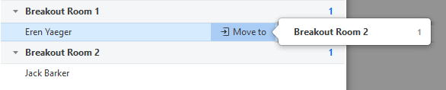
- Exchange (participant): Select a participant in another room to swap the selected participant with.
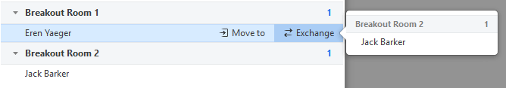
- Delete Room: Delete the selected room.
- Recreate: Deletes existing breakout rooms and creates new ones.
- Add a Room: Add another breakout room.
- Open All Rooms: Start the rooms. All participants will be moved to their respective rooms after confirming the prompt to join the breakout room. The host will be left in the main meeting until manually joining one of the rooms. The participants (and the host when manually joining a room) will see the following message shown when joining the breakout room.
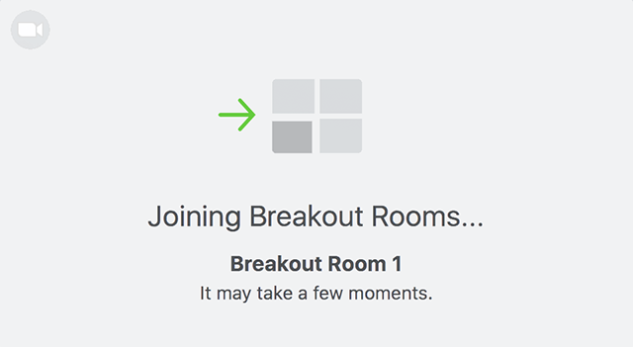

Managing breakout rooms in progress
Once the breakout rooms have been started, the participants will be asked to join the Breakout Session. The host will stay in the main meeting until joining a session manually. If a participant has not joined the session yet, it will be noted by (not joined) next to their name.
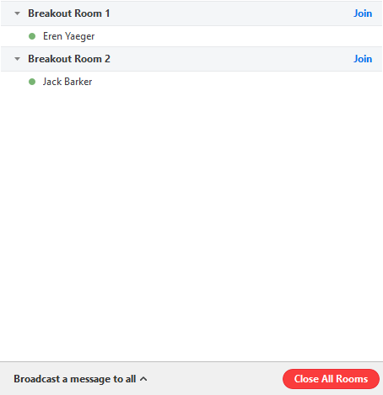
- Join: Join the breakout room.
- Leave: Leave the room and return to the main meeting (only shows when in a breakout room).
- Close All Rooms: Stops all rooms after a 60 second countdown, shown to the host and participants, and returns all participants back to the main meeting.

Responding to requests for help
Participants in breakout rooms can request that the meeting host join their meeting by clicking Ask for Help.
You will be prompted to join the room where the request originated from. Click Join breakout room to join the room.
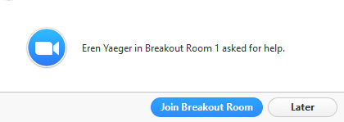

Broadcasting a message to all breakout rooms
The host can broadcast a message to all breakout rooms to share information with all participants.
- Click breakout rooms in the meeting controls.
- Click Broadcast a message to all, enter your message and click Broadcast.
- The message will now appear for all participants in Breakout Rooms.
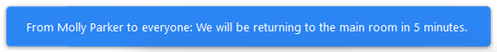

Controlling and disabling in-meeting chat
Overview
As the host, you can control which meeting or webinar participants can chat with. You can also disable the chat feature for all participants or disable private chat so participants cannot send private messages.
This article includes
- Controlling chat access
- Disabling in-meeting chat
Prerequisites
- Host privileges in meeting or webinar
- Zoom desktop client for Windows or macOS, version 4.x for host and participants to control chat access
- Zoom mobile client for iOS or Android, version 4.x for host and participants to control chat access

Controlling chat access
Meeting and webinar hosts can control whether participants can chat with everyone, with panelists and the host (for webinars), or with the host only.
- Start a meeting or webinar as host.
- Click Chat in the Meeting Controls.
- At the bottom of the in-meeting Zoom Group Chat window, click More, and then choose an option for Allow attendees to chat with.
  - For meetings, the host can allow attendees to chat with everyone or with the host only.
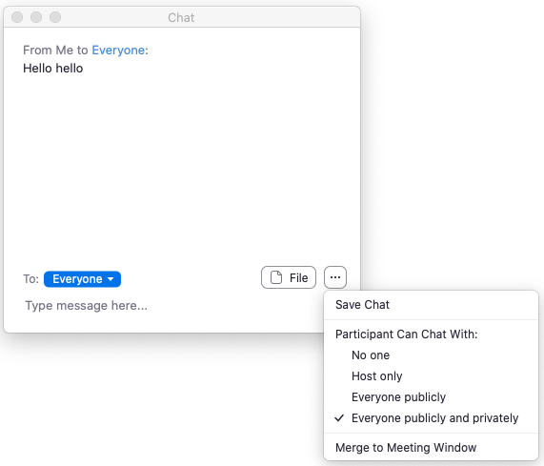
  - For webinars, the host can allow attendees to chat with no one, with all panelists (including host), or with all panelists and attendees.
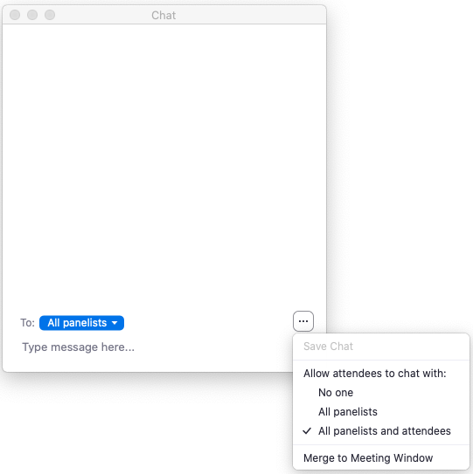

Disabling in-meeting chat
You can turn chat for all your meetings and webinars if you do not want to use the chat feature in your meetings and webinars. This will prevent the host, co-hosts, and participants from chatting for any meetings you host. The Chat option will no longer appear in the Meeting Controls.
You can disable the Private Chat, which will prevent participants from sending messages to individuals instead of the entire group.
- Sign into the Zoom web portal.
- In the navigation menu, click Settings.
- Navigate to Chat option under In Meeting (Basic).
- Click the Chat and Private Chat toggles to disable in-meeting chat.
- Click Save Changes.

Muting and unmuting participants in a meeting
Overview
As the host or co-host in a meeting, you can manage your participants, including muting and unmuting participants to manage background noise and distractions. All participants can also mute or unmute themselves, unless the host has prevented them from unmuting.
Due to privacy and security reasons, the host cannot unmute other participants without their consent. The host can either use the Ask All to Unmute option, which will prompt every user to unmute themselves, or can schedule the meeting with Request permission to unmute participants enabled, which will prompt the participants for pre-approval to be unmuted by the host.
Prerequisites
- Host permission in the meeting, or co-host permission (set by the host)
- Zoom desktop client for Mac, PC, Chrome OS or Linux
- Zoom mobile app for iOS or Android
- Pre-approved consent: desktop client or mobile app version 5.2.1 or higher.

Mute All Participants
The host or co-host can mute all participants that are already in the meeting as well as new participants joining the meeting.
- Click Participants
- Click Mute All
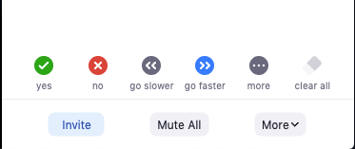
- Click Mute All to mute all current and new participants.
- (Optional) Check Allow participants to unmute themselves if you would like participants to be able to unmute at any time during the meeting.
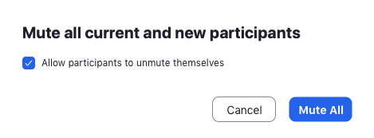

Ask All to Unmute
The host and co-host can also request everyone in the meeting to unmute themselves. This allows the participants to choose if they are ready to be unmuted or wish to remain muted.
- Click Participants.
- Click More, then click Ask All to Unmute from the list.
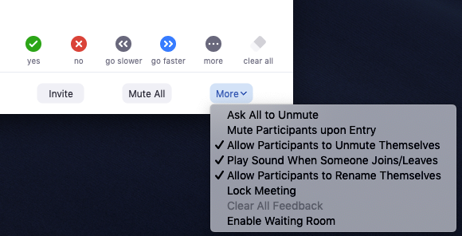
All other participants will then be prompted to Unmute or Stay Muted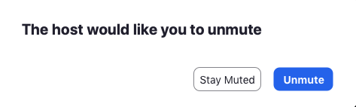

Enabling pre-approved consent to unmute

Account pre-approved consent to unmute feature for all users in account
- Sign into the Zoom web portal as an administrator with permission to edit account settings.
- In the navigation menu, click Account Management then Account Settings.
- In the Meeting tab, navigate to the Request permission to unmute option (under the In Meeting (Advanced) section) and verify that the setting is enabled.
Note: If the setting is disabled, click the Status toggle to enable it. If a verification dialog displays, choose Turn On to verify the change.
- (Optional) If you want to make this setting mandatory for all users in your account, click the lock icon, and then click Lock to confirm the setting.
Note: Users must have client/app version 5.2.1 or higher to see the option when scheduling.

Group pre-approved consent to unmute feature for all members of group
- Sign into the Zoom web portal as an administrator with permission to edit user groups.
- In the navigation menu, click User Management then Group Management.
- Click the name of the group, then click the Meeting tab to access Settings.
- In the Meeting tab, navigate to the Request permission to unmute option (under the In Meeting (Advanced) section) and verify that the setting is enabled.
Notes:
  - If the setting is disabled, click the Status toggle to enable it. If a verification dialog displays, choose Turn On to verify the change.
  - If the setting is grayed out, it has been locked at the Account level, and needs to be changed at that level.
- (Optional) If you want to make this setting mandatory for all users in your account, click the lock icon, and then click Lock to confirm the setting.

User pre-approved consent to unmute feature for your own use
- Sign into the Zoom web portal.
- In the navigation menu, click Settings.
- In the Meeting tab, navigate to the Request permission to unmute option (under the In Meeting (Advanced) section) and verify that the setting is enabled.
Notes:
  - If the setting is disabled, click the Status toggle to enable it. If a verification dialog displays, choose Turn On to verify the change.
  - If the setting is grayed out, it has been locked at either the group or account level, and needs to be changed at that level.

Pre-approved consent to unmute
To schedule a meeting with pre-approval to unmute participants, check the Request permission to unmute participants option under Meeting Options:
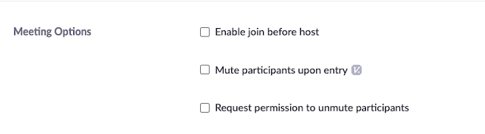
When the meeting starts, participants will be prompted to provide consent to be unmuted by the host:
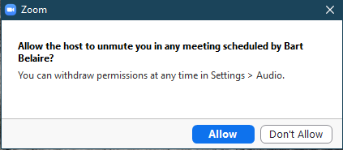
If provided consent to unmute, the host will have the option to unmute each person individually as needed from the participants list.
Note: Once consent has been given to a host, any future meetings with this host and this setting enabled will have the same pre-approved consent. Meetings without this setting will require the host to ask each participant to unmute themselves.

Revoking consent to be unmuted
Participants can revoke this consent at any time in the client settings.
- Open the Zoom desktop client and sign in.
- Click your profile picture then click Settings.
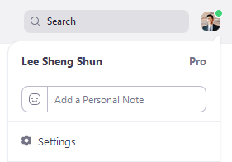
- Click on Audio.
- Click on Manage, next to the People who can unmute you.
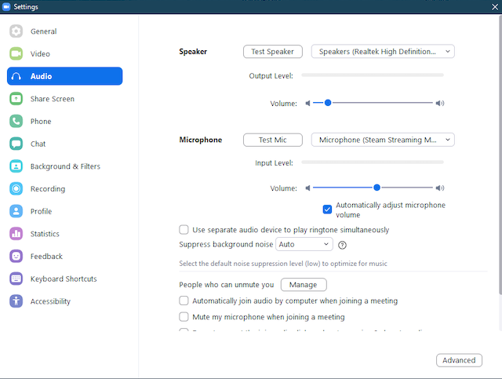
You will see a list of hosts you have given consent to in past meetings.
- Select a host from the list, then click Remove to revoke the consent.

Sharing your screen
Overview
While in a meeting, you can share the following content:
- Entire desktop or phone screen
- A specific application
- A portion of your screen
- Whiteboard
- Device audio
- Content from a second camera
- iPhone/iPad screen
Note:
- The host can disable participants' ability to share their screen.
- For Free/Basic accounts, screen sharing is set to Only Host by default.
- In a webinar, only the host, co-hosts, and panelists can share their screen.
- If you are using the desktop client, you can show Zoom windows during screen share.
Prerequisites
- Zoom desktop client
- Zoom mobile app
- Client version 5.0 or higher is required for joining a meeting after May 30, 2020.
Windows | macOS

Sharing your screen or content
- Click the Share Screen button located in your meeting controls.
- Select one of these screen share options:
  - Basic: Share your entire desktop, specific application window, whiteboard, or iPhone/iPad screen.
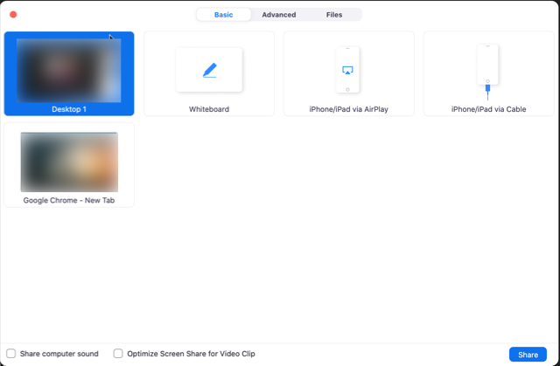
  - Advanced
    - Portion of Screen: Share a portion of your screen represented by a green border.
    - Music or Computer Sound Only: Only share your computer's audio (your selected speaker in your audio settings).
    - Content from 2nd Camera: Share a secondary camera connected to your computer; for example, a document camera or the integrated camera on your laptop.
  - Files: Share a file from a third-party sharing service like Google Drive or Microsoft OneDrive. Follow the on-screen prompts to sign into the third-party service and grant Zoom access.
Note: Alternatively, you can open the file in a web browser then share the browser window. For example, to share a Google doc, open the doc in Chrome, then share the Chrome window. The result is the same as using the sharing options in the Files tab.
- (Optional) Enable these features:
  - Check Share Computer Sound: If you check this option, any sound played by your computer will be shared in the meeting.
  - Check Optimize for full screen video clip: Check this if you will be sharing a video clip in full screen mode. Do not check this otherwise, as it may cause the shared screen to be blurry.
- Click Share.
  - Zoom will automatically switch to full screen to optimize the shared screen view. To exit full-screen, click Exit Full Screen in the top-right corner or press the Esc key.
  - To disable automatic full screen when viewing a shared screen, disable this option in your desktop client settings: Enter full screen automatically when a participant shares screen.
  - If you selected Portion of Screen, customize the screen portion by dragging or resizing the green border.
  - If you selected Content from 2nd Camera, click Switch Camera in the top-left corner to switch the shared camera.

Share screen menu
When you start sharing your screen, the meeting controls will move into a menu that you can drag around your screen.
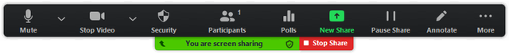
- Mute/Unmute: Mute or unmute your microphone.
- Start/Stop Video: Start or stop your in-meeting video.
- Participants/Manage Participants: View or manage the participants (if the host).
- New Share: Start a new screen share. You will be prompted to select which screen you want to share again.
- Pause Share: Pause your current shared screen.
- Annotate / Whiteboard: Display annotation tools for drawing, adding text, etc.
- More: Hover over more for additional options.
  - Chat: Open the chat window.
  - Invite: Invite others to join the meeting.
  - Record: Start recording locally or to the cloud.
  - Allow/Disable participants annotation: Allow or prevent the participants from annotating on your shared screen.
  - Show/Hide Names of Annotators: Show or hide the participants' name when they are annotating on a screen share. If set to show, the participant's name will briefly display beside their annotation.
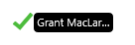
  - Live on Workplace by Facebook: Share your meeting or webinar on Workplace by Facebook. Learn more about live-streaming a webinar.
  - Optimize Share for Full-screen Video Clip: Start optimizing for a video clip in full screen mode.
Note: Do not enable this setting if you are not sharing a full screen video clip, as it will blur your screen share.
  - End Meeting: Leave the meeting or end the meeting for all participants.

Showing Zoom windows during screen share
By default, the Zoom window is not shared while sharing your screen. Showing the Zoom window during screen share can be useful if a participant is helping you use Zoom.
- Sign into the Zoom web portal.
- In the navigation menu, click Settings.
- In the In Meeting (Basic) section, make sure Show Zoom windows during screen share is enabled. This setting will allow the setting to appear in the desktop client.
- Sign out of the Zoom desktop client and sign back in. Alternatively, you can exit the client and re-open it.
- Click your profile picture then click Settings.
- Click the Share Screen tab and make sure Show Zoom windows during screen share is enabled.

Using dual monitors while sharing screen
If you are using a dual monitor set-up, you can turn on the dual monitors feature to see the screen sharing on one monitor and participants on the second.
Note: On Mac OS 10.15 Catalina, you need to allow Zoom access to screen recording to share your screen. You can do this in your System Preferences > Security & Privacy > Privacy > Screen Recording. Check the option for zoom.us.
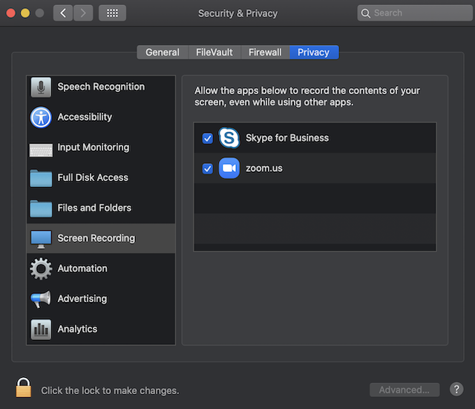

Using the whiteboard in Zoom Rooms for Touch
Overview
Zoom Rooms for Touch is equipped with a whiteboard. You can start a whiteboard session, and then invite others to view and annotate. You can save the whiteboard image and annotations at any time by sending the image file to email recipients you specify.
The whiteboard also supports multi-touch with up to 10 touch points if you have a compatible touchscreen monitor.
Prerequisites
- Zoom Rooms for Conference Room for PC, 4.6.0 (1193.1215) or higher
- Windows PC version 8.1 or higher
- Touch drivers installed on the computer
- Single touchscreen monitor or dual monitors

Starting a whiteboard session and using whiteboard controls
- From the home screen, tap Whiteboard.
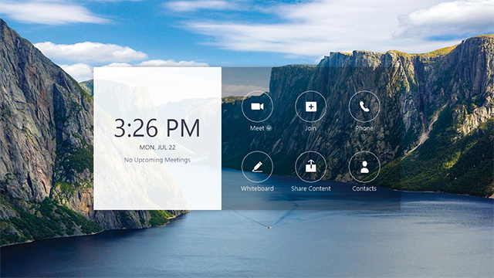
- The whiteboard control bar is displayed at the bottom of the screen, enabling you to switch from the default color (black) to another color (red, yellow, green, or blue) to draw on the screen.
You will also have access to these features:
  - CLOSE: Close the whiteboard and return to the home screen.
  - Moon icon : Change the background of the whiteboard to black.
  - Save icon : Email the whiteboard as an image or PDF.
  - Add page icon : Add a new whiteboard page. After adding a page, you will see an icon showing the number of pages . Tap this icon to see view and delete pages.
  - Drawing tools
  - NEW SHARE: Start screen sharing. You will be able to access the drawing tools after starting the screen share.
  - START MEETING: Start a meeting and share the whiteboard with participants. After starting a meeting, you will see these options in the bottom-right corner:
    - Mic icon: Mute or unmute the Zoom Room's mic.
    - More icon (...): Access the integrated controller.
    - END MEETING: End the meeting for all participants.

Using drawing tools (free-form and smart-recognition drawing)
After starting a whiteboard session in Zoom Rooms for Touch, you can use two types of drawing methods:
- Free form: Zoom will not smooth out your lines or auto-convert drawings to shapes. Your drawings will appear on the whiteboard exactly as you drew them.
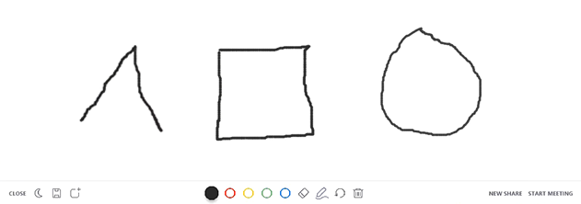
- Smart recognition drawing: Zoom will smooth out your lines and auto-convert drawings to shapes immediately after you draw on the touchscreen monitor.
Note: In addition to the whiteboard, these tools are also available when annotating on a participant's screen shared.
- Click the pencil or shape icon in the bottom bar.
- Select a drawing method:
  - Free form: Select None. You can also change the line thickness.
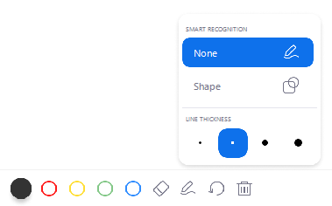
  - Smart recognition: Select Shape to turn on smart recognition drawing. You can also change the line thickness.
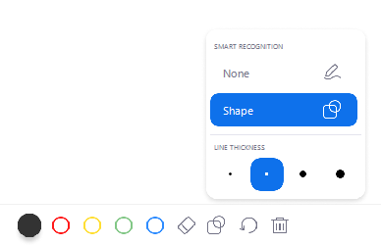
- Choose a color and touch the screen to begin drawing.
- Tap the screen to draw.
- Click the undo icon to undo your last drawing or click the trash bin con to clear all drawings on the currently opened whiteboard.

Inviting participants to a whiteboard session
If you start a whiteboard session outside of a meeting, you can share it with remote participants by starting a meeting. The whiteboard that you have been using is available to share with the participants you invite to the meeting.
If you have set up Zoom Rooms for Touch with dual monitors, the whiteboard session will remain on the touchscreen monitor while participants' video will appear on the regular monitor.
- From the home screen, tap Whiteboard.
- Tap a color and begin drawing.
- Tap START MEETING in the bottom-right corner.
- Tap ... in the bottom-right section to display the integrated controller.
- Tap Invite in the meeting controls.
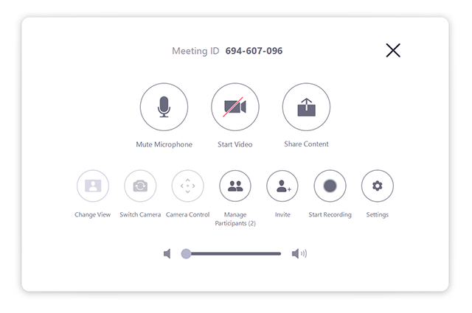
- Use the search bar to search for contacts to invite.
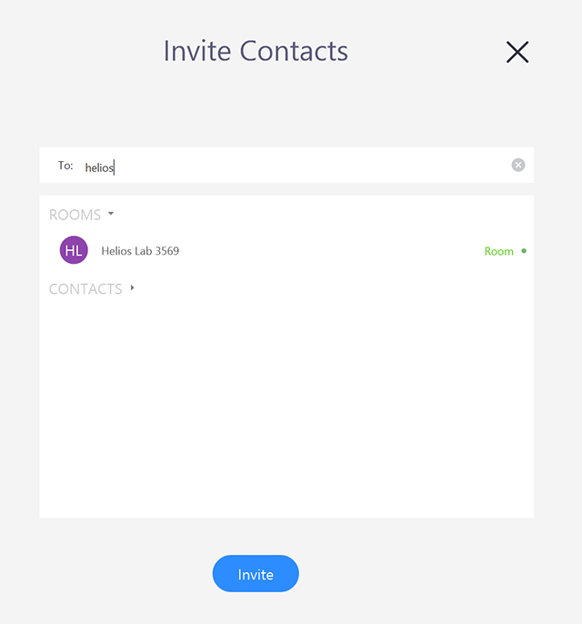
- Select participants from the search results, then tap Invite.
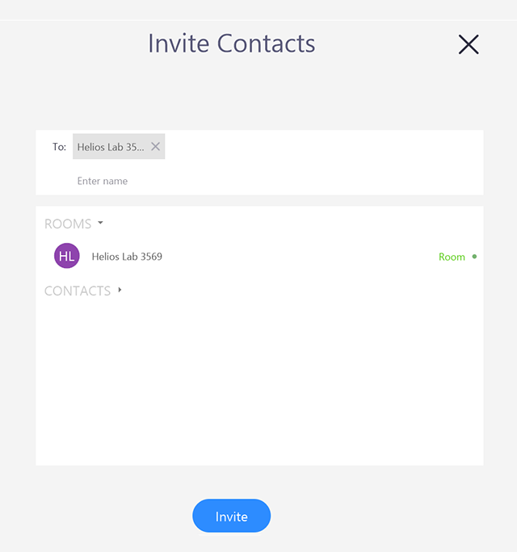
All participants can see the whiteboard you are sharing and can annotate it using the whiteboard annotation tools from their own Zoom application.

Saving a whiteboard session
You can save and share a whiteboard session, including annotations, by sending an email containing an image or PDF of the whiteboard.
If your whiteboard has multiple pages, each page will be a separate image. If you select PDF, all whiteboard pages will be in a single PDF.
- Start a whiteboard session.
- Tap the save icon in the whiteboard controls.
- If you have multiple whiteboard pages, you will be prompted to select the ones you want to send.
- Enter an email address to send the whiteboard to.
- In the bottom-right corner, select a format for the whiteboard. Select PDF if you have multiple whiteboard pages and want to send them in a single file.
- Tap Send.
The whiteboard will be sent with the subject line “Saved Whiteboard Image(s)”. The sender will be the room name.

Restrict sending whiteboard to internal users (admin)
Zoom Rooms for Touch whiteboards can also be restricted to only allow sharing with internal users for additional security. This option can be enabled account-wide or at the device level.
Account
- Sign into the Zoom web portal.
- Click Room Management > Zoom Rooms.
- Select Account Settings.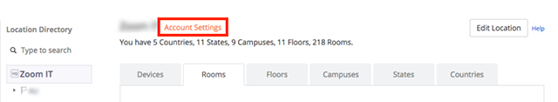
- Click Meeting.
- Click Send Whiteboard to internal contacts only.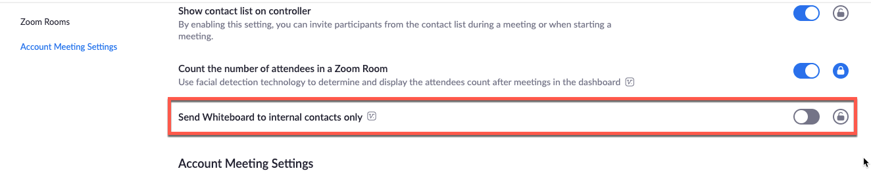
Zoom Room
- Sign into the Zoom web portal.
- Click Room Management > Zoom Rooms.
- Click the Edit to the right of the Zoom Room name.
- Click Meeting.
- Send Whiteboard to internal contacts only.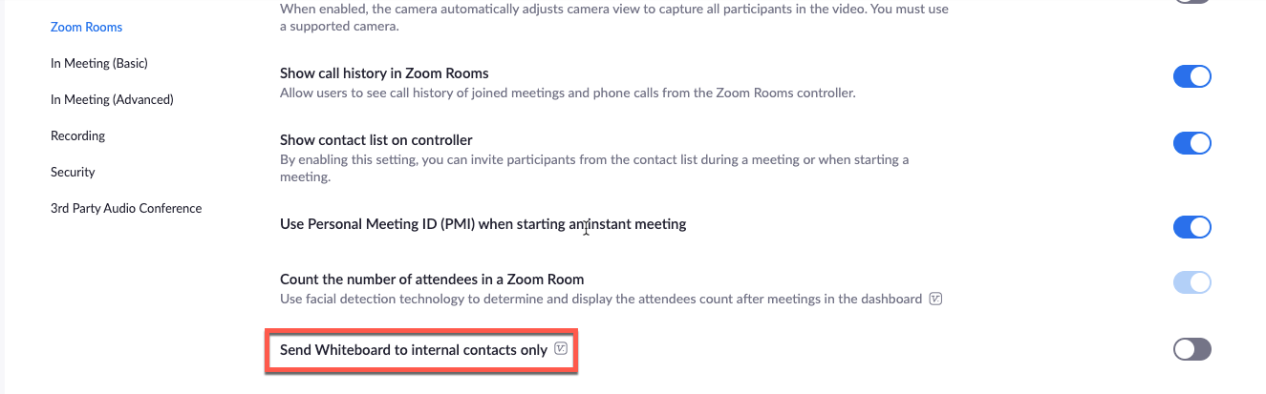

Using annotation tools on a shared screen or whiteboard
Overview
Meeting participants can annotate on a shared screen as a viewer or the one that started sharing your screen. You can also use annotation tools when sharing or viewing a whiteboard.
Prerequisites
- Annotation enabled
- Zoom Desktop Client for Windows, macOS, and Linux
- Zoom Mobile App for Android and iOS
- Joined or started a meeting with screen sharing
Note: The meeting host can disable attendee annotation. If you do not have the annotation option, confirm that the host has not disabled annotation.

Enabling annotation for meetings
Before using annotation, make sure it is enabled in the Zoom web portal.

Enabling annotation for all users in account
- Sign into the Zoom web portal
- In the navigation panel, click Account Management then Account Settings.
- Click the Meeting tab.
- Under Meeting (Basic), verify that Annotation is enabled.
- If the setting is disabled, click the toggle to enable it. If a verification dialog displays, click Turn On to verify the change.
- (Optional) Click the check box to allow saving of shared screens with annotations.
- (Optional) Click the check box to restrict annotation to only the user sharing content.
- (Optional) If you want to make this setting mandatory for all users in your account, click the lock icon, and then click Lock to confirm the setting.

Enabling annotation for Group User
- Sign into the Zoom web portal.
- In the navigation panel, click User Management then Group Management.
- Click the applicable group name from the list, then click the Settings tab.
- Click the Meeting tab.
- Under Meeting (Basic), verify that Annotation is enabled.
- If the setting is disabled, click the toggle to enable it. If a verification dialog displays, click Turn On to verify the change.
Note: If the option is grayed out, it has been locked at the account level, and needs to be changed at that level.
- (Optional) Click the check box to allow saving of shared screens with annotations.
- (Optional) Click the check box to restrict annotation to only the user sharing content.
- (Optional) If you want to make this setting mandatory for all users in your account, click the lock icon, and then click Lock to confirm the setting.

Enabling annotation for your own use (User)
- Sign into the Zoom web portal.
- In the navigation panel, click Settings.
- Click the Meeting tab.
- Under Meeting (Basic), verify that Annotation is enabled.
- If the setting is disabled, click the toggle to enable it. If a verification dialog displays, click Turn On to verify the change.
Note: If the option is grayed out, it has been locked at either the group or account level. You need to contact your Zoom admin.
- (Optional) Click the check box to allow saving of shared screens with annotations.
- (Optional) Click the check box to restrict annotation to only the user sharing content.

Using annotation tools
Windows | macOS | Linux
Accessing annotation tools if you started screen sharing
After sharing your screen or whiteboard, annotation controls will display. If you don't see the annotation tools, click Annotate (if you are sharing your screen) or Whiteboard (if you are sharing a whiteboard).

Accessing annotation tools if you are viewing a shared screen
While viewing a shared screen or shared whiteboard, click View Options then Annotate at the top.

Annotation tools
You will see these annotation tools:
Note: The Select, Spotlight, and Save options are only available if you started the shared screen or whiteboard.
- Mouse: Deactivate annotation tools and switch to your mouse pointer. This button is blue if annotation tools are deactivated.
- Select (only available if you started the shared screen or whiteboard): Select, move, or resize your annotations. To select several annotations at once, click and drag your mouse to display a selection area.
- Text: Insert text.
- Draw: Insert lines, arrows, and shapes.
Note: To highlight an area of the shared screen or whiteboard, select following square or circle icon to insert a semi-transparent square or circle.
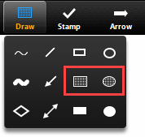
- Stamp: Insert predefined icons like a check mark or star.
- Spotlight / Arrow: Turn your cursor into a spotlight or arrow.
  - Spotlight (only available if you started the shared screen or whiteboard): Displays your mouse pointer to all participants when your mouse is within the area being shared. Use this to point out parts of the screen to other participants.
  - Arrow: Displays a small arrow instead of your mouse pointer. Click to insert an arrow that displays your name. Each subsequent click will remove the previous arrow placed. You can use this feature to point out your annotations to other participants.
- Eraser: Click and drag to erase parts of your annotation.
- Format: Change the formatting options of annotations tools like color, line width, and font.
- Undo: Undo your latest annotation.
- Redo: Redo your latest annotation that you undid.
- Clear: Delete all annotations.
- Save: Save shared screen / whiteboard and annotations as a PNG or PDF. The files are saved to the local recording location.
Note: This option is only available to viewers if the host has allowed others to save.
  - To change the file format, click the downward arrow next to Save and select one of these options:
    - PNG: Save as a PNG file. If there are multiple whiteboards, Zoom will save a PNG file for each whiteboard.
    - PDF: Save as a PDF. If there are multiple whiteboards, Zoom will save a single PDF containing all whiteboards.

Annotation settings
If you started the shared screen or whiteboard, click More in the screen share controls for these annotation settings:
- Allow/Disable participants annotation: Allow or prevent the participants from annotating on your shared screen.
- Show/Hide Names of Annotators: Show or hide the participants' name when they are annotating. If set to show, the participant's name will briefly display beside their annotation.

Annotation shortcuts
Windows:
- Undo: Ctrl + Z
- Redo: Ctrl + Y
- Mouse mode: Right-click anywhere
Mac:
- Undo: Command + Z
- Redo: Command + Shift + Z
- Mouse mode: Right-click anywhere
Linux:
- Mouse mode: Right-click anywhere

Requesting or giving remote control
Overview
The remote-control feature allows you to take control of another participant's screen in a meeting. You can either request remote control of another participant's screen or the other participant can give control to you.
If you need admin functionality such as the ability to restart another participant's computer, see Remote Support Session.
Note: For Mac OSX, you will need to give Zoom access in the Accessibility tab in the Privacy and Security preferences of your Mac.
Prerequisites
- Zoom Desktop Client for Windows, Mac, or Linux
- iPad with Zoom Mobile App
- For use in webinars, must be the host, co-host, or panelist
Windows | Mac

Requesting remote control
You can request remote control from the host or participant who is sharing their screen.
- While viewing another participant's screen share, click the View Options dropdown menu located at the top of your in-meeting window.
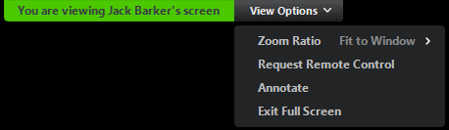
- Select Request Remote Control, then click Request to confirm.
The host or participant will get a notification asking if they want to allow you to control their screen.
- Click inside the screen share to start controlling the participant's screen.
- To stop remote control, click the View Options dropdown and select Give Up Remote Control.
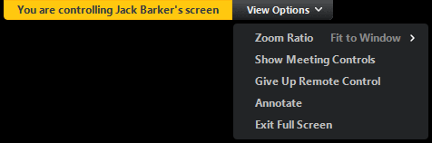

Giving remote control
While screen sharing, you can give remote control to another participant who is in the meeting. If the participant is on iOS or Android, they can remote control your screen using their mobile device.
- While screen sharing, click Remote Control and select the participant you want to give control to.
The participant can click anywhere on their screen to start control.
- To regain control, click anywhere on your screen. The other user can still restart remote control by clicking on their screen.
Tip: You can also click Stop Share to regain control and not allow the other participant to start remote control again.

Virtual Background
Overview
The Virtual Background feature allows you to display an image or video as your background during a Zoom Meeting. This feature works best with a physical green screen and uniform lighting to allow Zoom to detect the difference between you and your background. You can upload your own images or videos as a virtual background. You can also use Virtual Background in a Zoom Room.
Prerequisites
Make sure your computer meets the system requirements for Virtual Background.
Recommended setup
- To achieve the best virtual background effect, Zoom recommends using a solid color background, preferably green. Recommended physical green screens from Webaround or Amazon.
- Higher quality cameras result in a better virtual background. See camera recommendations for details.
- Use uniform lighting and color.
- Do not wear clothing that is the same color as the virtual background.
Background image
- There are no size restrictions when adding your own virtual backgrounds, but we recommend cropping the image to match the aspect ratio of your camera before uploading it.
Example: If your camera is set to 16:9, an image of 1280 by 720 pixels or 1920 by 1080 pixels would work well.
- If you are not sure about your camera aspect ratio, use a background image with a minimum resolution of 1280 by 720 pixels.
- Use these sources for royalty-free images: Pexels, Unsplash, Pixabay.
Background video
- A video (MP4 or MOV file) with a minimum resolution of 480 by 360 pixels (360p) and a maximum resolution of 1920 by 1080 pixels (1080p).

Enabling Virtual Background
Note: Users must sign out of the Zoom Desktop Client and sign back in for Virtual Backgrounds to take effect.
Account
To enable the Virtual Background feature for all users in the account:
- Sign into the Zoom web portal as an administrator with permission to edit account settings.
- In the navigation menu, click Account Management then Account Settings.
- In the Meeting tab, navigate to the Virtual Background option (under the In Meeting (Advanced) section) and verify that the setting is enabled.
Note: If the setting is disabled, click the toggle to enable it. If a verification dialog displays, choose Turn On to verify the change.
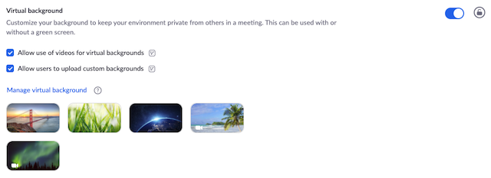
- (Optional) If you want to make this setting mandatory for all users in your account, click the lock icon, and then click Lock to confirm the setting.
- (Optional) Check Allow use of videos for virtual backgrounds then Save to confirm the change, to grant your users access to video virtual backgrounds.
- (Optional) Check Allow users to upload custom backgrounds then Save to confirm the change, to grant your users access to upload their own virtual backgrounds in addition to the backgrounds currently uploaded.
- (Optional) Click Manage virtual background to upload default background images available for users.
Note: Users must have client/app version 5.1.1 or higher to see the background images you upload.

Group Virtual Background feature
To enable the Virtual Background feature for all members of a specific group:
- Sign into the Zoom web portal as an administrator with permission to edit user groups.
- In the navigation menu, click User Management then Group Management.
- Click the name of the group, then click the Meeting tab to access Settings.
- In the Meeting tab, navigate to the Virtual Background option and verify that the setting is enabled.
Notes:
  - If the setting is disabled, click the Status toggle to enable it. If a verification dialog displays, choose Turn On to verify the change.
  - If the setting is grayed out, it has been locked at the Account level, and needs to be changed at that level.
- (Optional) If you want to make this setting mandatory for all users in this group, click the lock icon, and then click Lock to confirm the setting.
- (Optional) Check Allow use of videos for virtual backgrounds then Save to confirm the change, to grant your users access to video virtual backgrounds.
- (Optional) Check Allow users to upload custom backgrounds then Save to confirm the change, to grant your users access to upload their own virtual backgrounds in addition to the backgrounds currently uploaded.
- (Optional) Click Manage virtual background to upload default background images available for users.
Note: Users must have client/app version 5.1.1 or higher to see the background images you upload.

User Virtual Background feature
To enable the Virtual Background feature for your own use:
- Sign into the Zoom web portal.
- In the navigation menu, click Settings.
- In the Meeting tab, navigate to the Virtual Background option (under the In Meeting (Advanced) section) and verify that the setting is enabled.
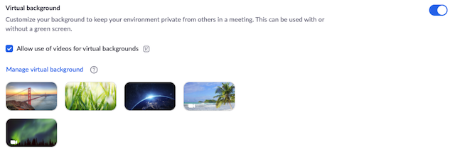
Notes:
  - If the setting is disabled, click the status toggle to enable it. If a verification dialog displays, choose Turn On to verify the change.
  - If the option is grayed out, it has been locked at either the group or account level, and you will need to contact your Zoom administrator.

Admin management of virtual backgrounds
Admins can upload their own virtual backgrounds for all users on their account to use or can assign certain virtual backgrounds for use by specific user groups. The admin can allow users to add their own virtual backgrounds or restrict them to just what admins have provided.
- Enable the virtual background feature in Account Settings or Group Settings.
- Click Manage virtual background.
- Click Choose Files or drag and drop the images you want to upload.
- Wait for the upload to finish before closing this window. A small banner will appear along the top of the page when the upload is successful.
After the new backgrounds are uploaded, users will need to sign-out of the client and then back in to retrieve the backgrounds from the web.
Notes:
- Users must be on version 5.1.1 or higher to utilize this feature.
- The default Zoom virtual backgrounds cannot be removed from the web portal.
- Video virtual backgrounds cannot be uploaded at this time.

Using Virtual Background
Windows | macOS
- Sign into the Zoom desktop client.
- Click your profile picture, then click Settings.
- Select Virtual Background.
Note: If you do not have the Virtual Background tab and you have enabled it on the web portal, sign out of the Zoom Desktop Client and sign in again.
- Check I have a green screen if you have a physical green screen set up. You can then click on your video to select the correct color for the green screen.
- Click on an image to select the desired virtual background or add your own image by clicking + and choosing if you want to upload an image or a video.
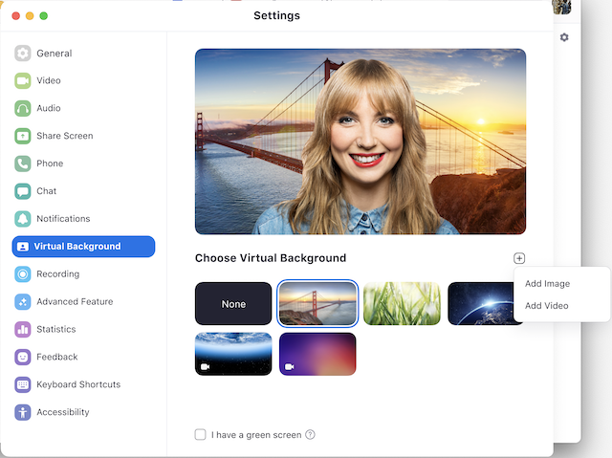
If prompted, click Download to download the package for virtual background without a green screen.
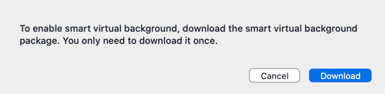
Notes:
  - Ensure that you are using a solid background color.
  - After you select an option, that virtual background will display during your meetings.
  - To disable Virtual Background, choose the option None.
Linux
Android | iOS

Enabling Virtual Background during a meeting
If you have already had Virtual Background enabled in the web portal, you can turn it on during a meeting.
Zoom Desktop Client
- In a Zoom meeting, click the upward arrow (^) next to Start/Stop Video.
- Click Choose Virtual Background....
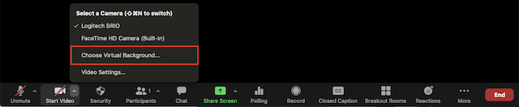.
- If prompted, click Download to download the package for virtual background without a green screen.

Troubleshooting Virtual Background issues
If you are experiencing issues with Virtual Background, try the following troubleshooting tips:
- If you do not have the Virtual Background tab in your desktop client settings after enabling it, sign out of the client and sign in again.
- Manually pick the background color to ensure the correct color is selected. This option is only available after you click an image.
- Ensure that the background is a solid color with minimal shadows. Also ensure the background is uniform in lighting. A 3-point lighting setup is ideal.
- Ensure that your green screen color does not match your shirt or eye color.
- If you continue to have problems with Virtual Background contact the Systems Administrator

Outputs:
- Zoom has the capabilities of recording your meeting or presentation please record to the cloud and make sure you have a strong Internet connection when doing so.
- If using a slide deck or PowerPoint be sure to share your screen during the recording
- Once you have finished your recording press Stop recording or end Meeting in any of the three locations.
It will take time for zoom to process the video but the Host email will receive a notification when the video is ready
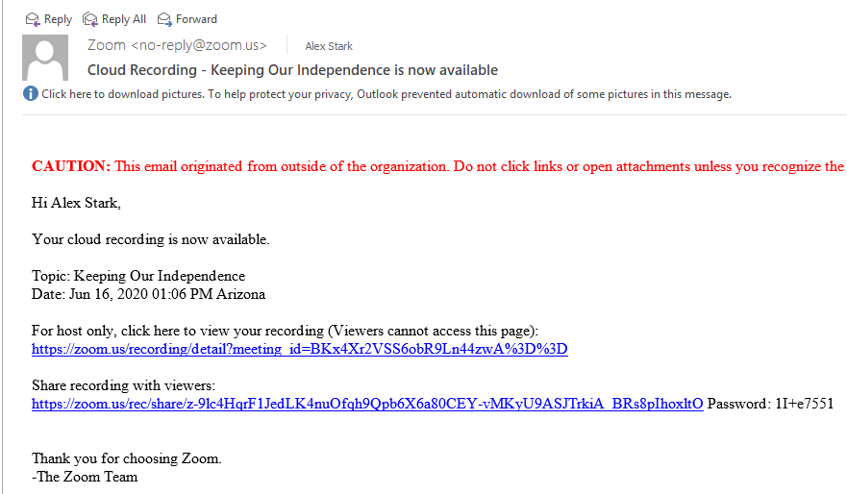

Generating Meeting Reports for Registration and Polling Webinar Reporting
Overview
If your Zoom meeting has registration or polling enabled, you can generate a registration or polling report for further analysis.
The registration report contains the following information of registered participants:
- First and last name
- Email address
- Date and time of registration
- Approval status
The polling report contains the following information of participants that answered a poll question:
- Username and email address
- Date and time, they submitted their answer
- The poll question and the participant's answer
Note:
- Meeting reports are automatically deleted 30 days after the scheduled date. This is also when the meeting is removed the from the Previous Meetings page in the web portal.
- If you delete a meeting from your Meetings list in the web portal, you cannot generate reports for that meeting. You can still download any reports you generated before deleting the meeting.
- You should generate meeting reports after your meeting has ended. If generated a report before starting the meeting, you should re-generate the report to obtain the data collected during the meeting.
Prerequisites
- Host of the meeting, role with Usage Reports enabled, Account Admin or Owner
- Pro, API Partner, Business or Education plan
Instructions
- Sign into the Zoom web portal.
- Navigate to Account Management > Reports.
- In the Usage Reports tab, click Meeting.
A list of upcoming and previous meetings will be generated. You can search by time range or by meeting ID.
- Next to Report Type, select the Registration Report or Poll Report.
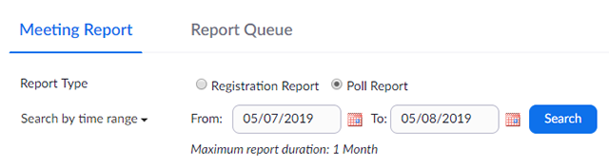
- In the drop-down menu below Report Type, select one of these options:
  - Search by time range: Select a time range then click Search.
  - Search by meeting ID: Enter the meeting ID and click Search.
- Click Generate in the last column. You can also use the check boxes to select multiple meeting then click Generate at the top.
Zoom will redirect you to the Report Queues tab where you can download the report as a CSV file.
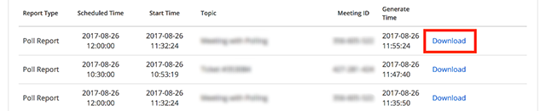

Webinar Reporting Instructions
Overview
Webinar Reports allows users to generate different metric and information reports including:
• Registration: Displays a list of registrants and their registration details.
• Attendee: Displays details about each attendee.
• Performance: Displays engagement statistics on registration, attendance, and feedback.
• Q&A: Displays questions and answers from the webinar.
• Polling: Displays each attendee poll result.
These reports can be exported in a .CSV format for further analysis. Reports are available for the previous year.
Prerequisites
• Webinar Host, Admin User, or have a role with access to Usage Reports
- Sign into the Zoom web portal and select Reports. If you are an account Admin/Owner or have access to the Usage Report role, you will need to select Account
- Management > Reports.
- Click Webinar.
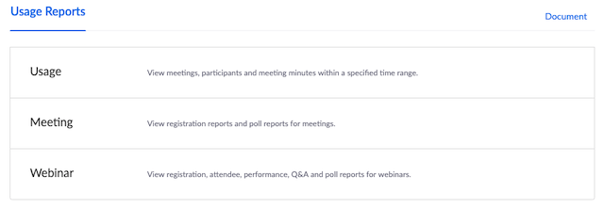
- Select the Report Type you would like to search for:
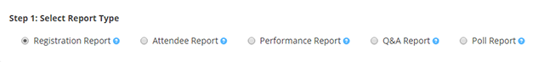
Note: Attendee, Performance, Q&A, and Poll Reports are available after the webinar has ended.
- Enter the date range for the webinar and select Filter or enter the Webinar ID number and select Search.
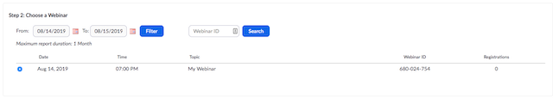
- Select the Webinar, and then select click Generate CSV Report.
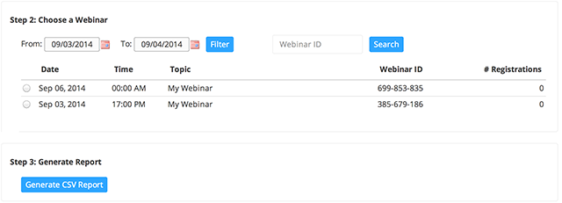
- Once the report has been generated, it will automatically download and can be opened in Excel, Notepad, or any other application compatible with the .CSV format.

Dual monitors with slide show and presenter's views
For example, in a conference room where there is a tv monitor and a presentation laptop.
Follow these steps if you are using dual monitors and want to present your PowerPoint file in one monitor while viewing the presenter's notes in another monitor.
- Open the PowerPoint file you want to present.
- Start or join a Zoom meeting.
- Click Share Screen in the meeting controls.
- Select your primary monitor then click Share. If you are not sure which monitor is your primary, select the one that PowerPoint opens in.
- While sharing your screen, switch PowerPoint to slide show mode by clicking the Slide Show tab > From Beginning or From Current Slide.
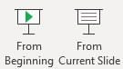
If you correctly shared your primary monitor, participants would see the PowerPoint in slides how view. The green border indicates the monitor you are currently sharing.
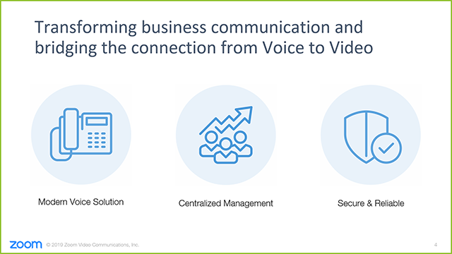
- The presenter's view will appear on your secondary monitor. Use this to view your slide notes and control the presentation.
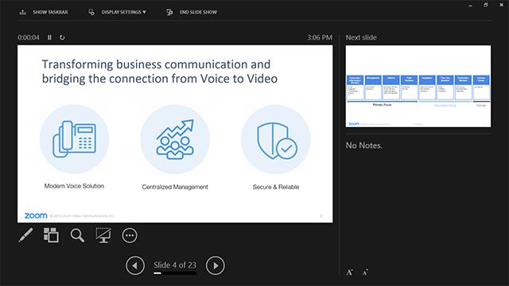
- If you are not sharing the correct monitor, click Display Settings then Swap Presenter View and Slide Show. PowerPoint will switch the monitor that is used for slide show view.
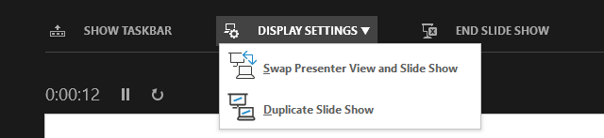
Alternatively, you can click New Share on your screen share controls and select the screen showing the PowerPoint in slide show view.
- If you want to duplicate the slide show on both the tv monitor and presentation laptop then in displace settings select duplicate slide show.

Application Known Issues / Limitations
For example, database optimization, application optimization needed.
Zoom Security:

In-meeting security options
Overview
The Security icon in the meeting controls allows the host or co-host of a meeting to enable or disable options during a meeting to secure the meeting and minimize disruption during the meeting. Most of the settings can be controlled from Account, Group, and User settings prior to the meeting. If applied at the Account, Group, or User level, these settings will be applied in meeting by default. The Security icon combines them all in one place for easy access during the meeting.
If the options are enabled/disabled and locked by an account admin, they will not be modifiable in-meeting by the host or co-host.
Available security settings are:
• Lock Meeting: Locks the meeting, keeping new participants from joining the meeting.
• Enable Waiting Room: Enables Waiting Room for incoming new participants or to move current participants into the Waiting Room.
- Allow participants to:
• Share Screen: Allows participants to start Screen Shares
• Chat: Allows participants to use the chat function.
• Rename Themselves: Allows participants to rename themselves from the Participants panel.
• Unmute Themselves: Allows participants to unmute themselves without the host's permission.
• Annotate on Shared Content: Allows participants to annotate over content shared during the meeting. The host can enable or disable annotation when the host is sharing.
• Remove Participant: Allows the removal of a participant from a meeting. The participant cannot re-join unless Allow removed participants to rejoin is enabled in Meeting settings.
• Report: Allows you to report a user to Zoom's Trust and Safety team. You will be able to select which user to report and provide details about the problem. You can also upload evidence, such as screenshots.
Prerequisites
- Zoom Desktop Client
  - Windows: 4.6.10 (20033.0407) or higher
  - macOS: 4.6.10 (20041.0408) or higher
  - Linux: 3.5.383291.0407 or higher
  - Chrome OS: 3.6.5 (4111.0413) or higher
- Zoom Mobile App
  - Android: 4.6.20000.0407 or higher
  - iOS: 4.6.10 (20012.0407) or higher
- Zoom web client
- Must be host or co-host in meeting
Instructions

Scheduling a Zoom Meeting
Zoom.us
Outlook Plugin
User should contact the Sun Health Service Desk to request the Microsoft Outlook Plugin for Zoom to enable Zoom / Outlook integration and simplify the scheduling of Zoom Meetings.
Once the plugin is installed Zoom meetings can be scheduled directly from Microsoft Outlook Calendar
- Begin by scheduling a meeting using the plug in icon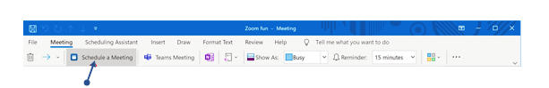
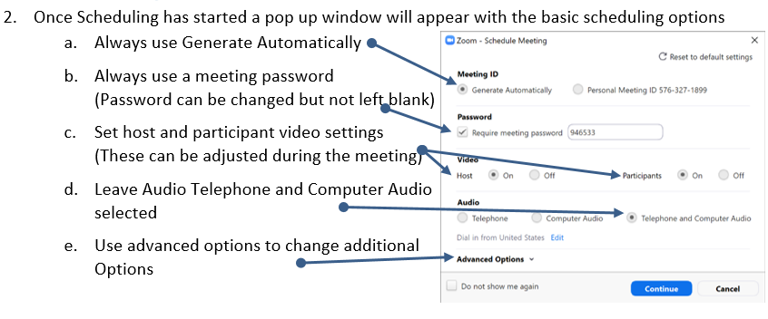

- From Advanced options you will be able to Change your Default advanced settings including:
  - Enable/Disable Waiting Room
  - Enable/Disable Joining before host (Only use for Internal Meetings)
  - Enable/Disable Mute Participants on Entry
  - Enable/Disable only authenticated users (Have zoom account)
  - Enable/Disable Automatically record (Wait till start of presentation to record recommended)
  - Enable/Disable Force include URL in Location Field (Outlook Plugin Only)
  - Enable/Disable insert meeting invitation in description above existing text
  - Change Language of instructions
  - Add alternative hosts (Must be official Sun Health Account User)
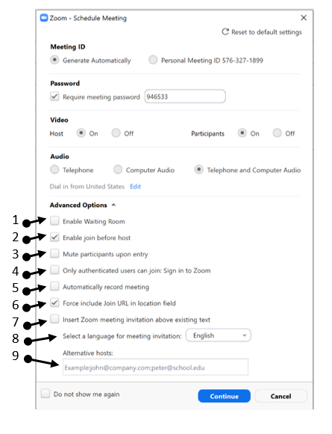
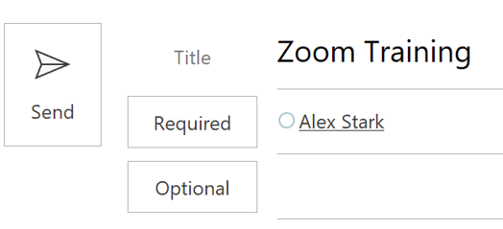
- Click Continue
- Click send to finalize

Windows | macOS
- Start a Zoom meeting
- Click Security.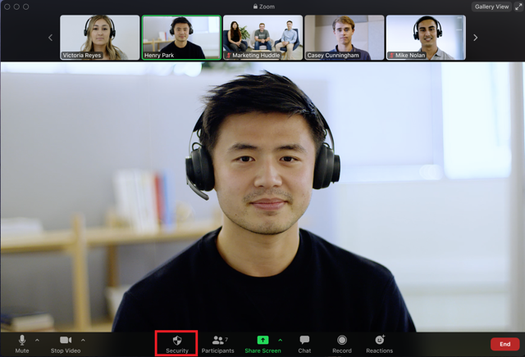
- The following settings can be enabled from the menu:
  - Lock Meeting: Locks the meeting, keeping new participants from joining the meeting.
  - Enable Waiting Room: Enables Waiting Room for incoming new participants or to move current participants into the Waiting Room.
  - Allow participants to:
    - Share Screen: Allows participants to start Screen Shares
    - Chat: Allows participants to use the chat function.
    - Rename Themselves: Allows participants to rename themselves from the Participants panel.
    - Unmute Themselves: Allows participants to unmute themselves without the host's permission.
    - Annotate on Shared Content: Allows participants to annotate over content shared during the meeting. The host can enable or disable annotation when the host is sharing.
  - Remove Participant: Allows the removal of a participant from a meeting. The participant cannot re-join unless Allow removed participants to rejoin is enabled in Meeting settings.
  - Report: Allows you to report a user to Zoom's Trust and Safety team. You will be able to select which user to report and provide details about the problem. You can also upload evidence, such as screenshots.
