  - APPLICATION:
Wordpress
  - Document Release Date: <Release Date>
Reviewed Date: <Reviewed Date>
Approved Date: <Approved Date>
Version: 0.1

Table of Contents

Application Overview 2
WordPress is a free and open-source website content management system. 2
Usage 2
Sun Health uses Wordpress for the management of our websites and employee portal. 2
Application Details and Ownership 2
Access 3
Permissions and Login 3
How to change your password 3
User Guide 4
Introduction 4
Purpose 4
Basic Usage 4
Dashboard 4
Menu 5
Posts 5
Media 5
Forms 6
Pages 6
Add Media to a Page 6
Appearance 7
Plugins 7
Users 7
Application Known Issues / Limitations 7

Application Overview

WordPress is a free and open-source website content management system.

Usage

Sun Health uses Wordpress for the management of our websites and employee portal.

Application Details and Ownership
Application Manager: Ashley Durham
Vendor: Wordpress
Vendor POC Name: N/A
Vendor POC Contact Information: N/A
License Type: Free
Subject matter expert(S): Ashley Durham, Danielle Kusksowski
Current Release of Software: Wordpress 5.6 (Simone) 12/8/2020
Application Location: Online

Access

Permissions and Login
Each Wordpress user will have a different level of permission based on their role at Sun Health. New users or revised roles can be granted through the corporate Marketing department.
To log in to the main Sun Health websites, please visit:
https://cms.sunhealth.org/wordpress/wp-login.php
To log in to Sun Health’s employee portal, please visit:
https://employees.sunhealth.org/wp-admin

How to change your password
Visit the above login screens and click the “Forgot Password” link.

User Guide
Wordpress is a complex system which requires one-on-one user training. For questions about this process, please contact the Application Manager.
For purposes of this training handbook, a general overview of the program and its uses will be outlined below.

Introduction
WordPress is a free and open source content management system (CMS) based on PHP and MySQL. This tool makes it possible for users to manage and edit website content easily – with no programming knowledge needed.
Purpose
Sun Health utilizes Wordpress for content management of our websites and employee portal.
To begin, please log in to one of the platforms as instructed in the ‘ACCESS’ section in the beginning of this handbook.

Basic Usage

Dashboard
Once logged in, from the Dashboard Screen, you can quickly access your site’s content and access to various menus.
The Dashboard screen presents information in blocks called widgets.
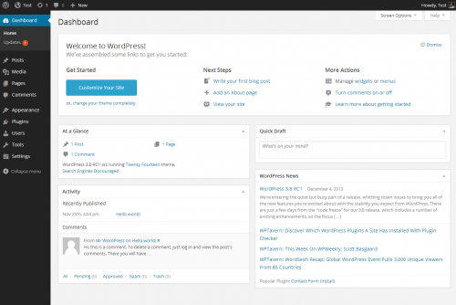

Menu
On the left hand side of the screen, there is a column which contains the sidebar menu. This area provides access to the content, features and functions of the website. It is important to understand that this menu will look different for each user and that these menu items will change depending on which website you are logged into.
For purposes of this handbook, we will be addressing the most common menu items to Sun Health.
To access any of these menu, simply click on the area.

Posts
Posts are blog content listed in a reverse chronological order (newest content on top). Due to their reverse chronological order, your posts are meant to be timely. Older posts are archived based on month and year. You can add and edit your WordPress posts from the ‘Posts’ menu in your dashboard.
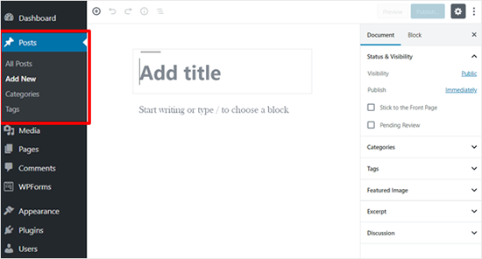

Media
Media is a tab in your WordPress admin sidebar which is used to manage user uploads (images, audio, video, and other files). Under the Media menu, there are two screens. The first screen Library lists all the files in the media library. These files can be edited and deleted from the library. The second screen is Add New, which allows users to upload files.
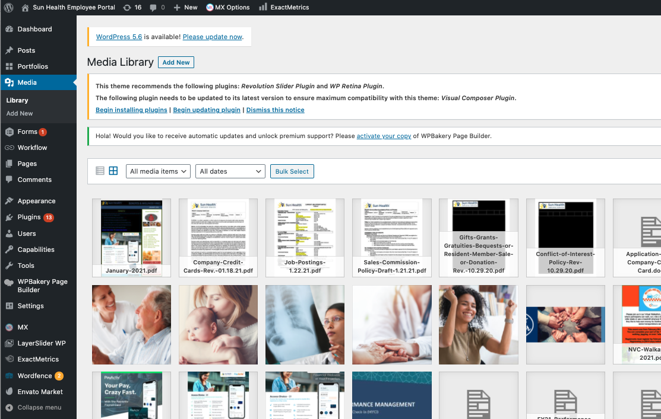

Forms
Forms are utilized to collect information from website visitors. Form creation and edits are managed by the marketing team.

Pages
Pages are static pages with content such as an about page, privacy policy, contact page, etc. While the WordPress database stores the published date of the page, pages are timeless entities. You can add and edit pages in WordPress from ‘Pages’ menu in your dashboard. Here is how the ‘Add New Page’ screen appears:

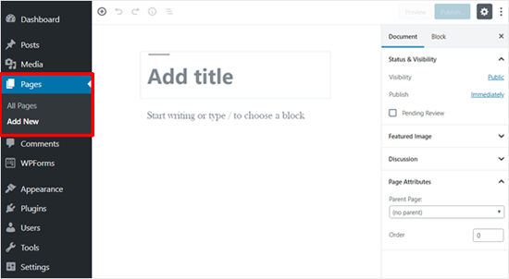

Add Media to a Page
From the post or page where you want the link:
- Click the Add Media button
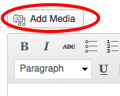
- Choose Upload Files and Select File to locate the file on your hard drive (you can also drag and drop the file)
- Change the Title field if you need to, this will become the name of the link embedded in your post
- Set the Link To field to Media File otherwise an additional page will be created to download the file from
- Click the "Insert into post" button to create the text link to the file
- Publish your post
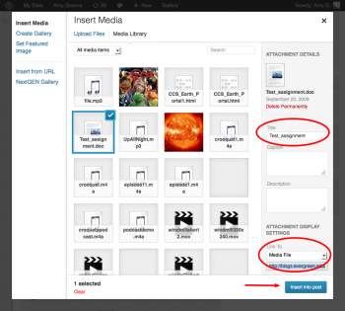

Appearance
The various Appearance menus allow you to change how the website looks and behaves. On our Employee Portal, this section also allows the navigation menus to be edited.

Plugins
A plugin is a piece of software containing a group of functions that can be added to a WordPress website. They can extend functionality or add new features to your WordPress websites.

Users
Each user of the Wordpress website is given special permissions and access based on their roles.

Application Known Issues / Limitations
No known issues. For base-level modifications, please contact the corporate Marketing Department.

