How to Create an Electronic Signature
Part 1
- Click on Signature field on the PDF
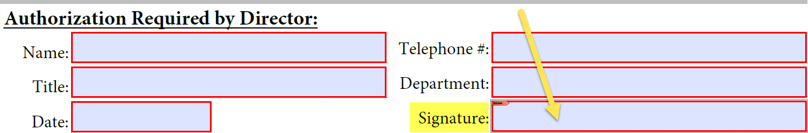

- Select existing signature and enter your password, or click on “Configure New Digital ID”
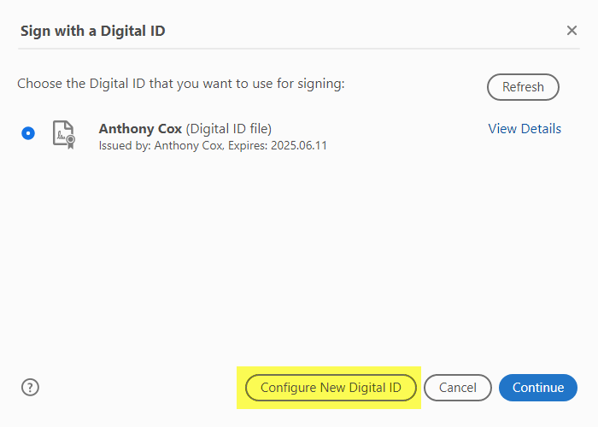

- Click on “Create a new Digital ID” then “Continue”
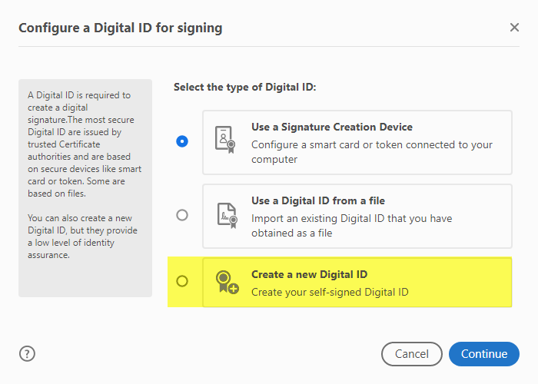
- Click “Save to File”, then “Continue”
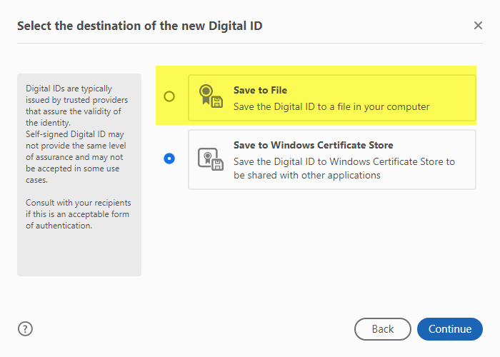

- Fill in the blank fields, then click continue
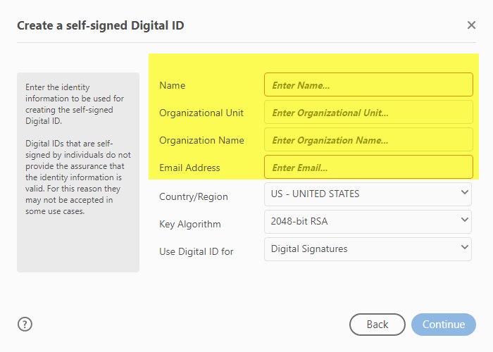
- Name – your name
- Organization Unit – your department
- Organization Name – Sun Health
- Email Address – your email address

- Create a password (password never expires) and click “Save”.

Part 2
Please follow the link and watch a quick 2-minute video. How to Create a Signature

